Lesson Plan – Political and Watershed Boundaries

Project Description: This project is a look into how political boundaries influence watershed protection and management.
Goals: Students will understand the arbitrary nature of political boundaries, the idea of trans-boundary pollution, difficulties associated with the fragmented nature of watershed management, and make policy recommendations for the future.

Relevant State Standards:
Communication Standards
Information Technology
1.18 Students use computers, telecommunications, and other tools of technology to research, to gather information and ideas, and to represent information and ideas accurately and appropriately.
Problem Solving Process
Reasoning and Problem Solving Standards
2.2 Students use reasoning strategies, knowledge, and common sense to solve complex problems related to all fields of knowledge.
Application
2.6 Students apply prior knowledge, curiosity, imagination, and creativity to solve problems.
Information
2.7 Students respond to new information by reflecting on experience and reconsidering their opinions and sources of information.
Understanding Place
Civic / Social Responsibility Standards
4.6 Students demonstrate understanding of the relationship between their local environment and community heritage and how each shapes their lives.
Causes and Effects in Human Societies
History and Social Sciences Standards
6.1 Students examine complex webs of causes and effects in relation to events in order to generalize about the workings of human societies, and they apply their findings to problems.
Geographical Knowledge
6.7 Students use geographical knowledge and images of various places to understand the present, communicate historical interpretations, develop solutions for the problems, and plan for the future
Governments and Resources
6.17 Students understand how governments affect the flow of resources, goods, and services.

Length: 1-2 hours.

Resources: Computers with Internet access and Google Earth standard installed.
For more instruction about using Google Earth, see http://earth.google.com/support/bin/topic.py?hl=en&topic=17090

Lesson Plan:
Introduction: What is a watershed?
A watershed is an area of land that all drains to the same point. The watershed boundaries that will be looked at in this exercise are HUC-8 and HUC-12 boundaries. HUC stands for Hydrologic Unit Code, and the number after is related to the number of digits in the code. “The United States is divided and sub-divided into successively smaller hydrologic units which are classified into four levels: regions, sub-regions, accounting units, and cataloging units.” (EPA website). The higher the HUC code is, the greater the subdivision. Therefore, the HUC-12 divisions are smaller than the HUC-8 divisions.

In Google Earth: Load the HUC-8 boundary layer into Google earth.
To do this, go to “File”, then “Open.”
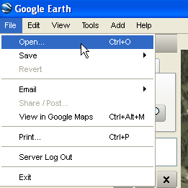
Next, select the HUC-8 file and click OK.
In order to navigate in Google Earth, you may use the white hand tool to click and pan: 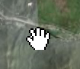
In addition, you may move the “N” icon, changing where “North” is, to turn the image around. You can also click on the four arrows inside the circle to pan as well.
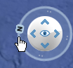

Discussion Questions:
Where are your school and stream collection sites?
What is the name of this watershed? Hint: The names of the watersheds are under the “Features” folder of the HUC-8 layer:
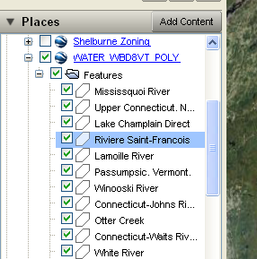

Vermont Political Boundaries:

In Google Earth: Open the town boundary and HUC-12 layers. To turn off the HUC-8 layers, click the check mark to the left of the layer name. Layers can be clicked on and off in this way depending on which ones you would like to show/hide:
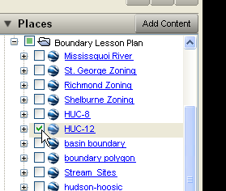

Discussion Questions:
How do the political boundaries in Vermont match up with watershed boundaries?
Why do you think this is?
What do you notice about the watershed boundaries and their location with respect to elevation? Hint: In order to get a better look at the terrain, use the arrows located near the “north” indicator to tilt your view or hold down the “Shift” key and roll the middle button on your mouse:
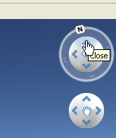
What do you notice about town/political boundaries? Do they seem to follow the terrain in some cases? Do they seem arbitrary in other cases?

Discussion Points:
Note the arbitrary nature of the political boundaries, and that they are chosen for reasons that are often political and have little to do with terrain.
The watershed boundaries fall along elevation peaks. The points of lowest elevation (often streams) may double as political boundaries. This leads to a very large discrepancy in the types of boundaries because they often follow opposite rules.

In-Depth Look at the Champlain Basin:
Definition: “Transboundary pollution is pollution that originates in one country but, by crossing the border through pathways of water or air, is able to cause damage to the environment in another country.” (OECD)

In Google Earth:
Open the Champlain Basin layer
Make sure the other layers are all unchecked.

Discussion Questions:
What do you notice about the basin boundary and state/country boundaries?

In Google Earth:
Open the Mississquoi River layer. Click the plus sign next to the layer to bring up the drop-down list. Then do the same under “Features.” Double click on the point titled “Mississquoi Headwaters:” This will zoom you in to the headwaters.
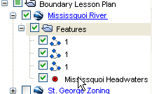
Next, starting at the headwaters, follow the Mississquoi downstream until you reach Lake Champlain.

Discussion questions:
Describe where the river goes.
What implications does this have for monitoring the health of this river?
What would your policy recommendation be for dealing with this boundary discrepancy and the evident trans-boundary pollution problem?

Discussion Points: The Lake Champlain basin falls into Vermont, New York, and parts of the Quebec province of Canada. This makes the management of the water quality in the basin exponentially more difficult because it involves coordination between different countries.

Zoning

In Google Earth: Open the Hinesburg, Williston, Shelburne, Richmond, and St. George zoning layers. It should look like this:
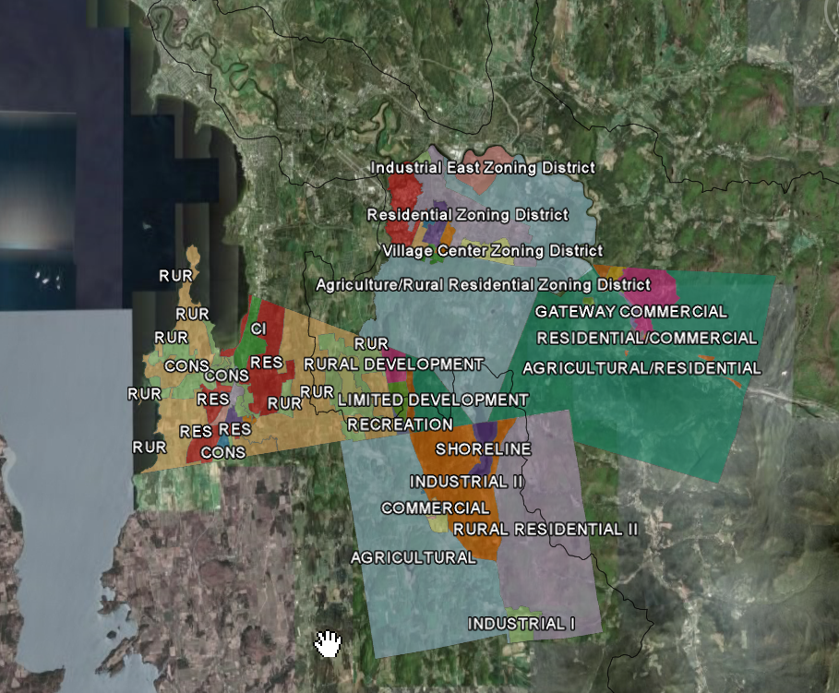

Next, zoom into Williston. You may do this by double-clicking on the Williston layer, or by using the mouse-roller to zoom in and out.

Discussion Questions: What do you notice about the zoning boundaries in Williston?
How do the zoning patterns treat proximity to bodies of water in the different towns?

Discussion Points: Williston’s northernmost boundary is a body of water, the Winooski River. Other zoning boundaries follow smaller streams or roads. Important to note Shelburne’s conservation practices (especially surrounding bodies of water), and Hinesburg’s “shoreline” zone around surface water. This same body of water shared with Williston does not have a protective zoning layer.

In Google Earth: Upload the wetlands layer. Keep the zoning layers selected as well. Wetlands are important to watershed management in several respects: they act as buffers to streams by filtering out pollutants, they provide flood control, they help to limit erosion and sediment deposition into streams, and wetlands also help to refill aquifers and protect drinking water supplies.

Discussion Questions: In your opinion, which of the towns is doing the best job, at this point, in protecting wetlands within its jurisdiction? Why?
Imagine you are given the task of reviewing the zoning for Williston, and you have the ability to recommend new zoning policy. How would you best protect the wetlands?

Discussion Points: Having buffers around water bodies and wetlands may limit the amount of phosphates and other pollutants due to run-off into surface water. It is also important to consider elevation and land-use type in the development of buffers and their relative sizes.

GIS Data Source:
Vermont Center for Geographic Information, www.vcgi.org

http://www.epa.gov/owow/watershed/whatis.html
http://stats.oecd.org/glossary/detail.asp?ID=2754
http://www.epa.gov/bioiweb1/aquatic/importance.html

