Rapid Assessment for Reptiles and Amphibians

on

The Lincoln Town Forest, Lincoln, Vermont

Fall, 2003

Funded by the Colby Hill Ecological Project

James S. Andrews
Biology Department
Middlebury College
Middlebury, Vermont 05753
Introduction

The Lincoln Town Forest is a 175-acre parcel on Bald Hill which is located in the northwest corner of Lincoln along the Bristol border. The parcel sits on the western slope of the Green Mountains at an elevation of 1,300 to 1,600 feet.

I was asked to perform a rapid ecological assessment of the reptiles and amphibians that were using the parcel and an assessment of the herptile habitat availability and quality. The goal was to gather the maximum amount of information within just a couple quick visits in an effort to keep the cost and time required to a minimum.

It is understood that this type of assessment will not be complete. Those species which are very secretive, have a limited window of opportunity (e.g. season, weather conditions) during which they can be found, or are rare, may well be missed. However, the majority of herptile species using the site can be located and fairly accurate estimations of the other species using the site can be made based on community type, elevation, location within the state, and known populations on nearby lands or on similar habitat in nearby towns.

Methods

My assistant Erin Talmage and I visited the parcel briefly on Sept. 12, 2003. I returned and spent a full day on the property on Sept. 22, 2003. On September 27, I was on the property again while leading a portion of a workshop. Only one method (active search) was used. An active search consists of turning cover, looking and listening for small movements, and listening for calls while exploring the variety of habitat types found on the property. A more thorough search makes use of a variety of techniques used over the course of a year in a variety of weather conditions. However, if only one technique is to be used, using this method in the fall while populations are at their yearly peak, provides the largest amount of information in the shortest amount of time. The variety of microhabitats for breeding, feeding, foraging, and overwintering can be seen and those species not located can be pretty safely assumed. Other field surveys performed in similar habitat and on adjacent properties provide useful information on any species that may have been missed. Over 45,000 records of reptiles and amphibians from throughout the state have been entered into the Vermont Reptile and Amphibian Database and this information can be used to help predict the species likely to be using similar habitat at similar elevations and latitudes.

Results

Species and significant habitat located

The site contains very little breeding habitat for most amphibians, no permanent or semipermanent ponds (either natural or manmade), no streams, and no vernal pools.

What are found on the property are a few excellent seeps feeding small seasonal brooks. Two very productive examples of the rocky seeps are found near the western border of the property draining west (Figure 1). I also found a smaller rocky seep and a grassy seep at the head of the small drainage that drains south and east on the property. These seeps (both rocky and grassy) provide breeding, feeding, and probably overwintering habitat for Northern Dusky Salamanders (Desmognathus fuscus) in good numbers. They also provide feeding areas and moisture for amphibians breeding off the property. UTM coordinates for the grassy and rocky seeps draining east are included with the printout of herptiles found (Appendix A).

A man-made pool on the property immediately south of this parcel probably provides the breeding habitat for the American Toads (Bufo americanus), Green Frogs (Rana clamitans), Pickerel Frogs (Rana palustris) Wood Frogs (Rana sylvatica), and Spring Peepers (Pseudacris crucifer) we located primarily in or near the seeps. Some of the Spring Peepers were also calling from annual vegetation (primarily sensitive fern) in some of the drier hardwood areas. The Green and Pickerel frogs may also have come from more distant permanent water on the Lester Anderson lands to the northwest or perhaps beaver ponds along the stream drainages off the property.

The Wood Frogs and Spring Peepers could also have come from a vernal pool (Figure 1) just east of the north east corner of the property (off the parcel). This pool probably also produces Spotted Salamander (Ambystoma maculatum) that feed and overwinter on the property, although we did not find them. There are a few ephemeral pools on the saddles between the peaks on the property but I do not believe they hold water long enough for amphibian production.

The Eastern Red-backed Salamander (Plethodon cinereus) does not require open water for any of its life cycle, only moisture. Consequently we were able to find a few on the property. A large percentage of the woods were very dry due to recent dry weather, shallow soils, or slope. In addition, the southeastern section has recently returned to woodlands. As a result, the leaf litter is shallow, and the necessary cover (coarse woody debris) is thin. Still, portions of the west drainage and eastern drainage near the seepage areas have enough soil moisture and cover for this species and we found a few very large adults.

Another amphibian that we did not locate that almost certainly travels to the property in small numbers from the nearby permanent water is the Eastern Newt (Notophthalmus viridescens). During dry weather the terrestrial phase (Red Eft) of this species hides under cover in moist areas and those using the property were well hidden during our visits. This species is very abundant in deciduous woods near permanent water bodies with emergent vegetation. However, as you travel away from those water bodies this species becomes less abundant.

Another species that breeds in similar habitat is the Gray Treefrog (Hyla versicolor). This species is most abundant near the large emergent marshes at lower elevations but it also breeds in smaller permanent water bodies with emergent vegetation at this elevation. Small numbers of adults may use this property though we did not locate them. The adults are arboreal and hence hard to find when they are not calling or moving to breeding sites. The young can sometimes be found in the low annual vegetation close to the breeding sites.

Two other species of salamander are found in seeps in Vermont. One of them might use the seeps here. The Northern Two-lined Salamander (Eurycea bislineata) is a very common species along the margins of small brooks and the seeps feeding into them. Although I did not find any, I would not be at all surprised if further effort turned up a few in the seepage areas.

We located only one species of reptile: Common Gartersnake (Thamnophis sirtalis). This species is by far the most abundant snake and the least restricted by habitat type or elevation in Vermont. I strongly suspect Red-bellied Snakes (Storeria occipitomaculata) also inhabit the property in small numbers as they are found on the nearby lands of Lester and Monique Anderson. However, sunny exposed openings, cover, and food are limited on the parcel. The stone wall along the southern boundary, the northern peak, and the small man-made openings have the best chance of holding these species. Another species that may be found in the same areas of the property is the Milksnake (Lampropeltis triangulum). They have been located on nearby properties that are more open.

The lack of large permanent water bodies (streams or ponds) on or near the property makes it unlikely that any turtle species use the parcel.

Management Recommendations

All of the species located or suspected on the property are currently quite common in Vermont. However, at the rate we humans are consuming habitat in this state (6,500 acres per year as of 1992, USEPA 1999), undeveloped sites such as this one will become more and more important for the long-term survival of herptiles and other native flora and fauna.

Of the species located, this parcel is providing year-round habitat for only the Eastern Red-backed salamander, Northern Dusky Salamander, and Common Gartersnake. Other species suspected but not located that may have all their seasonal needs provided are the Red-bellied Snake, Northern Two-lined Salamander, and perhaps the Ring-necked Snake. An important concept to remember though is that this property is one piece in the mosaic of lands and habitat requirements used by the rest of the herptiles using it. Although they may breed or den on adjacent properties, an interconnected mosaic of habitat types is required for them to survive and they all are equally important. The seeps provided on this property are breeding habitat for the Northern Dusky and perhaps Northern Two-lined Salamander but they are important moisture refuges for all the woodland species that travel here from more distant breeding habitat. The woodlands are important feeding and overwintering habitat for all but the seep species on this property. The northern hardwoods on the northeastern border of the property are well within the foraging and overwintering life-zone of the vernal pool amphibians breeding in the vernal pool on the adjacent property to the east.

General amphibian microhabitat requirements include;

- breeding locations that hold water at least through July,
- coarse woody debris in adjacent forested areas,
- foliage height diversity in adjacent forested areas,
- canopy cover over breeding and foraging areas,
- deep deciduous leaf litter for moisture retention and feeding,
- cool and moist conditions.

General reptile microhabitat requirements include;

- coarse woody debris (standing and down),
- small open patches for basking, mixed with well shaded refugia for warm weather and feeding,
- undisturbed areas in and around wetlands for feeding and breeding,
- access to safe denning areas.

Table 1. Reptiles and amphibians found or suspected on the Lincoln Town Forest Lands as a result of the fall, 2003 rapid ecological assessment.

Species Found

Common name | Scientific name | State Rank

Reptiles

Common Gartersnake Thamnophis sirtalis S5

Amphibians

Northern Dusky Salamander Desmognathus fuscus S4
Northern Red-backed Salamander Plethodon cinereus S5
American Toad Bufo americanus S5
Spring Peeper Pseudacris crucifer S5
Green Frog Rana clamitans S5
Pickerel Frog Rana palustris S4
Wood Frog Rana sylvatica S5

Species Strongly Suspected
based on habitat, elevation, latitude, and other records from the area

Common name | Scientific name | State Rank

Reptiles

Ring-necked Snake Diadophis punctatus S4
Milksnake Lampropeltis triangulum S5
Red-bellied Snake Storeria occipitomaculata S5

Amphibians

Spotted Salamander Ambystoma maculatum S5
Northern Two-lined Salamander Eurycea bislineata S5
Eastern Newt Notophthalmus viridescens S5
Gray Treefrog Hyla versicolor S5

Figure 1. Lincoln Town Forest Lands with significant microhabitat features for herptiles.

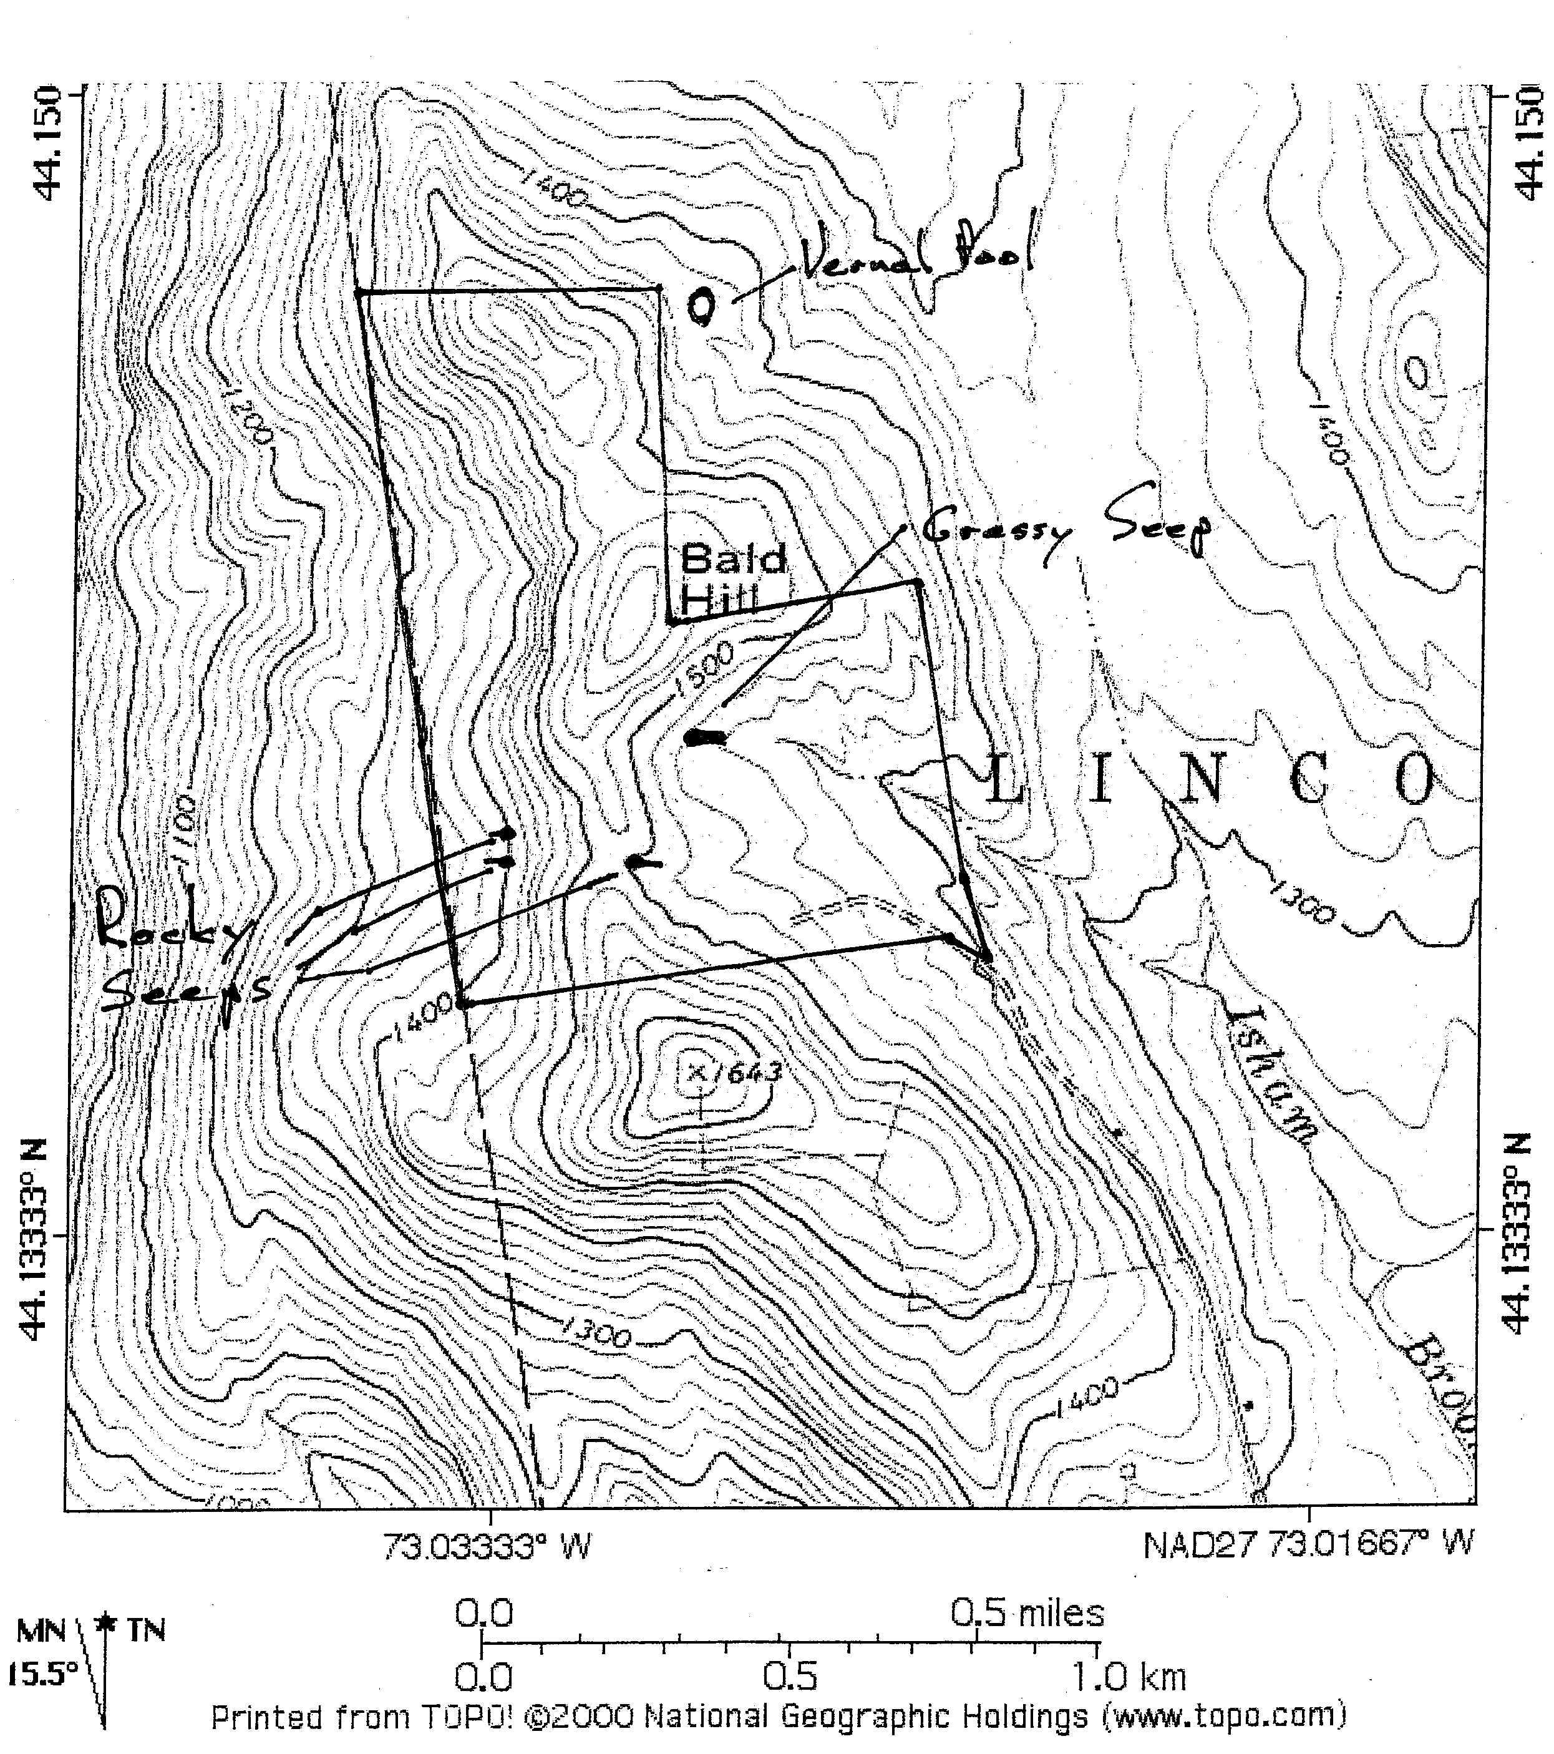

Seepage areas

The seepage areas were the most unique herptile microhabitats on the property. They need to be kept shaded so that the moisture content will remain high and the mosses will continue to grow (Northern Dusky Salamanders lay their eggs under the moss). They don't need to be large to be significant; they may be only a few feet across as long as they stay moist. The three rocky seepage areas sampled (Figure 1) all had very high densities of Northern Dusky Salamanders. During periods of drought, this habitat becomes a very important refuge as a wide variety of other more terrestrial amphibian species will join the Dusky Salamanders in their moist hideouts. My recommendations for seepage areas in general are listed below. Some are not concerns at this site.

- Maintain a 100 ft. wooded buffer (50 foot minimum) to keep the seeps well shaded and moist. The 100-ft. buffer will be most effective at preventing light penetration, intercepting sediment and nutrients, and providing future coarse woody debris.

- Minimize erosion and keep sediments and chemicals from draining into seepage areas and small streams.

- Nearby logging should be during dry or frozen ground conditions when erosion is minimized.

- Locate roads out of the buffer areas.

- Don't allow septic overflow, fertilizers, pesticides, herbicides, or equipment fluids to drain into the sites.

- Don't channelize, ditch or drain the area.

- Leave existing coarse woody debris but don't smother the sites with tops or branches.

- Leave rocks in place, don't remove them.

- Don't flood the areas by damming up the drainage.

- Remove invasive exotic vegetation (I did not see any at these sites).

- Keep livestock out.

- Keep logging equipment, ATVS, and other vehicles out of the buffer area.

- Locate trails so that foot traffic, bicycles, and sunlight are kept off the seepage areas.

Woodlands

The southern portion of the hardwood forest (east slope, south of drainage) needs to mature so that the leaf litter will deepen and the coarse woody debris will accumulate. The rest of the woodlands are more mature and more suitable habitat for woodland herptile use.

I include my general recommendations for woodlands. Many deal with the impacts of cutting timber. Although reckless timber cutting has the potential for doing great damage to herptile populations, it can be done in such a way that herptile populations are maintained. In some cases, it may keep the land from being used for less compatible purposes. On the other hand, timber cutting is certainly not necessary for herptile populations.

General

- Maintain large down trees (>2 per acre, 7 per hectare), dead standing trees (> 4 per acre), and a future supply consisting of older standing trees.

- Maintain standing trees with knotholes and dead branches.

- Within areas that are heavily cut, patches of older trees should be left in addition to the scattered mature trees.

- Maintain a thick layer of deciduous litter.

- Softwood plantations limit the number and diversity of amphibians (decreased coarse woody debris, decreased structural diversity, decreased hardwood leaf litter, increased acidity). In these situations maintaining pockets of hardwoods and leaving large debris on the ground would help to minimize the impact.

- Long rotations provide the old mature growth and dense forest cover amphibians prefer. As forests age they show increasing amphibian abundance up to an age of 60 to 70 years old in wet cool habitats and up to 120 years in warm, dry, lowland habitats (deMaynadier and Hunter 1995).

- Minimize compaction of the soil and direct mortality by keeping heavy equipment off the site when the ground is saturated. Winter logging or logging in late summer and early fall conditions should help minimize this effect.

- Protect and maintain shrub cover in the forest and on forest edges (vertical complexity).

- Do not create ditches and ruts that will hold water only briefly. Amphibians often lay their eggs in these small patches of water which dry too soon to permit the larvae to transform and leave. They should either be prevented or they should be deep and shaded enough to hold water through July.

Chemicals

- Amphibians absorb any chemicals which are in the water (dew, ground water, streams etc.) around them. Minimize use of herbicides, pesticides, and other biocides. Almost none of these chemicals have been tested on our native herptiles. In some cases even the inactive ingredients (e.g., surfactants in Roundup) have been found to be deadly to amphibians. Indirect, long-term, and sublethal effects have almost never been tested before marketing.

Roads

- Minimize the number of roads, size of roads, and the amount of traffic on roads. Close the roads to wheeled traffic after logging activities. A tremendous amount of herptile mortality is caused by vehicles. Snake in particular are attracted to the open areas on cold mornings. Most amphibian crossing activity will be while the ground is wet and at night.

Rocky outcroppings

Rocky outcroppings provide cover and retain heat for woodland snakes. Whereas amphibians need a moist and cool environment, snakes need warm places with sun exposure to raise their body temperatures and in some cases (in this case Milksnakes and Ring-necked Snakes) places to lay their eggs. On this property there is a combination of sun and rock in two types of places, one natural and one man-made. The man-made site is the stone wall on the south boundary of the property and the natural sites are the tops and west slopes of the small hills on the northwestern end of the property.

Other small openings along the old wood roads have been created and are probably used by snakes for basking and foraging. Live-bearing snakes like Gartersnakes and Red-bellied Snakes can move between very small sunny patches to heat themselves and their developing young. Egg-laying snakes (Milksnakes and Ring-necked Snakes) need more consistently sunny locations where their eggs can be left to incubate. The combination of sun and rock cover is ideal. When these two are located near water, the water provides the additional attraction of a handy food source (amphibians).

If openings are to be created in the process of extracting timber, small patch cuts (1/4 acre or less) could be located in such a way as to expose rock walls, or ledges. Consequently the cuts would be on the south and/or west sides of such areas to allow the greatest sun exposure.

General considerations for woodland openings

- Maintain a natural pattern of forest cover with small forest breaks.

- Large clear-cuts regularly show fewer amphibians than adjacent older growth. Successive short rotation clear-cuts showed the lowest abundance of amphibians (deMaynadier and Hunter 1995). Natural disasters such as diseases and storms seem to have less of an effect on amphibian abundance as clear-cuts, probably because of the amount of coarse woody debris left behind.

- Large clear-cuts seem to block the movements of some amphibian species.

- Small upland meadows with nearby woods provide partial habitat requirements for some snake species.

- In small upland meadows exposed rock piles, sawdust piles, and coarse woody debris can provide good habitat for snakes.

- Open areas with dense annual or shrubby growth near water bodies or on the edge of woods provide foraging areas for some species.

- Open areas that are to be kept open should be cut high and either not raked or raked by hand, (direct mortality should be minimized). These areas could be cut after the first heavy frost and before the first snows (reptiles and amphibians would no longer be active). A less desirable alternative would be to cut during mid-day or mid-summer when the snakes are fully alert and active. If mowers are to be used they should mow in a pattern that pushes herptiles off to the side rather than into the middle of an open area.

Vernal Pools

Although there were no vernal pools located during this survey, some of this property is located within the life-zone of the vernal pool amphibians breeding on the adjacent property to the east (Figure 1). A very small portion may be within the recommended buffer zone for the pool. Consequently the hardwoods on the northeast boundary of the property on the east-facing slope should be managed accordingly.

- A buffer strip of 100 ft. should be maintained around vernal pools (also brooks, seeps, and ponds). These strips minimize siltation, maintain shade, maintain undisturbed soil and deep leaf litter, provide patches of older growth as sources for recolonization, and provide movement corridors. The width of undisturbed buffer strip should be a minimum of 100 ft. with a wider zone of up to 600 ft. where cutting and its impacts are limited. Buffer strips should be widest where streams are larger, where the intensity of harvest is greatest, where the surrounding terrain is steepest, or where rare, threatened, or endangered species are found. deMaynadier and Hunter (1995) suggest no more than 25% of the basal area should be cut in this second tier buffer. Alternatively, I believe that small patch cuts (less than 1.4 acre) could impact this second tier buffer but should not make up more than 25% of the second tier buffer of the pool with the rest of the buffer left undisturbed.

Connectivity

Since most of the amphibians on this property come from breeding areas on adjacent lands, this parcel needs to be connected to a larger permeable mosaic of lands in order for it to maintain its herptile biodiversity even for the short-term. Conversely, it is providing essential feeding and overwintering habitat and moisture refuges (the seeps) for the amphibians that breed on adjacent properties. Over the long-term the herptiles will also require those connections for colonization, recolonization and migration movements as the habitat changes and weathers stochastic events. Large interconnected mosaics of uplands and wetlands provide the greatest stability for herptiles over the long run. As disease, drought, global warming, habitat consumption or alteration, pollution, etc, alter the landscape and eliminate local populations, herptiles need to be able to move across the landscape to colonize new sites and recolonize old sites. In order for this to happen, lands need to be interconnected and the surrounding landscapes need to be permeable to wildlife.

Creation of breeding sites

It is possible to create breeding sites on this property in order to augment breeding habitat or to guard against the loss of breeding habitat on adjacent lands. Either vernal pools or permanent ponds could be created on the property. They do not need to be large. Even an area as small as 100 square ft. would be adequate as long as it holds water at least through mid-July in average rainfall years for vernal-pool species. Usually this requires approximately three feet of water in the spring. Obviously, ponds for permanent water species should hold water year around and need to be deep enough for tadpoles to overwinter under the ice without freezing. These ponds should be located so that they will either fill with run off or ground water and they should not flood or destroy existing herptile or wetland habitat. A new source book on creating vernal pools is listed in the management section.

Conclusion

The most significant features of this property relative to herptiles are the seeps. However, the woodlands provide necessary habitat for amphibians breeding on adjacent lands. This parcel serves as part of a still primarily intact larger mosaic of breeding, foraging, and overwintering habitat in the surrounding area. These intact mosaics are becoming less common and need to be preserved if we hope to maintain populations of all our native herptiles.

Attached (Appendix A) are a printout of all reptiles and amphibians seen during the survey as well as notes on some of the significant seeps. Also attached are an updated Vermont reptile and amphibian species list (Appendix B), suggested resources for herptile identification, natural history, and management (Appendix C) and a copy of a short article on seepage salamanders (Appendix D).

Sources cited and/or recommended

Management guides are just beginning to be available. All of the following include reptile and amphibian related information.

Biebighauser, T. 2002. A guide to creating vernal ponds. USDA Forest Service in cooperation with the Izaak Walton League of America. Morehead, Kentucky. 33 pp. (Call 606-784-6428 to order or find it on the web.)

Calhoun, A.J.K. and M. W. Klemens. 2002. Best Development Practices: Conserving pool-breeding amphibians in residential and commercial developments in the Northeastern United States. MCA Technical Paper No. 5, Metropolitan Conservation Alliance, Wildlife Conservation Society, Bronx, New York. 57 pp. (Call 924-925-9175 to order.)

deMaynadier, P. and M. Hunter. 1995. The relationship between forest management and amphibian ecology: a review of the North American literature. Environmental Reviews 3: 230-261.

Evink, G. 2002. National Cooperative Highway Research Program Synthesis 305, Interaction between roadways and wildlife ecology, A synthesis of highway practice. Transportation Research Board, Washington D.C. 78 pp. (Impacts of roads on herptiles and some conservation strategies. A big problem, good information. Order at 202-334-3213 or on the web.)

Flatebo, G., C. Foss, and S. Pelletier. 1999. Biodiversity in the forests of Maine: Guidelines for land management. University of Maine Cooperative Extension Bulletin #7147. C. Elliot editor, University of Maine Cooperative Extension, Orono, Maine. 168 pp. (Contact UME Extension Office at 207-581-3188.)

Kingsbury, B. and J. Gibson. 2002. Habitat management guidelines for amphibians and reptiles of the Midwest. Midwest Partners in Amphibian and Reptile Conservation (Midwest PARC). 57 pp. (Visit the PARC website for more information: www.parcplace.org.)

United States Environmental Protection Agency. 1999. Keeping in Touch. EPA New England Regional Newsletter. Vermont State Program Unit. 8pp.

Appendix A

Herptiles and Features Located

Appendix B

Vermont Reptiles and Amphibians with Current State Status

Appendix C

Resources for Herptile Identification, Natural History, and Management

Appendix D

Seepage Salamanders

