2006 Camera Trap Survey at Guthrie-Bancroft Parcel,
Colby Hill, Lincoln and Bristol Vermont

Jan Decher

Summary
In 2006 camera trapping at the Guthrie-Bancroft parcel on Colby Hill, Lincoln and Bristol, Vermont, continued with one analog (Camtrakker) and one digital (Cuddeback) camera. Monitoring lasted from 24 July to 10 November 2006 with seven mammal and one bird species recorded. The Eastern gray squirrel (Sciurus carolinensis) was a new addition to the list of species recorded with camera traps. The porcupine (Erethizon dorsatum) is included here, however, it was not photographed by the camera trap, but rather during chance encounters while walking on the land.

Introduction
In 2006 we continued the monitoring of medium and large mammal species on the Guthrie Bancroft Parcel on Colby Hill, Lincoln and Bristol, Vermont, using one analog (Camtrakker) and one digital (Cuddeback) camera. The digital camera can be set to take 10-60 second videos simultaneously to the still image during daylight hours. This way often additional information can be captured. As an addition to my previous comments on game or wildlife camera performance in the 2005 report (Decher 2005), there now is an online review of digital game cameras (Whitetail Deer Management and Hunting Homepage 2004-2007). The Cuddeback 3.0 MP receives an average rating in this comparison.

Materials and Methods
Methodology was similar to that used in previous years (Decher 2005). Camera-trapping this year concentrated on Ecosystem 1, ES 6, and ES 2 and 12 (forest bordering the northern “tongue extension” of the Guthrie-Bancroft meadow). GPS waypoints were downloaded from a Garmin 12 receiver using the program Mac GPS Pro 7.1.0 and plotted on a scanned and geo-referenced digital USGS topographic map (http://www.macgpspro.com/). Figure 1 shows the 2006 camera trap locations plotted on the Starksboro/Bristol sheet of the New England USGS Topo Map 1:24K using Mac GPS Pro 7.1.0.

Results
In 2006 the film-based camera (Camtrakker) recorded 6 and the digital (Cuddeback) camera recorded 7 useful distinct events (Table 1). Newly added to the list of camera-trapped species this year was the Eastern gray squirrel (Sciurus carolinensis; Plate 17). The porcupine (Erethizon dorsatum) was photographed and filmed on two chance encounters in the meadow (ES 21) and in ES 6, while checking camera traps (Plate 16). White-tailed deer were recorded more frequently this year than in the previous two years (4 separate localities; Plates 1-8). Only one rather dark picture of a moose was recorded this year (Plate 9). The bear still photo (Plate 14) is so close that it is not very informative. The associated video file (Bear9Aug06.AVI; see enclosed CD) yields additional information. A bear with two cubs was also video-filmed during a chance encounter in the meadow (ES 21) on 14 Aug 06. The raccoon picture (Plate 15) shows two individuals, but the associated video file (Raccons13Aug06.AVI) appears to show three individuals visiting the bait area in the dense fern stand. Three videos of white-tailed deer yielded group sizes of one, two and three individuals, respectively. One encounter with two domestic dogs was recorded on camera this year at the edge of the meadow “tongue extension” (Plate 19).
As in 2005, waypoints plotted on the digital topographic map appear to be approximately in the right locations. However, analog camera locations CA01 and CA04 in Fig. 1 appear in the middle of the northern “tongue extension” of the Guthrie meadow rather than along its western edge. Deviations of plotted map from field impression may stem from the age of the topographic source map (Bristol, VT NE/4 Middlebury 15’ Quadrangle N4407.5–W7300/7.5 1963 Sheet), showing outdated forest-meadow boundaries or from slight inaccuracies of GPS readings. This 1963 map still shows a building (barn?) outline near the cellar hole at Guthrie.

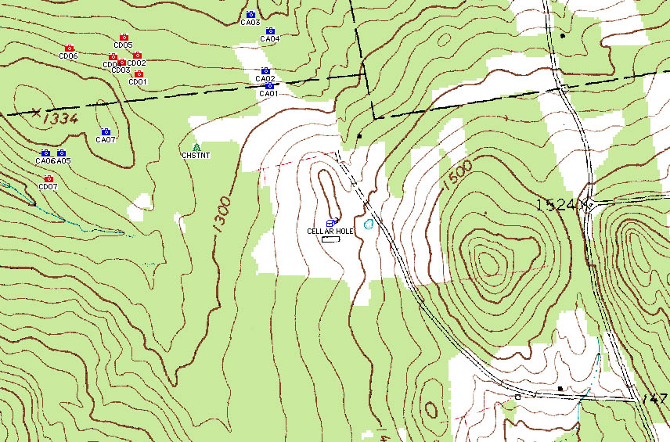
Fig. 1 - Plotted Garmin 12 GPS readings of 2006 camera trap localities on 1:24K USGS Map (www.MacGPSPro.com). For additional orientation the waypoint CHSTNT (location of large American Chestnut (Castanea dentata) tree) has also been plotted and the Guthrie cellar hole location has been inserted manually. Digital camera locations are shown in red, analog camera locations in blue.

Table 1. 2006 Wildlife recorded by two camera traps at Guthrie–Bancroft parcel, Colby Hill, Lincoln, between 24 July and 10 November 2006
Common Name | Scientific Name | Order, Family | Number of Photographs
M a m m a l s
Raccoon | Procyon lotor | Carnivora, Procyonidae | 1*
Coyote | Canis latrans | Carnivora, Canidae | 3
Black bear | Ursus americanus | Carnivora, Ursidae | 1*
Moose | Alces alces | Artiodactyla, Cervidae | 1
White-tailed Deer | Odocoileus virginianus | Artiodactyla, Cervidae | 4*
Porcupine | Erethizon dorsatum | Erethizontidae, Rodentia | [2]**
Eastern Gray Squirrel | Sciurus carolinensis | Sciuridae, Rodentia | 2
B i r d s
Turkey | Meleagris gallopavo |  | 1*
* plus video sequences ** hand-held camera, 2 direct encounters (ES 6 and ES 21)

Table 2 summarizes all GPS Codes for successful camera trap sites, their coordinates, approximate ecosystem, and recording dates, and all mammal and bird species recorded in 2004, 2005, and 2006.

Table 2: 2004, 2005 and 2006 camera trap GPS localities that yielded useful results (porcupines excluded).
 |  |  |  |  | Mammals |  |  |  |  |  |  |  |  |  | Birds
GPS Code | Date | ES | Latitude | Longitude | Bear | Fisher | W.-T. Deer | Moose | Raccoon | Coyote | Red Fox | East. Cottontail | East. Grey Squirrel | Peromyscus | Turkey | Ruffed Grouse | Wh.-br. Nuthatch | Hunters/Dogs
04CA01 | 19 May 04 | 14 | 44°08'57.4" | 73°01'05.3" |  |  |  |  |  |  |  |  |  |  | X
04CA03 | 09 Jun 04 | 14 | 44°08'57.5" | 73°01'08.1" | X
04CA04 | 12Jun 04 | 14 | 44°08'58.3" | 73°01'04.2" | X
04CA07 | 06Jul 04 | 4 | 44°08'56.1" | 73°01'02.1" |  |  |  |  | X | X
04CA08 | 11Aug 04 | 20 | 44°09'08.6" | 73°01'28.7" | X |  |  | X |  |  |  |  |  |  |  | X
04CA09 | 11Aug 04 | 2 | 44°09'09.9" | 73°01'28.9" | X |  |  |  |  |  |  | X
04CA13 | 22Oct 04 | 21,14 | 44°09'11.2" | 73°01'14.4" |  |  |  |  |  |  |  |  |  | X |  |  | X
05CA01 | 19 Jul 05 | 20 | 44°09'08.0" | 73°01'28.8" |  |  |  | X
05CA04* | 28 Sep 05 | 14/22 | 44°09'02.8" | 73°01'07.7" |  | X | X |  | X |  | X |  |  |  |  | X
05CD02 | 05 Oct 05 | 14 | 44°09'04.4" | 73°01'12.1" |  |  |  |  |  |  |  |  |  |  |  |  |  | X
05CD03 | 02 Nov 05 | 14 | 44°08'55.5" | 73°01'07.8" |  |  | X |  |  |  |  |  |  |  |  |  |  | X
06CA01 | 31 Jul 06 | 12 | 44°09’18.7” | 73°01’13.5” |  |  | X |  |  | X |  |  |  |  | X
06CA02 | 08 Aug 06 | 12/21 | 44°09’20.2” | 73°01’14.0” |  |  | X |  |  |  |  |  |  |  |  |  |  | X
06CA03 | 17 Aug 06 | 2/ 12 | 44°09’25.9” | 73°01’15.9” |  |  | X
06CD02 | 07 Aug 06 | 6 | 44°09’22.0” | 73°01’32.0” | X |  |  |  | X
06CD05 | 08 Sep 06 | 6 | 44°09’23.9” | 73°01’33.8” |  |  | X | X |  |  |  |  | X
06CD06 | 03 Oct 06 | 6 | 44°09’23.0” | 73°01’41.5” |  |  |  |  |  | X
06CD07 | 13 Oct 06 | 1 | 44°09’09.8” | 73°01’44.8” |  |  |  |  |  | X
 |  |  |  | Total Images: | 5 | 1 | 6 | 3 | 3 | 4 | 1 | 1 | 1 | 1 | 1 | 2 | 1 | 3
*Digital camera used on analog camera location (05CA04)

Discussion
In addition to one new species being recorded (gray squirrel, ES1), the 2006 camera trapping yielded some interesting information on group sizes of species (3 raccoons, 1-3 deer, 2 turkeys). Bear presence was verified for one (ES 6) and coyote for three (ES 1, 6 and 12) additional habitats. Coyote presence is another indication how successful this predator has spread into the Northeast since the 1930s and 40s (Gompper 2002). However, in some cases the same individual may have been observed this and last year, given the coyote home ranges of 18.7 km² and 17.1 km² for males and females, respectively, reported for the Champlain Valley (Person and Hirth 1991).
The camera traps also seem to confirm a subjective impression formed since the first year of the project (2000), that white-tailed deer appear to be more abundant in the northern part of the Guthrie parcel, perhaps due to old apple trees and more varied forest-meadow transitions present in this area.

How could camera trap records not just provide information on presence-absence of species, but also provide information on abundance and density? Studies of jaguars (Panthera onca) in Belize and Bolivia used grids of 9-34 camera stations with 2 cameras per station – one on each side of the trail--to photograph animals from both sides to provide enough redundancy in case of camera malfunction. The cat’s distinct coat patterns in the photographs were used to identify individuals (Silver et al. 2004). Subsequently, capture-recapture statistics (Program CAPTURE: http://www.mbr-pwrc.usgs.gov/software.html#a) could be used to calculate abundance estimates. However, many temperate zone mammals are not as distinctly patterned as the large striped cats, so individual identification can be difficult. A recent camera trap study attempted to address this shortcoming by choosing a spatial scale that minimized repeat visits of individuals. Seven to eight cameras were placed on linear transects and statistical methods (index of over-dispersion, bootstrap simulation, logistic regression) were used on presence-absence data to detect the spatial scale needed to reduce the error in indices of relative abundance (Kauffman et al. 2007). This method of assessing abundance and distribution of large carnivores with camera traps requires camera trap station to be spaced 1 km apart, which would require transects to go across property boundaries on Colby Hill. It would be useful to develop a method of camera detection that also yields reliable abundance data on a limited spatial scale, like the Guthrie-Bancroft parcel, which may only include part of some larger species’ home range.

Literature Cited

Decher, J. 2004. 2004 Camera Trap Survey at Guthrie-Bancroft Parcel, Colby Hill, Lincoln,
Vermont. Burlington: Colby Hill Ecological Project.
Decher, 2005. 2005 Camera Trap Survey at Guthrie-Bancroft Parcel, Colby Hill, Lincoln, Vermont.
Gompper, M. E. 2002. The ecology of Northeast coyotes: Current knowledge and priorities for future research. WCS Working Paper No. 17. July 2002. See also URL: http://www.wcs.org/media/file/Ecology_of_NE_Coyotes.pdf
Kauffman, M. J., M. Sanjayan, J. Lowenstein, A. Nelson, R. M. Jeo, and K. R. Crooks. 2007. Remote camera-trap methods and analyses reveal impacts of rangeland management on Namibian carnivore communities Oryx 41:70-78.
Person, D. K., and D. H. Hirth. 1991. Home range and habitat use of coyotes in a farm region of Vermont. Journal of Wildlife Management 55:433-441.
Silver, S. C., L. E. T. Ostro, L. K. Marsh, L. Maffei, A. J. Noss, M. J. Kelly, R. B. Wallace, H. Gomez, and G. Ayala. 2004. The use of camera traps for estimating jaguar Panthera onca abundance and density using capture/recapture analysis. Oryx 38:148-15. See also URL: http://savethejaguar.com/media/file/CameraTrapProtocolEnglishSSilver(revised)03.05FINAL.pdf
Whitetail Deer Management and Hunting Homepage. 2004-2007. See also URL: http://www.whitetaildeer-management-and-hunting.com/game-camera-review.html
Appendix: Photographs
1. Mammals
1.1 Artiodactyls
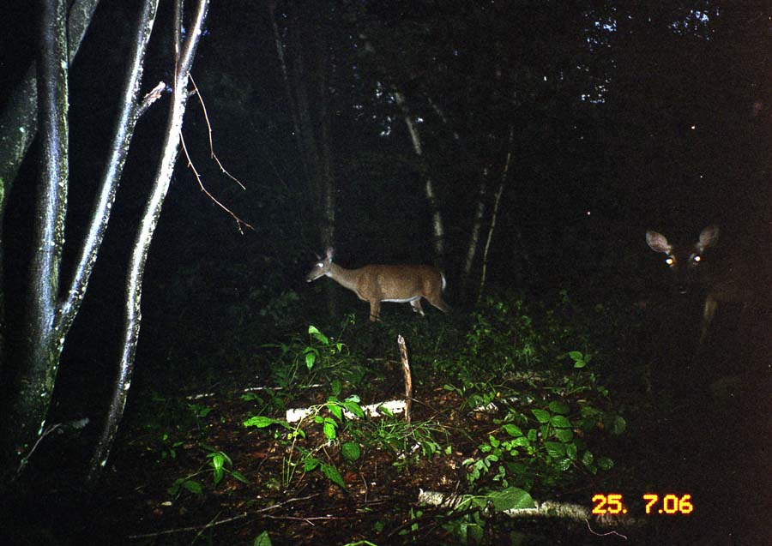

Plate 1. Odocoileus virginanus (White-tailed Deer). Date: 25 July 2006 Location Code: 06CA01.
GPS: 44°09’18.7”N, 73°01’13.5”W Habitat: ES 12; Forest corner just west of the top end of the “tongue” extension of the lower meadow.

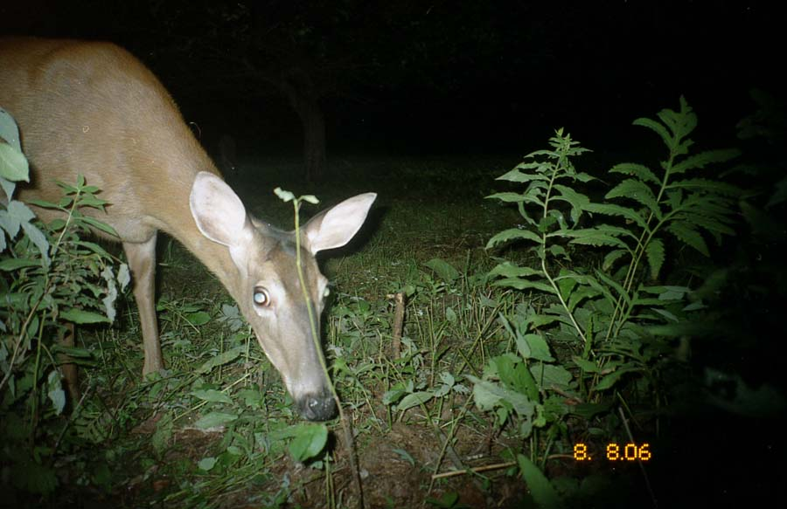

Plate 2. Odocoileus virginanus (White-tailed Deer). Date: 8 Aug 2006 Location Code: 06CA02.
GPS: 44°09’20.2”N, 73°01’14.0”W Habitat: ES 12+21; Western forest edge halfway down the “tongue” extension of the lower meadow.

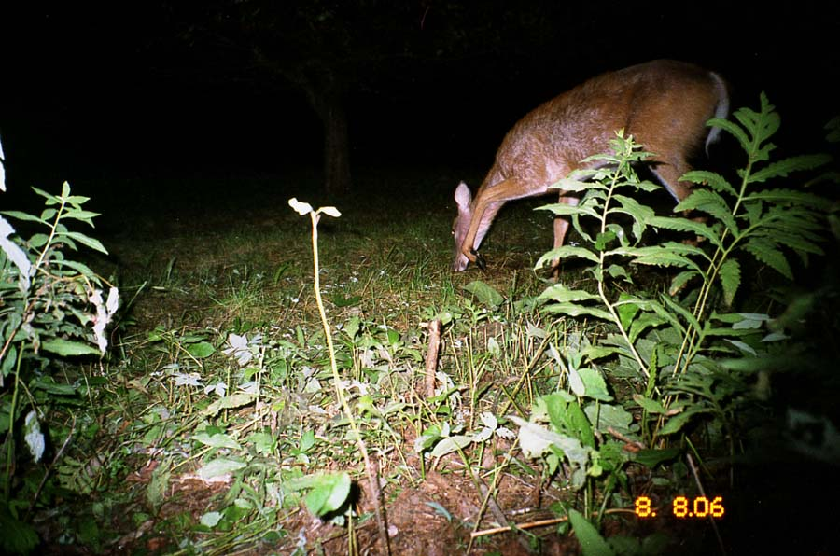
Plate 3. Odocoileus virginanus (White-tailed Deer). Date: 8 Aug 2006 Location Code: 06CA02.
GPS: 44°09’20.2”N, 73°01’14.0”W Habitat: ES 12+21; Western forest edge halfway down the “tongue” extension of the lower meadow.

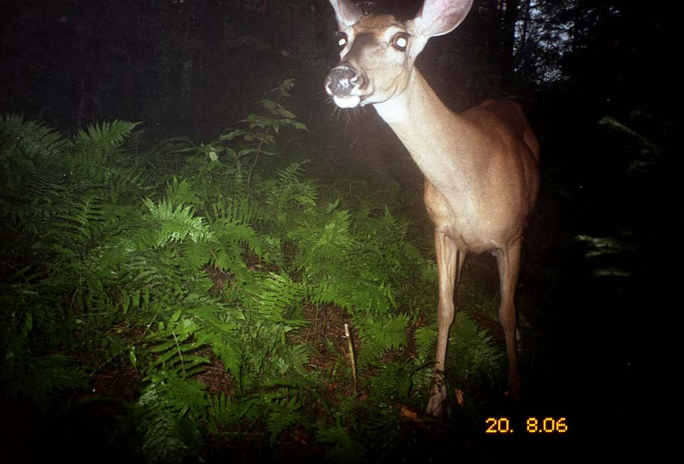

Plate 4. Odocoileus virginanus (White-tailed Deer). Date: 20 Aug 2006 Location Code: 06CA03. GPS: 44°09’25.9”N, 73°01’15.9”W Habitat: ES 12/ES2; Forest at end (northern tip) of “tongue” extension of the lower meadow. Dense ferns.

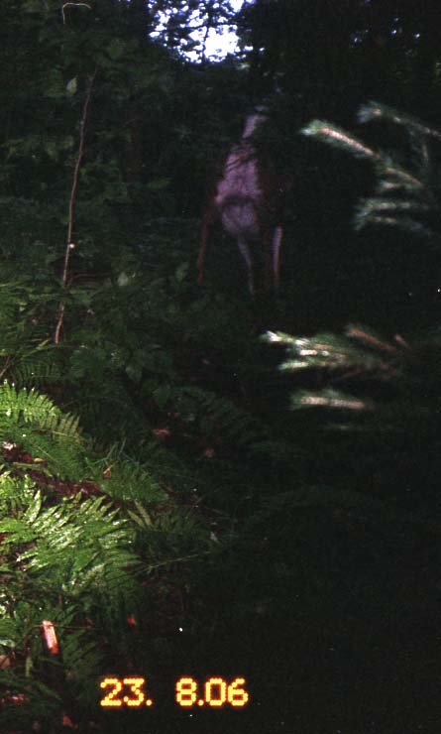
Plate 5. Odocoileus virginanus (White-tailed Deer - bounding off). Date: 23 Aug 2006 Location Code: 06CA03. GPS: 44°09’25.9”N, 73°01’15.9”W Habitat: ES 12/ES2; Forest at end (northern tip) of “tongue” extension of the lower meadow. Dense ferns.

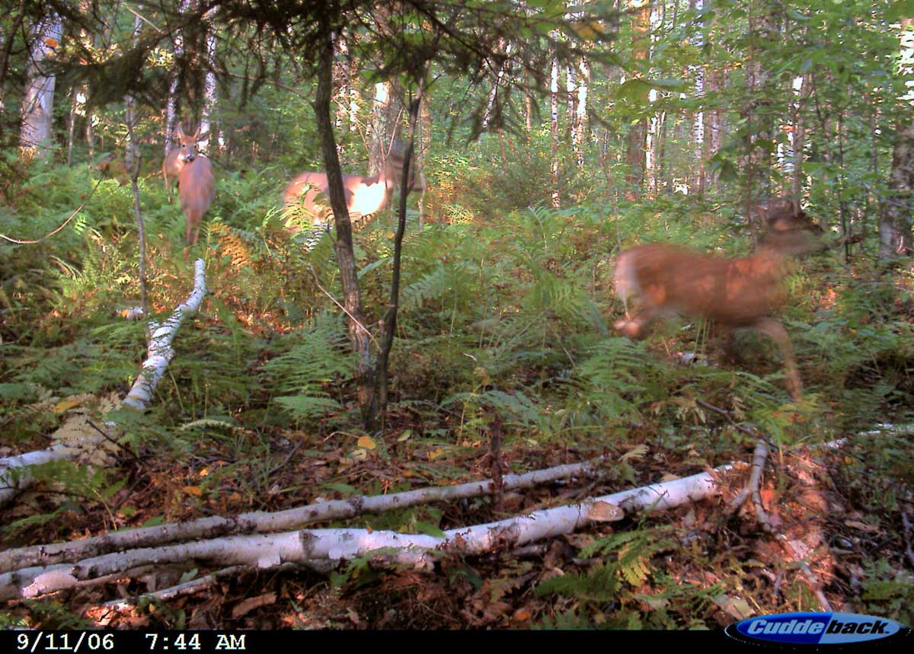
Plate 6. Odocoileus virginanus (3 White-tailed Deer). Date: 11 Sept 2006. Location Code: 06CD05. GPS: 44°09’23.9”N, 73°01’33.8”W Habitat: ES 6 (North of “pot road” trail)
[See also associated video file: 3Deer11Sep06.AVI for this location.]

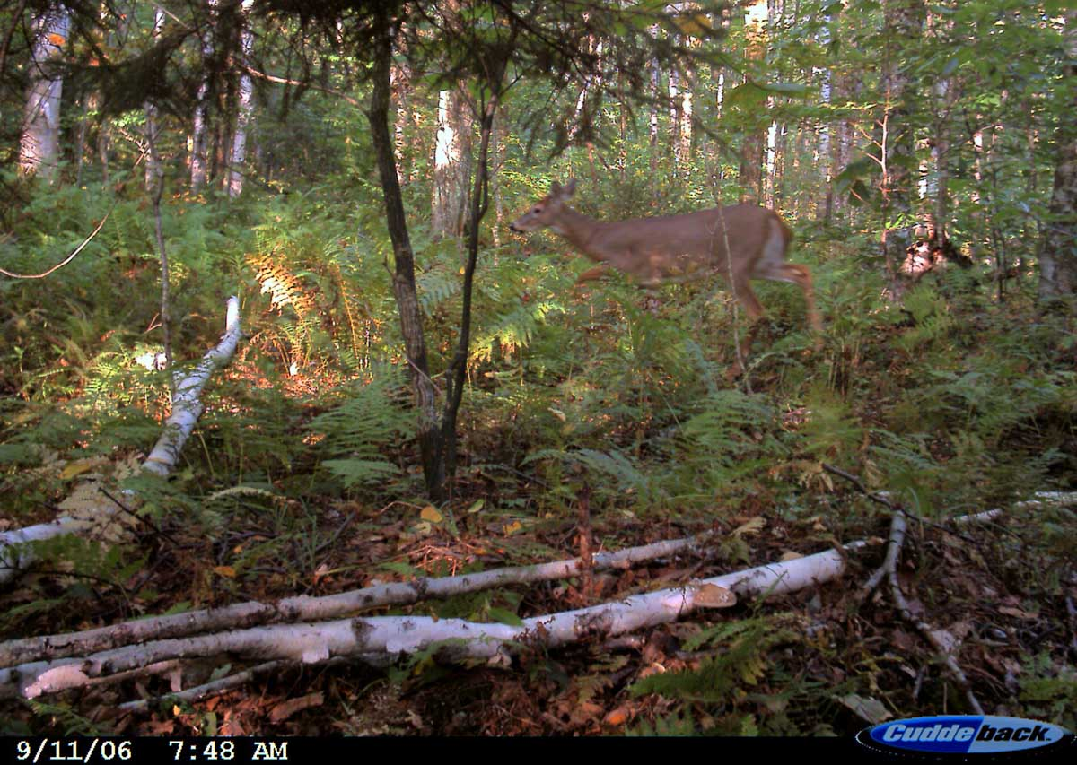
Plate 7. Odocoileus virginanus (White-tailed Deer). Date: 11 Sept 2006. Location Code: 06CD05. GPS: 44°09’23.9”N, 73°01’33.8”W Habitat: ES 6 (North of “pot road” trail)

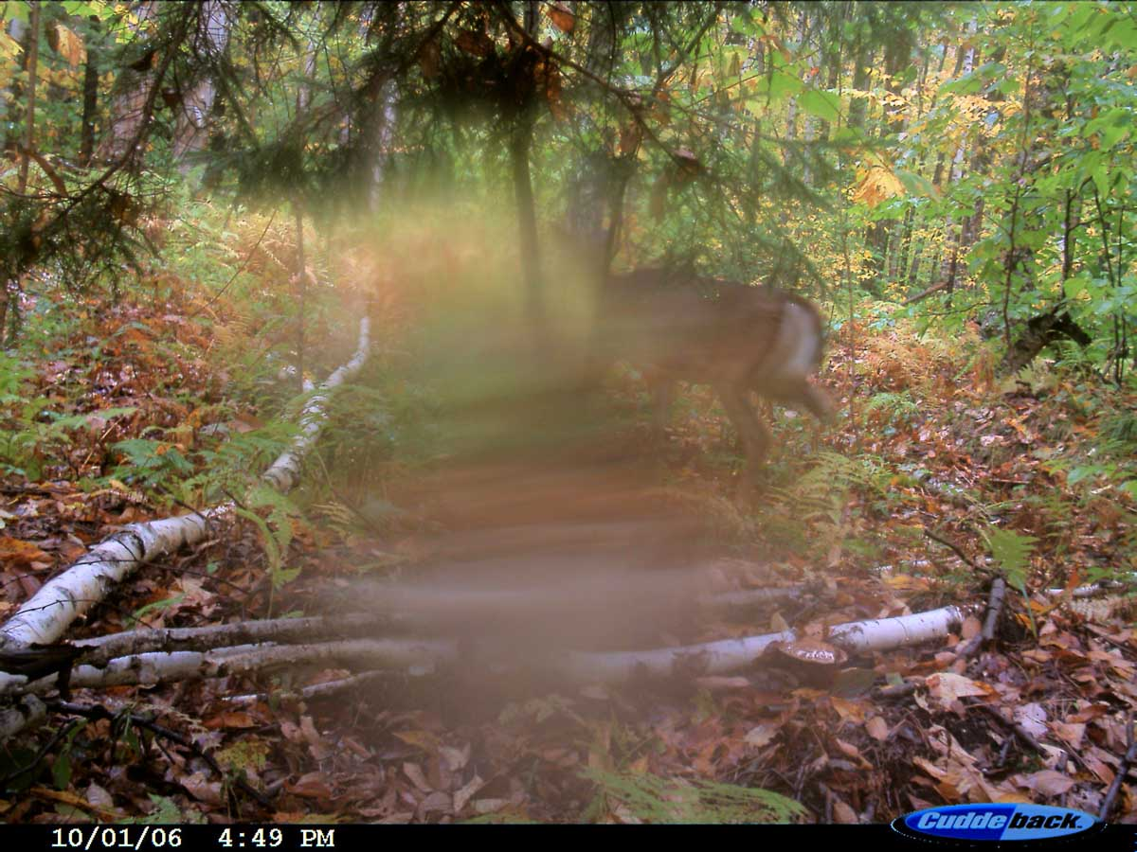

Plate 8. Odocoileus virginanus (White-tailed Deer). Date: 01 Oct 2006. Location Code: 06CD05. GPS: 44°09’23.9”N, 73°01’33.8”W Habitat: ES 6 (North of “pot road” trail)
[Disturbance on lens. See also associated video files: Deer1Oct06.AVI and ThreeDeer.AVI for this location.]

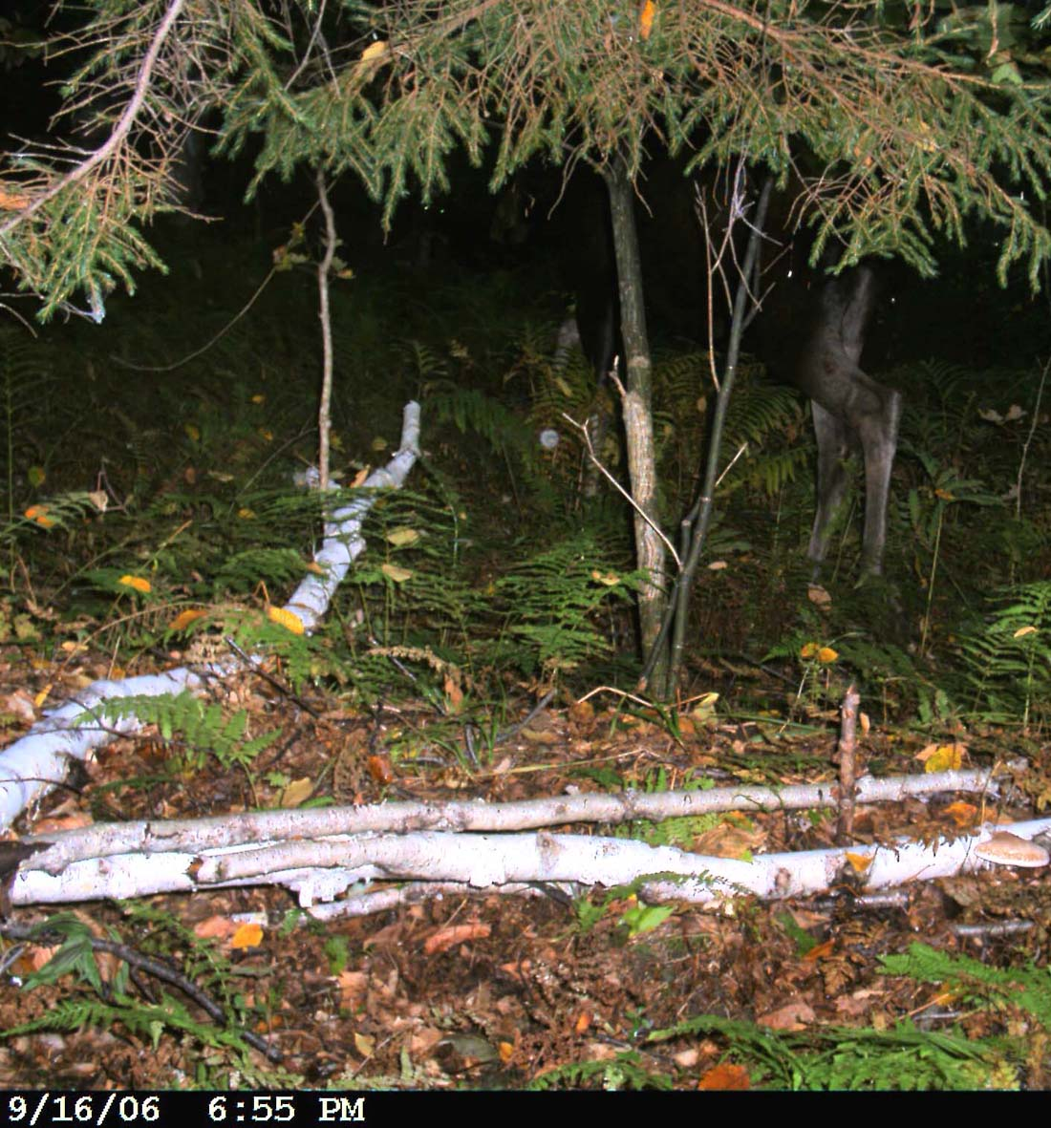
Plate 9. Alces alces (Moose). Date: 16 Sept 2006. Location Code: 06CD05. GPS: 44°09’23.9”N, 73°01’33.8”W Habitat: ES 6 (North of “pot road” trail.)

1.2 Carnivores
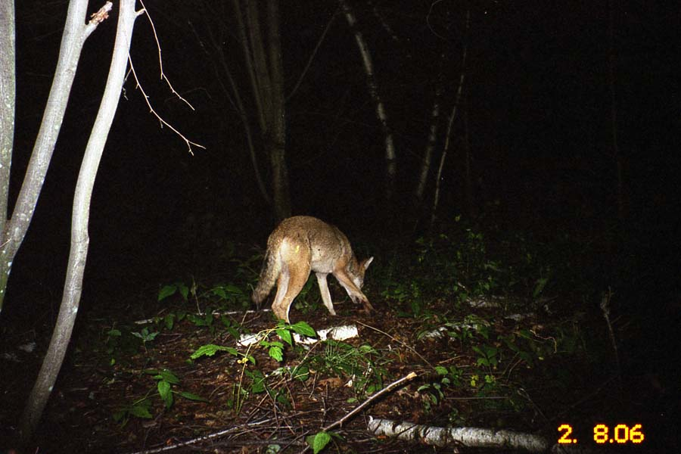
Plate 10 Canis latrans (Coyote). Date: 2 August 2006. Location Code: 06CA01
GPS: 44°09’18.7”N, 73°01’13.5”W. Habitat: ES 12; Forest corner just west of the top end of the “tongue” extension of the lower meadow.

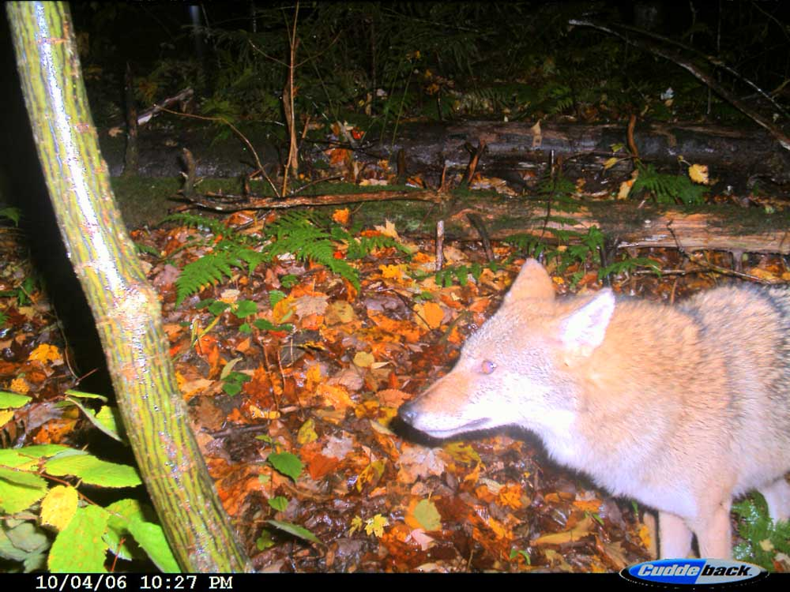
Plate 11 Canis latrans (Coyote). Date: 4 Oct 2006. Location Code: 06CD06
GPS: 44°09’23.0”N, 73°01’41.5”W. Habitat: ES 6; South of “pot road”.

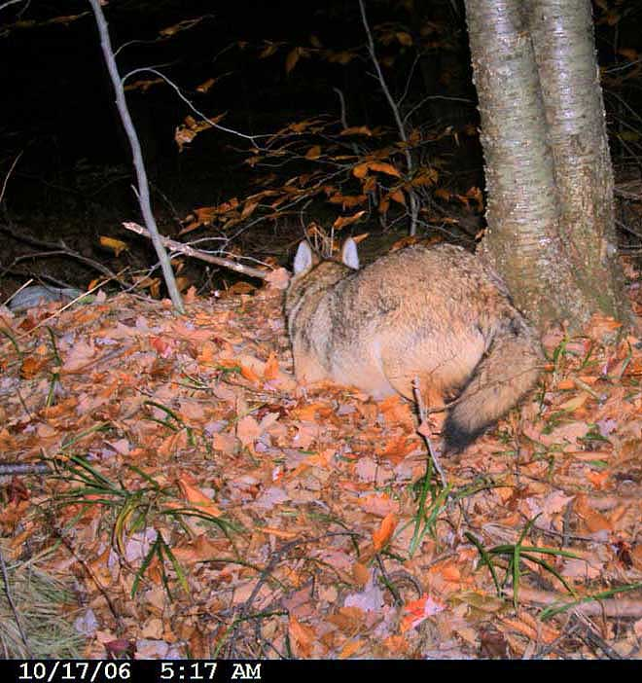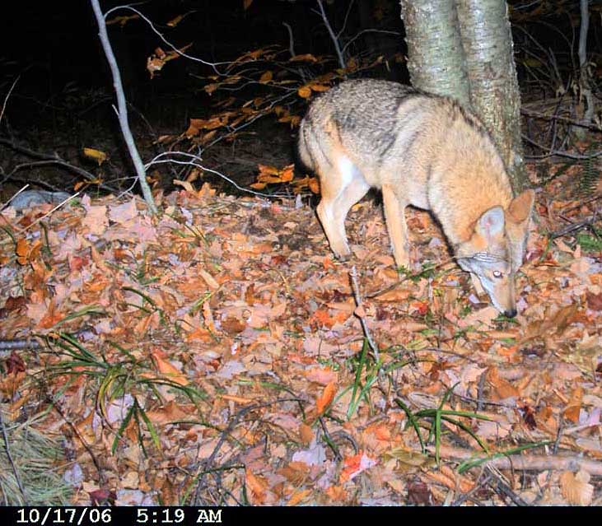

Plates 12 + 13 Canis latrans (Coyote). Date: 17 Oct 2006. Location Code: 06CD07
GPS: 44°09’09.8”N, 73°01’44.8”W. Habitat: ES 1; South of trail.

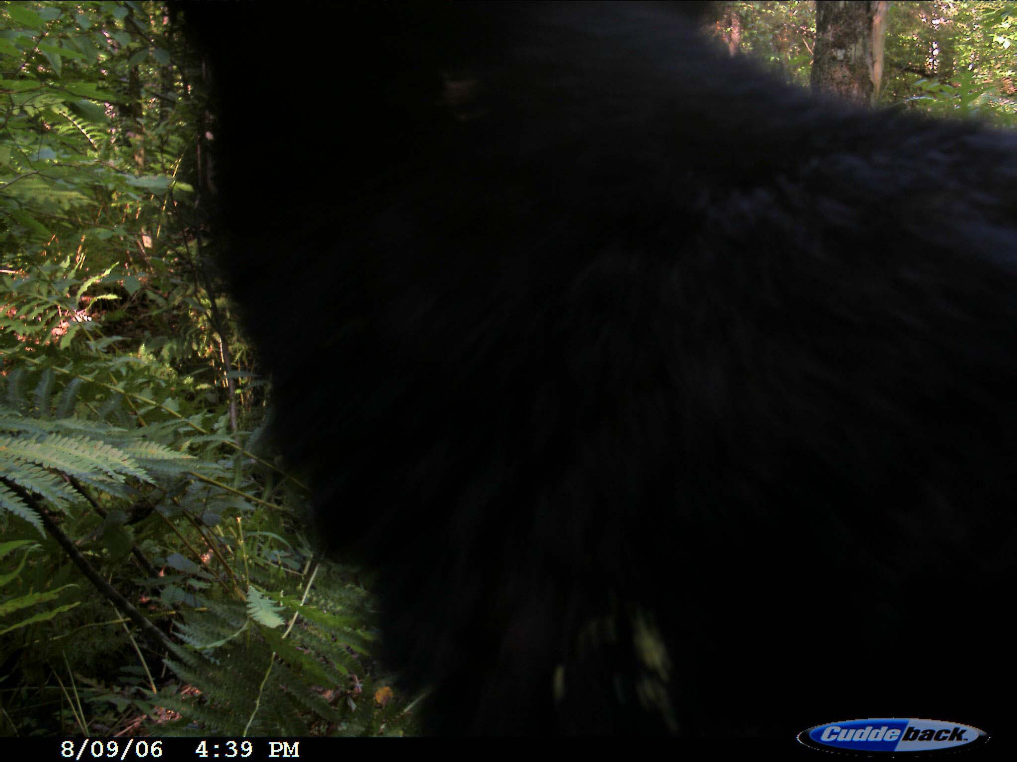
Plate 14 Ursus americanus (Black Bear). Date: 9 August 2006. Location Code: 06CD02.
GPS: 44°09’22.0”N, 73°01’32.0”W. Habitat: ES 6. North of “pot road” in ES6.
[See enclosed DVD for associated video sequence: Bear9Aug06.AVI].

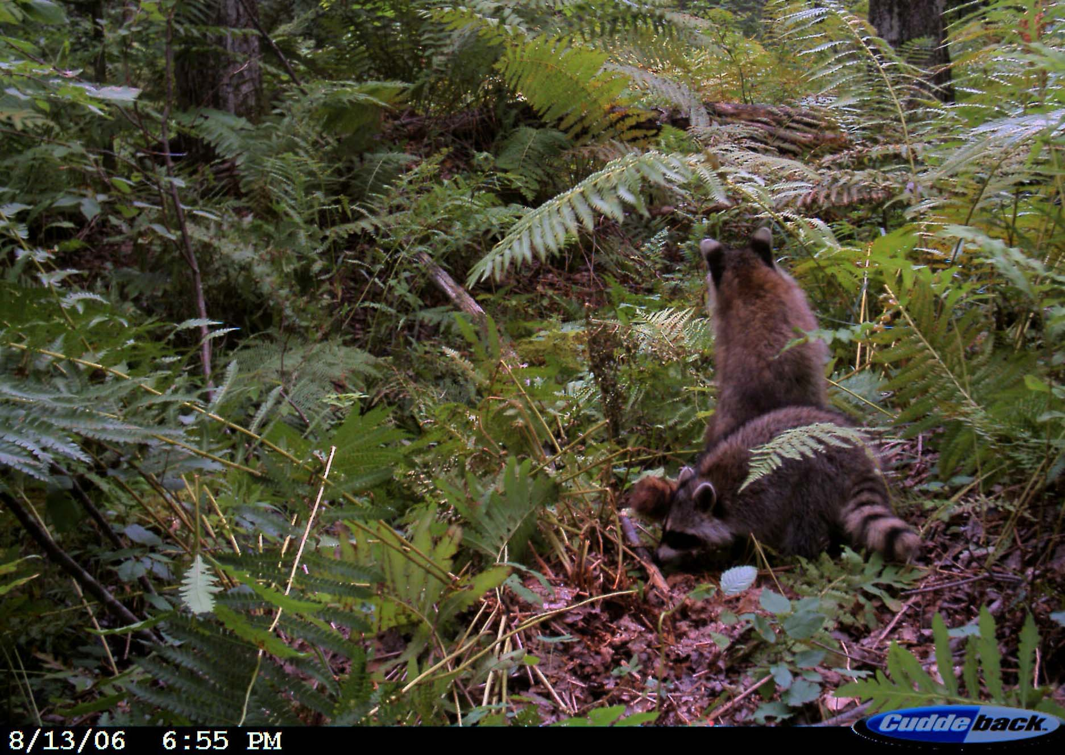
Plate 15 Procyon lotor (Raccoons). Date: 13 August 2006. Location Code: 06CD02.
GPS: 44°09’22.0”N, 73°01’32.0”W. Habitat: ES 6. North of “pot road” in ES 6.
[See enclosed DVD for associated video file: Raccoons13Aug06.AVI].

1.3 Rodents
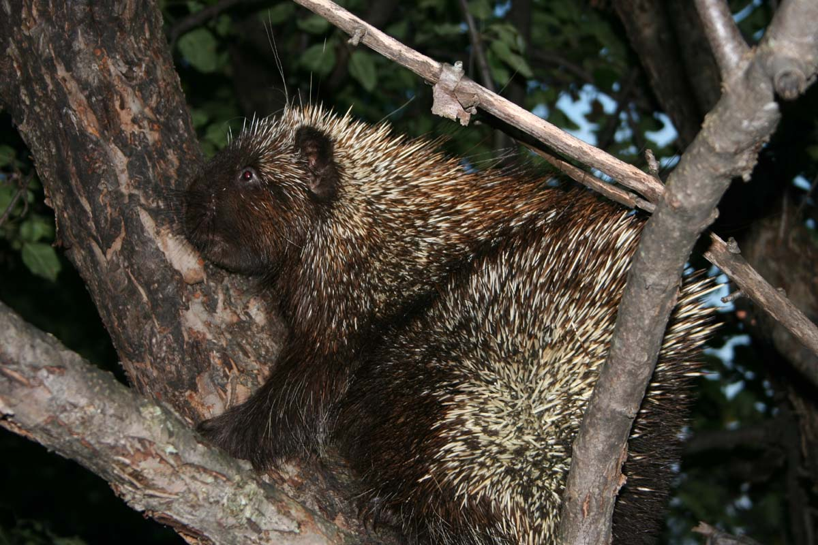
Plate 16 Erethizon dorsatum (Porcupine). Date: 8 August 2006. Canon Digital Rebel XT Photo. Habitat: Apple trees near top end of “tongue” extension of the lower meadow and near entrance to “pot road.” Also see video sequence of foraging porcupine on northern meadow taken on enclosed CD.

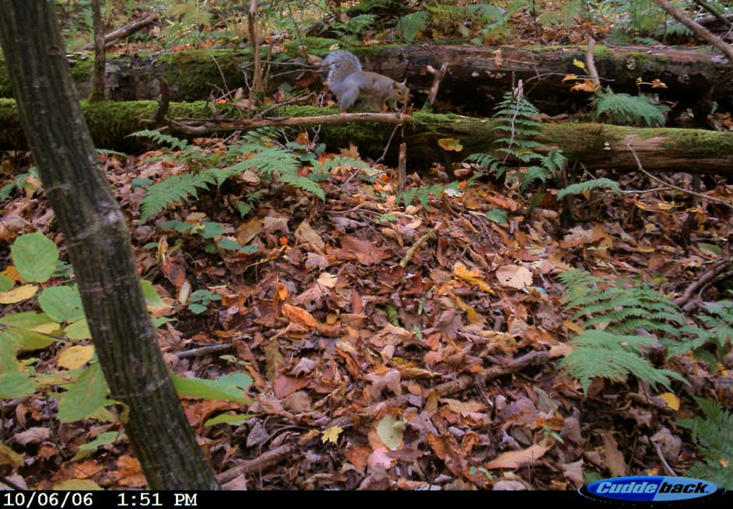
Plate 17 Sciurus carolinensis (Eastern Gray Squirrel). Date: 6 October 2006. Location Code: 06CD05 GPS: 44°09’23.0”N, 73°01’41.5”W. Habitat: ES 6. South or “pot road”.

2. Birds
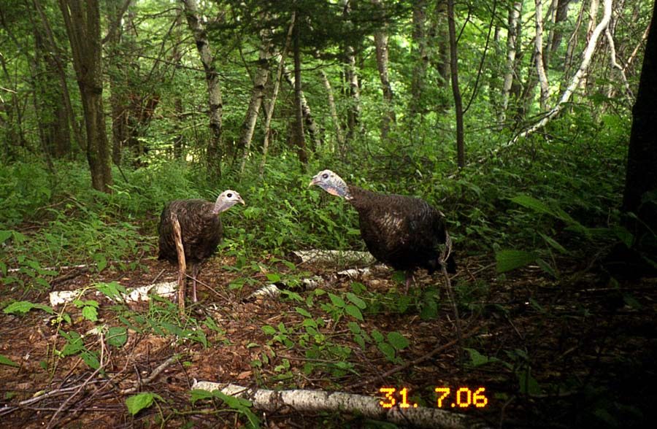
Plate 18 Meleagris gallopavo (Turkeys hens). Date: 31 July 2006. Location Code: 06CA01
GPS: 44°09’02.8”N, 73°01’07.7”W. Habitat: ES 12; Forest corner just west of the top end of the “tongue” extension of the lower meadow.

3. Domestic Dogs
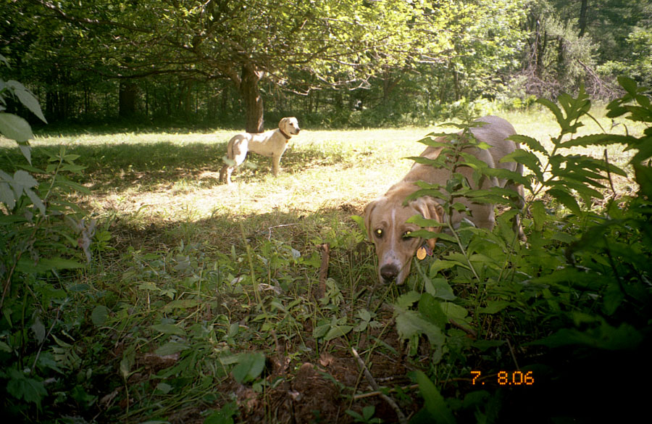
Plate 19. Domestic Dogs. Date: 7 Aug 2006 Location Code: 06CA02.
GPS: 44°09’20.2”N, 73°01’14.0”W Habitat: ES 12+21. Western forest edge halfway down the “tongue” extension of the northern end of the Guthrie meadow.

