2006 Camera Trap Survey

Jan Decher, Colby Hill Ecological Project, Lincoln, Vermont

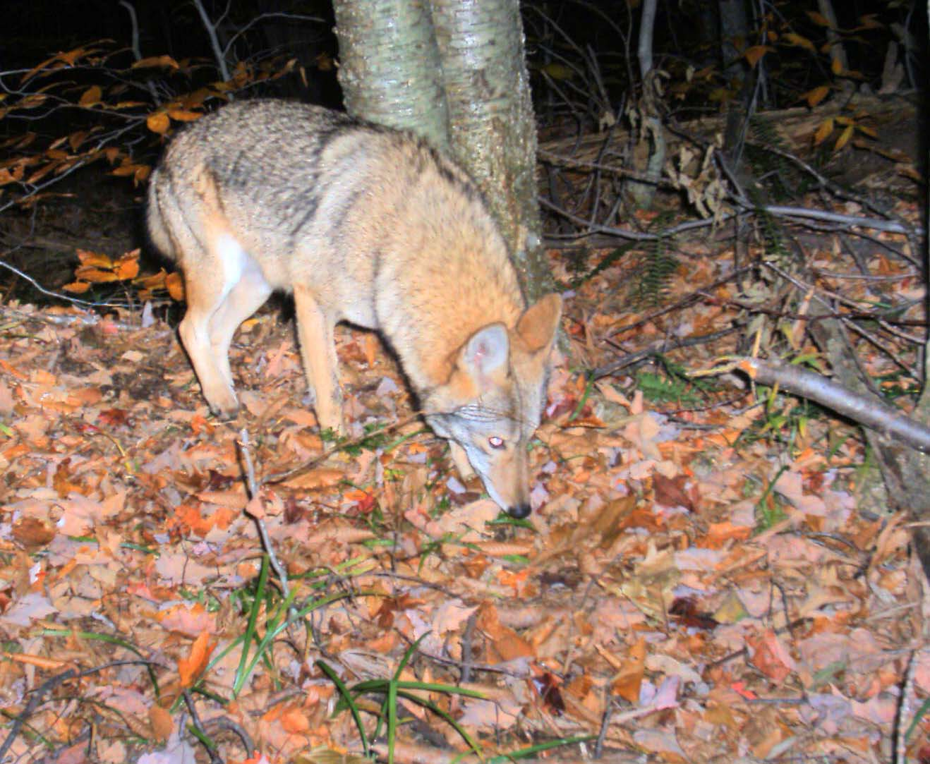

2006 Camera Trap Survey

Jan Decher, Colby Hill Ecological Project, Lincoln, Vermont

