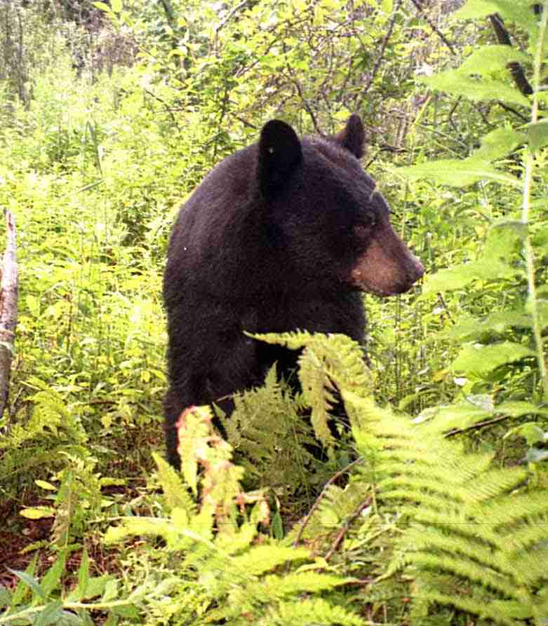
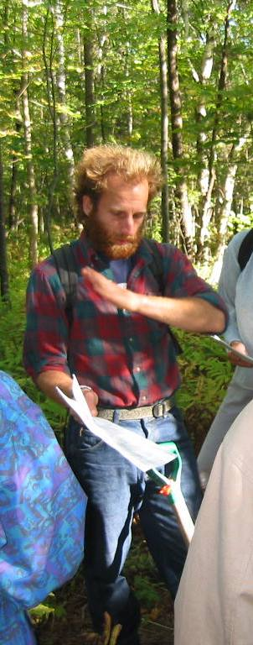
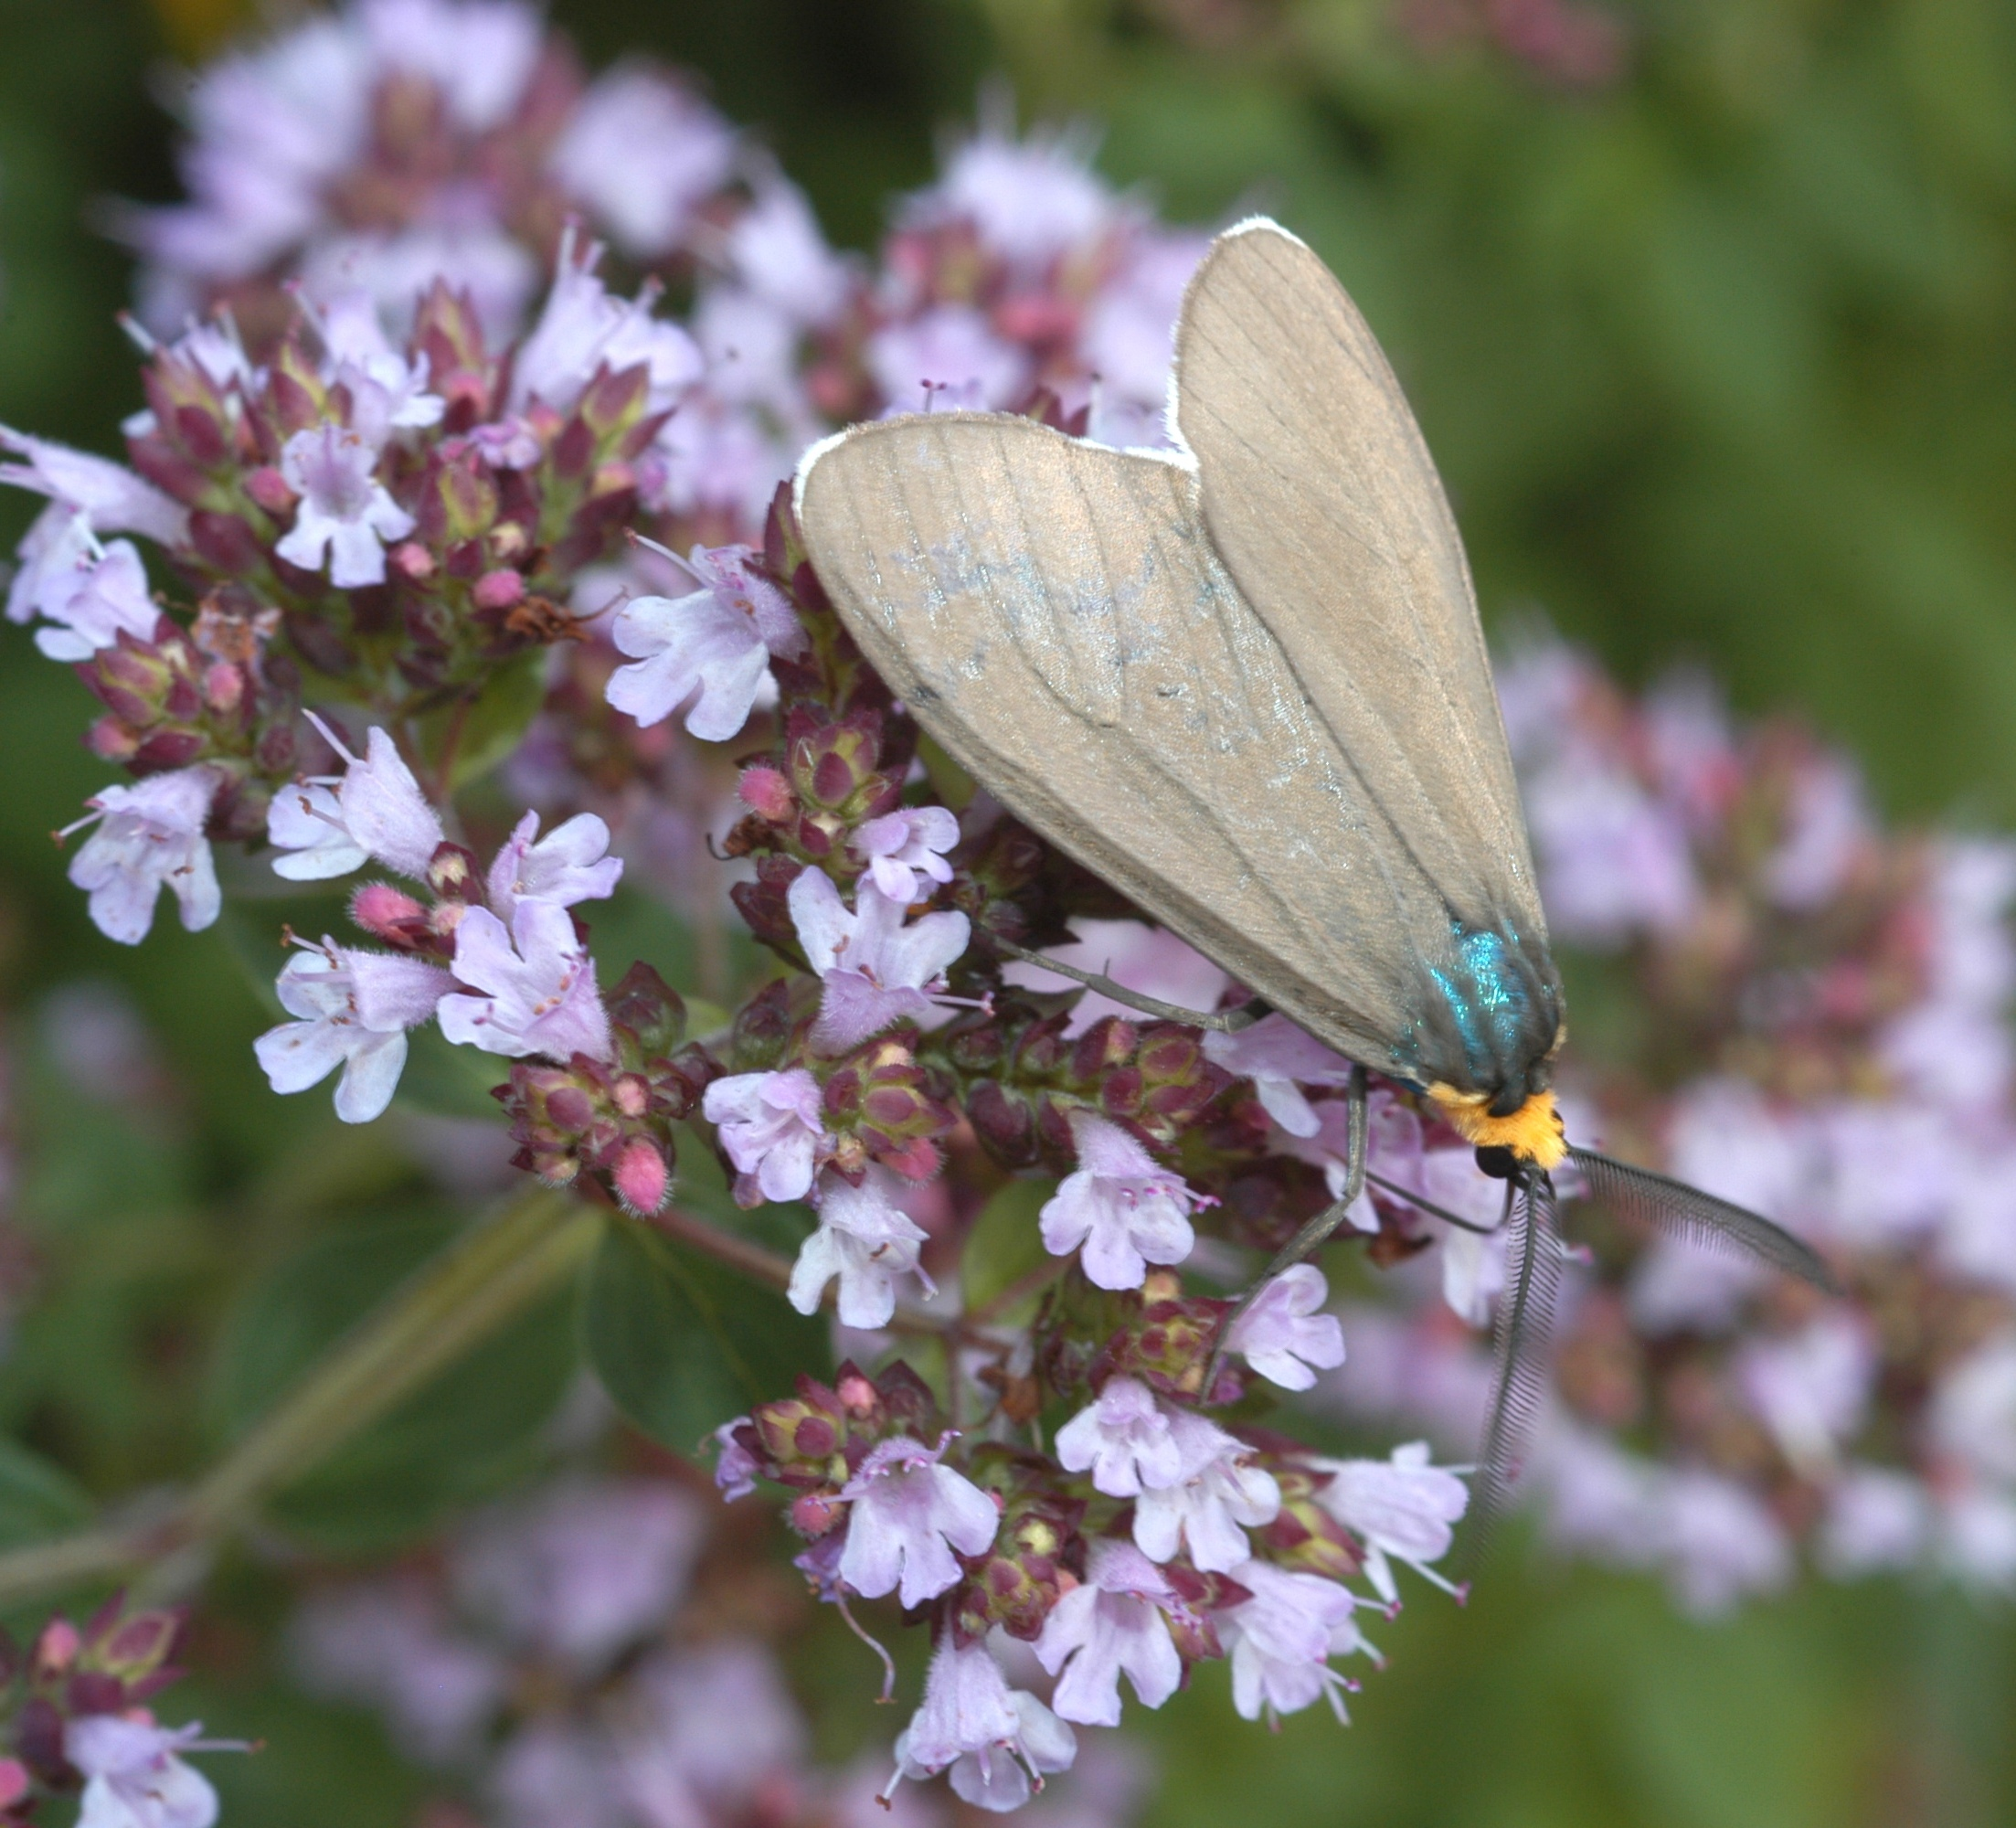
Executive Summary
Colby Hill Ecological Project
March 2005
Colby Hill Ecological Project
Lincoln, Vermont

Executive Summary
March 2005

INTRODUCTION
The Colby Hill Ecological Project, initiated in 1998, is an effort to catalog and monitor biological diversity on four old hill farms on the western lower slope of the Green Mountains in Addison County, Vermont. The lands, conserved as “forever wild,” lie at an elevation of 780’ to 1850’ with most terrain between 1100’ and 1500’. From a topographic, soils, and bedrock perspective, the parcels are not atypical of the landscape in this part of the western Green Mountains. An exception to the passive management of the lands as forever wild is that the existing meadows will continue to be mowed to maintain them as fields. Although all of the parcels have been inventoried, the Guthrie-Bancroft Farm, with 403 acres of forest and 33 acres of meadow, is the site of most of the long-term monitoring. It is the largest and most diverse parcel and features numerous upland forest types; herbaceous, shrub, and forested wetlands, permanent and intermittent streams, and an old farm pond.

The foci of the biological monitoring have been forest and wetland ecosystems, breeding birds, mammals (including terrestrial small mammals, bats, and large and meso-mammals), amphibians and reptiles, and, among invertebrates, butterflies and dragonflies, and surface-active invertebrates (with detailed focus on beetles, spiders, and ants).

Another aspect of the Project is an initiative to work with adjacent and nearby landowners to discuss landscape-level biological diversity, and, with the Colby Hill Ecological Project lands as a forever-wild “core,” work toward neighborhood biological diversity conservation. This effort was launched in 2004 and is still in its infancy.

This summary generally discusses work completed prior to the 2004 field season.

SMALL MAMMALS
Terrestrial small mammals have been monitored by trapline sampling for three years, 2000-2002, and bats have been monitored by mist netting for four years, 2000-2003. Jan Decher has been the small mammal investigator. Thirteen terrestrial small mammal species have been documented at Guthrie-Bancroft Farm, including nine rodent species, three shrew species and one mustelid. Four bat species have been documented, including small-footed bat (Myotis leibii), a rare species listed as threatened in Vermont.

Method – Traplines, 26 or 52 traps with two traps per station and seven pitfall traps installed along a plastic driftfence; each trapline was sampled for three or four nights each year. Six ecosystems, representative of the range of ecosystem types on the property have been sampled; three have been sampled for three consecutive years, two were sampled for two consecutive years, and one was sampled only one year.
Results –Overall, mice (Peromyscus leucopus and P. maniculatus), short-tailed shrew (Blarina brevicauda), and red-backed vole (Clethrionomys gapperi) were the most abundant small mammal species. Considerable fluctuations in occurrence and abundance, and concomitantly in biomass, have been seen in three years of trapping, and there were notable differences in small mammal populations among the ecosystems sampled. New species have been observed each year of trapping, and the species accumulation curve has not yet shown pronounced leveling. Classification of ecosystems based on small mammal data showed that unmaintained old fields, with high numbers of meadow voles (Microtus pennsylvanicus) and short-tailed shrews and low numbers of mice were quite different from other ecosystems. Northern hardwood forest types clustered together; the two types sampled each showed high proportions of mice, similar proportions of shrews, and relatively few other species. Rich, seepy northern hardwood forest was very similar to the non-enriched hardwood forests – moderately well drained northern hardwood forest and well drained red oak-northern hardwood forest. The rich, seepy forest, however, also showed high similarity to somewhat poorly drained conifer-hardwood mixed forest, another type with a very moist surface soil. The somewhat poorly drained conifer-hardwood mixed forest clustered with poorly drained deciduous swamp and somewhat excessively drained hardwood-spruce forest; these ecosystems share a diverse microtopography and relatively similar numbers and ratios of small mammal species. An open woodland seep with a small, intermittent stream and an alder-willow-sedge marsh/shrub swamp clustered together because of similar proportions of short-tailed shrew, mice, and red-backed voles. Rich, seepy northern hardwood forest and somewhat poorly drained conifer-hardwood mixed forest tended to have the highest species richness (a maximum of 6 species in the “best” year).
Method – Mist nets for sampling bats have been erected from 2000 to 2004 in a variety of vegetation conditions, including non-forested upland and wetland areas and presumed flyways in forested areas. Nets have been set at different heights depending on the equipment available.
Results – Bat sampling has had a low success rate. Few individuals have been caught, regardless of the location or position of the mist nets. One state-threatened species, small-footed bat, was captured at Guthrie-Bancroft Farm in 2003. Northern myotis (Myotis septentrionalis) has been captured most frequently; additionally, one female hoary bat (Lasiurus cinereus) and two little brown myotis (Myotis lucifugus) have been recorded.

AMPHIBIANS AND REPTILES
Amphibians and reptiles have been monitored by Jim Andrews using three different sampling methods. In an initial 1998 inventory, six species of salamanders, five frog species, and two reptile species were recorded. Subsequently, two additional reptiles, including the Vermont special concern species wood turtle (Clemmys insculpta), have been observed.

Method – Egg-mass counts have been conducted at four ponds to monitor two spring-breeding species with very large and easily identified egg-masses wood frog (Rana sylvatica) and spotted salamander (Ambystoma maculatum). The sampling indicates the relative size of female breeding population.
Results – Wood Frog: Guthrie Pond has been the most productive wood frog breeding pond; egg mass numbers ranged from 133 to 538 (years 2000-2003); the maximum count from nine other monitoring sites in Vermont was 225, thus Guthrie Pond is seen to be an exceptionally productive wood frog site. The Lower Fred Pierce Pond has been productive also, with a range of 101 to 210 (years 2000-2003) egg masses.
Spotted Salamander: The same two ponds have been the most productive for spotted salamander also. Lower Fred Pierce Pond was the most productive site, with egg mass counts ranging from 122 to 270 (years 2000-2003), while Guthrie Pond numbers ranged from 121 to 230 egg masses. The maximum number from nine other monitoring sites in Vermont is 292; thus Lower Fred Pierce Pond is seen to be a very good site for spotted salamander eggs. The species may not lay eggs every year; hence a different portion of the adult population is probably being sampled each year. The wide variation in egg masses (0 to 292 at one Vermont site) indicates the need for multiple-year baseline data, and that it is reasonable to expect rather wide fluctuation in egg-mass numbers from year to year.

Method – Cover-board sampling was established in 2000 to monitor salamander species and provide information on age-class structure. Three sets of two-tiered cover-boards consisting of 15, 15, and 16 stations have been sampled in rich, seepy northern hardwood forest, moderately well drained northern hardwood forest, and well drained red oak-northern hardwood forest. The cover-boards have been checked in September and October each year since 2000.
Results – Only one species was found frequently enough to be monitored, eastern red-backed salamander (Plethodon cinereus). General results have been that on the first cover-board fall count in September, there was an average of one red-backed salamander using each cover board. The salamanders’ use of artificial cover has consistently declined after mid-September, and this appears not to be associated with the disturbance of lifting the boards to check. Corey (2002) found that adult red-backed salamanders were only rarely found with adults of the same sex and were much more often found with larger young or with opposite-sex adults. This suggested that due to territoriality there was an upper limit to the numbers of adults that could be found under cover boards, and also it suggested that small-size individuals were excluded by the adults. Thus, age-class data may not be accurate portrayal of the population.

Method – Snake covers, an experimental effort to monitor snake populations, were established in 2000. Two-tiered slate cover arrays were placed in upslope eastern edges of fields to maximize exposure to the warming southern and western aspects.
Results – Red-bellied snakes (Storeria occipitomaculata) used cover boards the first year. In 2002 and 2003, common garter snakes (Thamnophis sirtalis) and milksnakes (Lampropeltis triangulum) were also observed. Red-bellied snakes have been the most common species each year.

BIRDS
Method – Breeding-bird monitoring has been conducted at the Guthrie-Bancroft Farm since 1998. The sampling is part of the Forest Bird Monitoring Program (FBMP) of the Vermont Institute of Natural Science (VINS), and the methodology follows the protocol of that project. Warren and Barry King have conducted the breeding bird monitoring. At Guthrie-Bancroft Farm, a one-kilometer transect is sampled along five point-count listening stations spaced approximately 200m apart. Counts are made twice annually in the first and third weeks of June. The transect runs through three or four different forest ecosystems, including rich, seepy northern hardwood forest, moderately well drained northern hardwood forest, and well drained red oak-northern hardwood forest.
Results – Thirty-six species have been recorded at the listening stations and an additional 21 species have been identified at the farm. An average of 24 species was observed at each point (both June counts combined) from 1998 through 2003; the maximum species at a point was 27 and the minimum was 19. The second sampling time added an average of 3.68 species at a point, which represents a 30% increase over the first count average number of species at a point. On average, 37% of the species at each point was recorded at a point on both the first and second count. Over the six year period, the number of species recorded on the transect ranged from 17 to 26, with an average of 22 species per year. The two most ubiquitous species have been red-eyed vireo (Vireo olivaceus) and ovenbird (Seiurus aurocapillus), and they each were most commonly (80%) recorded at a point both the first and second count. Some other species, however, showed very different patterns. White-throated sparrow (Zonotricha albicollis), for instance, was recorded only at a single point (the wettest and closest to a canopy gap) for three years, on both counts for all three years. Hermit thrush (Catharus guttatus), in contrast, was recorded on 13 point counts, but only two of the observations (15%) occurred at the same point in both counts of a year. Both veery (Catharus fuscescens) and least flycatcher (Empidonax minimus) have been recorded much more frequently in the first count of a year than the second count; no species has been seen to exhibit greater frequency in the second count. Species that occurred in the same frequency at each point (i.e., showed no preference for points) included yellow-bellied sapsucker (Sphyrapicus varius), American robin (Turdus migratorius), red-eyed vireo, ovenbird, scarlet tanager (Piranga olivacea) and rose-breasted grosbeak (Pheucticus ludovicianus). Among those species that showed a preference for certain points in the transect were Canada warbler (Wilsonia canadensis), great crested flycatcher (Myiarchus tyrannulus), brown creeper (Certhia americana), black-throated blue warbler (Dendroica caerulescens), eastern wood pewee (Contopus virens), least flycatcher, wood thrush (Hylocichla mustellina), American redstart (Setophaga ruticilla), and black-throated green warbler (Dendroica virens). Seven species were observed only one or two of the six years. The results of six years from a single transect represent a very modest sample and the relationships seen will become clearer with a longer sampling time and in the context of the entire FBMP (Faccio et al. 1998).

BUTTERFLIES and DRAGONFLIES
Method – Lepidoptera and Odonata have been surveyed by a random walk method for four consecutive years from 1999 to 2002; in 2003 only an abbreviated sampling was undertaken and the results are not included here. The butterfly and dragonfly investigator has been Don Miller. Sampling has occurred at various times during the summer-fall season, beginning as early as 29 May and ending as late as 3 October. Sampling has taken place at Guthrie-Bancroft, Fred Pierce, and Wells farms.
Results – Butterflies. Forty-three species of butterflies, including ten skipper species, have been observed. Of those, only three species have not been seen at Guthrie-Bancroft Farm and no species has been documented at Wells Farm and not at the other two farms. Of the 43 species, nine have been documented only one of the four years, and another seven have been seen only two years; hence, approximately two-thirds of the butterfly species have been documented all four years, but the sampling effort has varied somewhat over that period. All of the species observed are ranked as widespread and common in Vermont. Few new species have been added to the list since the second year of sampling. Of the 15 species recorded each year, nine feed on grasses, and five of the butterfly species are non-indigenous to the area. The native species are primarily woodland butterflies. A species of greater interest is Silver-bordered Fritallary (Boloria selene), which is apparently becoming rare in southern New England, where it was once abundant. The species’ primary food plants are violets (Viola spp.) and it seems to thrive best in moist areas with openings, such as woodland seeps, small marshes, and swamps.
Odonates. Forty-five species of dragonflies and damselflies have been observed. Several species have been found at Fred Pierce Farm but not at Guthrie-Bancroft Farm. Of the 45 species, 11 have been seen only one year and eight have been observed only two years; thus, over one-half of the species have been documented all four years (but note that the sampling effort has varied somewhat over that period). Three of the odonate species sampled are considered rare in Vermont – black-tipped darner (Aeshna tuberculifera), northern pygmy clubtail (Lanthus parvulus), and beaverpond clubtail (Gomphus borealis). Another six species are ranked as uncommon in the state, and an additional two species may be uncommon but little is known of their populations in the state. Of the rare species, the former two have been observed only one year, while the latter was observed for two consecutive years. Species richness increased each of the four years, as ten and five additional species were recorded in the third and fourth year of sampling, respectively. Guthrie Pond has been an excellent site for the uncommon crimson-winged whiteface (Leucorrhina glacialis), as well as azure bluet (Enallagma aspersum), which may be less common than its state-rank would imply. Amber-winged spreadwing (Lestes eurinus) may be uncommon in Vermont and was seen to breed at Guthrie Pond for the first time in 2002. The alder-willow-sedge marsh/shrub swamp on the Guthrie-Bancroft Farm has also been very productive for odonates. Upper Isham Brook at the Fred Pierce Farm supported a few species that prefer running streams and were not found elsewhere within the sampled area.

Method – During two seasons, 2000 and 2001, blacklighting was done at the Fred Pierce Farm to sample moths. In 2001, two different sites (one a shrub wetland, the other adjacent to a man-made pond surrounded by forest) were sampled for one night each, in early August. Some of the specimens were sent to Warren Kiel for determination.
Results – The 2000 sampling was conducted in late September yielded no moths due to cold weather the one night of sampling. In 2001, 32 species of macro-moths were identified. Cutworms (Family: Noctuidae) comprised 56% of the species. Geometridae, with 25% of the species, was the second most speciose family. All species collected are considered general feeders on a broad spectrum of plants; none species are considered uncommon or rare in the state. It is of interest that the number of macro-moth species identified in just two nights of sampling equals three-quarters the total of butterfly species identified in five years of field work. Clearly, the moth fauna exceeds that of the diurnal Lepidoptera and is an important component of the biological diversity.

SPIDERS, BEETLES, ANTS and OTHER SURFACE-ACTIVE INSECTS
Method – Surface-active invertebrates were sampled along pitfall-trap transects at Guthrie-Bancroft Farm from 1999 to 2002. Mark Ward, Jeffrey Collins and Susan Morgan conducted the investigation. Traps were set approximately 5m apart along a linear transect in three forest ecosystems – rich, seepy northern hardwood forest; well drained red oak-northern hardwood forest; and somewhat poorly drained conifer-hardwood mixed forest. Traps were left open for one week and were sampled once in May or June and once in July or August. When the traps were recovered, three four-liter samples of forest litter were also collected near the traps. Transects consisted of from six to ten pitfall traps; the number varied from year to year due to disturbance of traps, presumably by birds or mammals. An additional transect was sampled in 2002 at Wells Farm in a rich, but not seepy, northern hardwood forest. Adult specimens recovered from pitfall traps and litter samples were identified to the family level for all but three orders. Also, three groups – ground beetles (Family: Carabidae), ants (Family: Formicidae), and spiders (Order: Areneida) – were selected as focal groups, and individuals were identified to species (with the exception of spiders in the family Linyphiidae, which were identified below the family level only for one year’s sample).
Results – Family Analysis: Mites (Order: Acarina) comprised over 50% of the specimens collected; springtails (Order: Collembola) and beetles (Order: Coleoptera) were the next most abundant captures. Beetles displayed the largest number of families of any order. The number of families observed in all orders was a minimum of 104 (several orders were grouped and thus there are likely even more families). Rich, seepy northern hardwood forest had the most families (70), followed by somewhat poorly drained conifer-hardwood mixed forest (67) and well drained red oak-northern hardwood forest (63), and the family diversity (Shannon-Wiener index) of rich, seepy northern hardwood forest was significantly greater than the other two forest ecosystems. Similarity tests showed that rich, seepy northern hardwood forest and somewhat poorly drained conifer-hardwood mixed forest were most similar, and the rich, seepy forest and well drained red oak-northern hardwood forest were least similar. From a spatial perspective, the least similar forest ecosystems were adjacent.
Species Analysis of Three Families: After four years of sampling, there were still substantial numbers of new species observed in rich, seepy northern hardwood forest, whereas the numbers of species had leveled off by year three in the other two forest types.
Ants. Five species of ants were observed, and two species accounted for more than 80% of all ants collected. The most commonly collected species was absent from somewhat poorly drained conifer-hardwood mixed forest, but one other species was observed only in that forest type.
Ground beetles. Ground beetles were represented by 26 species, and the most commonly collected species accounted for greater than 40% of all beetles sampled. Eight species were observed only once. Several species were either absent or rarely collected in the red oak-northern hardwood forest, but were frequent in the other two forest ecosystems, and a number of other species were much more common in the red oak-northern hardwood forest than in the other two types.
Spiders. Twelve families of spiders were observed, for a total of 36 species. The four most commonly collected species accounted for 65% of spider observations. More than two-thirds (25) of the spider species were collected from only one of the forest ecosystems, and fourteen species were represented by only a single specimen.
Similarity of species composition among forest ecosystems. With regard to similarity of forest types, tests were run for ground beetles and spiders, but there were not enough ant species to include ants in the analysis. Well drained red oak-northern hardwood forest and somewhat poorly drained conifer-hardwood mixed forest were least similar for both beetles and spiders. Depending on the similarity index used, the most similar types had between 57% and 84% similarity, and the least similar types had between 23% and 53% similarity. The results suggested that there are important contributions to biological diversity of ground beetles and spiders from each of the three forest ecosystems. The observation that two of the five ant species were found in only one ecosystem reinforced the importance of diversity of ecosystem types to diversity of the invertebrate fauna.

LARGE and MEDIUM MAMMALS
Method – A transect to survey wildlife sign was established at Guthrie-Bancroft Farm in 2002 and has been sampled four times annually, once in each season of the year, since October 2002. The methodology follows protocol of Keeping Track, Inc.; observers record sign of black bear (Ursus americanus), bobcat (Lynx rufus), Canada lynx (Lynx canadensis), mountain lion (Puma concolor), fisher (Martes pennanti), mink (Mustela vison), moose (Alces alces) , American marten (Martes amaericana), river otter (Lontra canadensis), and gray wolf (Canis lupus). Additionally, on this transect porcupine (Erethizon dorsatum) sign has been recorded. Greg Borah has conducted the sampling. A second transect was established at Wells Farm, but there has not been any sampling there to date.
Results – After one and three-quarters years of sampling, bear sign was the most frequent observation made on the transect. Thirty-seven observations of bear sign were recorded, including 17 marking events and nine feeding events. In total, 11 different trees have been marked along the transect; the most commonly marked species was balsam fir (Abies balsamea); other species marked were red and white pines (Pinus resinosa, P. strobus, respectively) northern white cedar (Thuja occidentalis), and paper birch (Betula papyrifera). Of the feeding sign, five observations were bear having fed in apple (Malus spp.) trees (all on the same sampling date), and two bear observations that bear had been grubbing in the soil. Moose tracks were seen occasionally, and a single tree-bark feeding was noted. Fisher tracks were also occasionally observed, as was one fisher kill of a shrew. A porcupine den was found along the transect and two animals have been seen on several different dates; the den is in a large (42” dbh) white ash. One pile of quills was observed beneath a tree, presumably the remains of a porcupine carcass. Other tracks observed on the transect were of bobcat and mink (one time each). Additional tracks have been observed in areas apart from the systematic sample; fox, coyote (Canis latrans), weasel (Mustela sp.), and raccoon (Procyon lotor) were noted.

Method – A 35mm camera with a passive infrared motion detector has been positioned at several places on Guthrie-Bancroft Farm from May to November 2004. The primary intent of camera sampling is to record presence of meso-mammals, some, but not all, of which are sampled via the wildlife sign transect. The camera is monitored by Jan Decher and is checked every seven to ten days.
Results – The camera has thus far recorded six mammal species (eastern cottontail (Sylvilagus floridanus), moose, coyote, raccoon, black bear, and white-footed or deer mouse). Three bird species were also recorded (wild turkey (Meleagris gallopavo), ruffed grouse (Bonasa umbellus), and white-breasted nuthatch (Sitta carolinensis)).

FOREST ECOSYSTEMS
Method – Long-term, one-tenth hectare plots to quantify structural, compositional, and soils characteristics of different forest types and to monitor long-term changes were established in five different ecosystem types. Marc Lapin has been the forest ecology researcher. Three plots were sampled in somewhat poorly drained conifer-hardwood mixed forest, two were sampled in each of rich, seepy northern hardwood forest and moderately well drained northern hardwood forest(early mid-successional status). One plot each was placed in well drained red oak-northern hardwood forest and well drained northern hardwood forest (early mid-successional status). The sampling quantified vegetation in tree, shrub and groundcover layers, dead wood, physiography, and microtopography. Soils were described from one soil pit adjacent to each plot and laboratory analyses of nutrients, pH, and texture were performed at the Cornell Nutrient Analysis Laboratory.
Results – No results are yet available from the long-term plots. Resampling is scheduled to be conducted at approximately 20-year intervals. Data analysis in comparison to other forest plots in the region may be conducted to see how the Guthrie-Bancroft forests compare with other forests in northern New England and northern New York.

Neighborhood Biological Diversity Conservation Outreach
Method – Between September 2003 and October 2004, the Project conducted four workshops to introduce Lincoln residents and the public at large to the concept and practice of biological monitoring. These workshops included Conducting a Biological Inventory in Your Family Forest: A Case Study of Lincoln’s Colby Hill Town Forest (25 participants), Winter Tracking (20 participants), Bird Habitat Stewardship in the Family Forest (15 participants), and Natural Community Mapping (13 participants). The first three workshops were conducted on the Town of Lincoln’s Colby Hill Town Forest, which abuts the southwest corner of the Guthrie-Bancroft Farm. The natural community mapping workshop was held in Bristol, Vermont. This workshop series was followed by an effort to more precisely target landowners near or adjacent to the monitored Project lands to raise their awareness of the region’s biodiversity and its ecological importance as a link between large conserved forest tracts – the main spine of the Green Mountains, the Bristol Cliffs Wilderness, and Hogback Mountain. Project staff identified 10 landowners for focused outreach. During the summer of 2004, Project staff developed information folders that included a cover letter explaining the packet and background information on the Colby Hill Ecological Project. Landowners also received three maps in the outreach folder – a 1:30,000 scale orthophoto map of the Colby Hill area with overlays of property boundaries, rivers, roads, wetlands, and significant Natural Heritage features; a 1:50,000 scale orthophoto map that reveals the region’s proximity to the three large conserved forest tracts, and a 1:30,000 preliminary natural community map.
Results – One landowner responded enthusiastically to the prospect of a one-on-one meeting and the subsequent meeting was successful, as gauged by enthusiasm and willingness to participate in future conversations about neighborhood conservation and management of that parcel. Most landowners were more guarded in their response and did not at this time schedule a meeting to learn more about the project and their lands. Project members agreed that outreach will necessarily be a long-term commitment and that this initial outreach served to sow seeds that may bear fruit years in the future. Proposed future outreach includes workshops in the local schools, additional public workshops and forums, and an informational gathering for adjacent and nearby landowners.

For additional information please visit the Colby Hill Ecological Project website www.familyforests.org/public-education/colby -hill.shtml

or contact:
Marc Lapin
Coordinator, Colby Hill Ecological Project
239 Cider Mill Road
Cornwall, VT 05753
mlapin@shoreham.net
(802) 462-2514

Corey, C. L. 2002. Factors influencing the effectiveness of artificial cover objects as a method for sampling the terrestrial salamander, Plethodon cinereus. Senior high-honors thesis, Middlebury College, Middlebury, Vermont.
Faccio, S. D., C. C. Rimmer, and K. P. McFarland. 1998. Results of the Vermont Forest Bird Monitoring Program, 1989-1996. Northeastern Naturalist 5:293-312.

