Colby Hill Ecological Project
Ground beetle survey
Summary report: 2005

Submitted by Steve Trombulak (April 2006)

During 2005, ground beetles (Coleoptera: Carabidae) were surveyed along a transect in spruce-fir habitat (Figure 1). Pitfall traps were placed in five locations at least 50 m apart along a qualitatively-assessed moisture gradient from dry (east) to wet (west). At each location, six traps were placed within 3 m of each other: three on high, dry ground and three on low, wet ground. This resulted in a total of 30 pitfall traps arranged within a single plant community type along moisture gradients on two scales: moderate-scale (hundreds of meters) and small-scale (ones of meters).

This experimental design is intended ultimately to answer the question of the extent to which the carabid fauna associated with a particular plant community type (as described earlier at Colby Hill by Ward et al. [2005]) shows a homogenous or heterogeneous distribution. Knowledge of how a fauna is distributed within a single plant community is important when deciding whether a sampling scheme is sufficient to compare faunas between communities; the more heterogeneous a fauna is within a community type, the larger the sampling effort needed to make comparisons between communities meaningful.

Each pitfall trap was made of a plastic container 7.5 cm deep and 11 cm in diameter, placed with its rim flush to the ground. A 25.5 cm diameter plastic plate was placed over each trap, elevated by 7.5 cm to allow beetles access to the traps but protecting the trap from the elements. Traps were half-filled with soapy water for two sampling periods: 3-8 July (5 days) and 29 July-4 August (6 days). At the end of each sampling period, the contents of each trap were returned to the lab and sorted. All specimens of carabid beetles were mounted, identified to species, and stored at Conservation Biology Laboratory at Middlebury College.

Preliminary results

- A total of 127 carabid beetles were collected and identified (Table 1). Identification of all specimens was verified from collections at the University of Vermont (Ross Bell) and the University of New Hampshire (Don Chandler).

- Of the 13 species collected during 2005, 10 were also collected by Ward et al. (2005) at the Colby Hill Ecological Project area. However, 3 species (Carabus goryi, Patrobus longicornis, and Pterostichus luctuosus) are newly reported for this area. Further, 1 of the species that I caught in the spruce-fir forest (Agonum mutatum) was not captured by Ward et al. (2005) in that habitat although they captured it in another plant community type in the area.

- Of the 13 species collected, none are surprises for this region or ecological zone, as all have been previously reported for forests in northeastern North America (Downie and Arnett, 1997).

- Of the 13 species collected, three were particularly numerous: Pterostichus coracinus (46), P. stygicus (31), and P. diligendus (20). Neither showed any noticeable variation in distribution along the two moisture gradients (Figure 2).

- Of the 13 species collected, two were recorded by only a single individual: Pterostichus rostratus, and Trechus apicalis. Thus, conclusions cannot be drawn about the response of this species to moisture.

- Of the remaining eight species, four do not show any clear evidence of a heterogeneous distribution based on moisture (Figure 3). However, four species (Agonum mutatum, Patrobus longicornis, Pterostichus luctuosus, and P. pennsylvanicus) show suggestions of heterogeneous distributions (Figure 4). With the exception of A. mutatum, however, few enough specimens were captured to yet draw any firm conclusions about the true nature of their distribution.

- Numerous other beetles were collected, but only a small number were mounted and identified because of the large number of beetles collected from the family Staphylinidae, whose taxonomy is poorly resolved. However, 11 specimens of carrion beetles (Silphidae) from three species (Nicrophorus tomentus, 2; N. orbicollis, 3; N. defodiens, 6) were collected and identified. Specimens were caught all along the moderate-scale moisture gradient (Location 2, 3, 4, and 5); however, with respect to the small-scale gradient, all of these specimens were caught in the drier (high) traps at each site.

Literature Cited

Downie, N.M., and R.H. Arnett. 1997. The Beetles of Northeastern North America. BioQuip Products.

Ward, M.A., J.M. Collins, and S.B. Morgan. 2005. Diversity of surface-active terrestrial invertebrates in forested landscape ecosystems, Lincoln and Bristol, Vermont 1999-2002: a report to the Colby Hill Ecological Project.

Table 1. Summary of the ground beetles (Coleoptera: Carabidae) captured in spruce-fir forest at the Colby Hill Ecological Project area (Lincoln, Vermont) in 2005.

Agonum mutatum | 5
Agonum retractum | 6
Carabus goryi | 2
Patrobus longicornis | 3
Pterostichus coracinus | 46
Pterostichus diligendus | 20
Pterostichus luctuosus | 2
Pterostichus pennsylvanicus | 2
Pterostichus rostratus | 1
Pterostichus stygicus | 31
Sphaeroderus lecontei | 4
Synuchus impunctatus | 4
Trechus apicalis | 1
Total | 127

Figure 1. Map of the trapping locations at the Colby Hill Ecological Project area (Lincoln, Vermont) during 2005. Trapping locations are labeled 1 through 5.

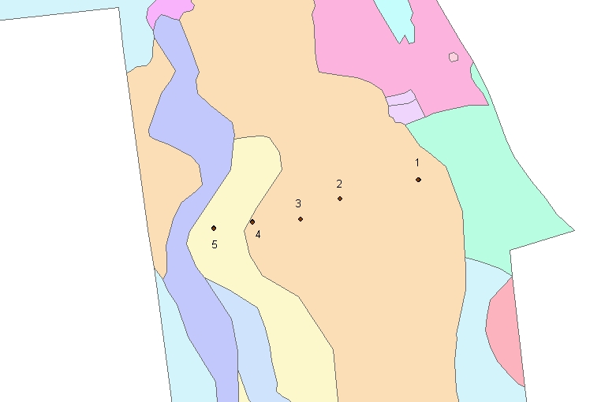

Figure 2. Distribution of common species of ground beetles (Coleoptera: Carabidae) captured in spruce-fir forest at the Colby Hill Ecological Project area (Lincoln, Vermont) in 2005. Moisture levels increase from locations 1 through 5. At each location, traps set in high (H) locations are drier than those set in lower (L) locations.

Figure 3. Distribution of uncommon species of ground beetles (Coleoptera: Carabidae) captured in spruce-fir forest at the Colby Hill Ecological Project area (Lincoln, Vermont) in 2005 for which there is no evidence of a heterogenous distribution based on moisture. Moisture levels increase from locations 1 through 5. At each location, traps set in high (H) locations are drier than those set in lower (L) locations.

Figure 4. Distribution of uncommon species of ground beetles (Coleoptera: Carabidae) captured in spruce-fir forest at the Colby Hill Ecological Project area (Lincoln, Vermont) in 2005 for which there is evidence of a heterogenous distribution based on moisture at either moderate or small scales. Moisture levels increase from locations 1 through 5. At each location, traps set in high (H) locations are drier than those set in lower (L) locations.

