2007 Camera Trap Survey at Guthrie-Bancroft Parcel, Colby Hill, Lincoln, Vermont

Jan Decher

Summary
In 2007 camera trapping at the Guthrie-Bancroft parcel on Colby Hill, Lincoln, Vermont, continued with one analog (Camtrakker) and one digital (Cuddeback) camera. Monitoring lasted from 19 June to 22 October 2007 for a total of 241 camera trap nights, recording 10 mammal species. Skunk (Mephitis mephitis), mink (Neovison vison), weasel (Mustela sp.), and red squirrel (Tamiasciurus hudsconicus) were recorded for the first time using camera traps.

Introduction
In 2007 we continued the monitoring of medium and large mammal species on the Guthrie Bancroft Parcel on Colby Hill, Lincoln, Vermont, using one analog (Camtrakker) and one digital (Cuddeback) camera throughout the summer and into fall at sites not sampled in previous years. Results are discussed here together with a summary of all four years or camera trapping.

Materials and Methods
Methodology was similar to that used in previous years (Decher 2004, 2005, 2006). Camera-trapping this year concentrated on Ecosystem 1, ES 6, and ES 2 and 12 (forest bordering the northern “tongue extension” of the Guthrie-Bancroft meadow. See Fig. 1). GPS waypoints were downloaded from the Garmin 12 GPS receiver using the program Mac GPS Pro 7.1.0 and plotted online on Google maps using the shareware program GPS Visualizer (http://www.gpsvisualizer.com/).

Results and Discussion
In 2007 the film-based camera (Camtrakker) recorded three useful photos, whereas the digital (Cuddeback) camera recorded 25 useful photographs and two videos. Newly added to the list of camera-trapped species this year were Mink (Neovison vison, Plate 7), Weasel (Mustela sp., Plates 8+9), Striped Skunk (Mephitis mephitis, Plate13), and Red Squirrel (Tamiasciurus hudsonicus, Plate 16). No coyotes and no birds were recorded in 2007 and Black Bear was recorded only once near the lower meadow not far from the large American Chestnut Tree (07CA02, see Fig. 1).
Location 07CD04 (Fig. 1) at a stone wall in ES 1 (GPS: 44°09'11.5"N, 73°01'44.7”W) proved to be the most productive site of all this year and is apparently an important “crossroads” location yielding 19 useful images recording eight species.

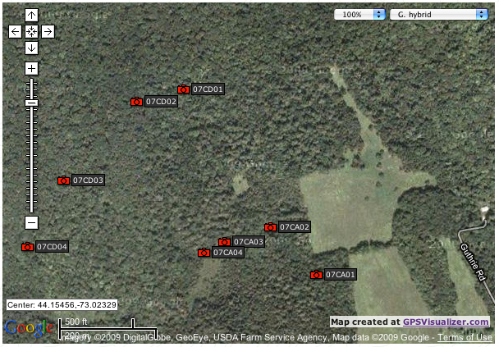
Fig. 1 - Plotted Garmin 12 GPS readings of 2007 camera trap locations plotted with GPS Visualizer (http://www.gpsvisualizer.com/) .

Overall trap success was 10.4 photographs per 100 trap nights (Table 1). The most commonly photographed species this year were Fisher (Martes pennanti), with 6 images from just one site, and White-tail Deer (Odocoileus virginanus), with five images from four sites (Table 1). For comparison, a camera trap survey done in the summer of 2009 at Bromley Mountain in Southern Vermont using five (1 analog and 4 digital) camera traps for a total of 718 trapnights yielded only 4.04 useful photographs per 100 trap nights (Decher, Gray, and Richardson 2009). A larger scale study at Salt Pond Mountain, Giles County, Virginia, using 28 cameras at 15 stations for a total of 891 trap nights, yielded 40.74 photographs per 100 trap nights, with White-tailed Deer and Gray Squirrel being the most frequently captured animals (Kelly and Holub 2008).

Table 1: Images and video recorded and number of sites and ecosystems covered with 2 automatic camera traps on the Guthrie-Bancroft parcel between 19 June to 22 October 2007.
Common Name | Scientific Name | Still images | No. of Camera Sites | No. of ES | Video Se-quences
White-Tailed Deer | Odocoileus virginianus | 5 | 4 | 3
Moose | Alces americanus | 1 | 1 | 1
Back Bear | Ursus americanus | 1 | 1 | 1
Racoon | Procyon lotor | 1 | 1 | 1
Fisher | Martes pennanti | 6 | 1 | 1
Weasel | Mustela sp. | 3 | 1 | 1
Mink | Neovison vison | 1 | 1 | 1
Skunk | Mephitis mephitis | 1 | 1 | 1
Gray Squirrel | Sciurus carolinenis | 2 | 1 | 1 | 1
Red Squirrel | Tamiasciurus hudsconicus | 4 | 1 | 1 | 1
Total |  | 25
Total No. of Camera Trap Nights |  | 241
% Total Trap Success (trap events / 100 trap nights) |  | 10.37

At most camera stations just one or two species were recorded except for Station 07CD04 in ES1 which recorded 19 images (Table 2).

Table 2: 2007 camera trap results by GPS locality (Compare Fig. 1)
 |  |  |  |  | Mammals
GPS Code | Dates | ES | Latitude | Longitude | Bear | Fisher | W.-T. Deer | Moose | Raccoon | Skunk | Mink | Weasel | Gray Squirrel | Red Squirrel
07CA01 | 19 Jun-13 Jul | n/a | 44°09'09.6" | -73°01'17.5" |  |  | 1 | 1
07CA02 | 13Jul-20Aug | n/a | 44°09'12.8" | -73°01'21.8" | 1
07CA03 | 20Aug-19 Sep | 20 | 44°09'11.8" | -73°01'26.2"
07CA04 | 19 Sep-22 Oct | 20 | 44°09'11.1" | -73°01'28.1"
07CD01 | 19-27Jun | 6 | 44°09'22.1" | -73°01'30.0" |  |  | 1
07CD02 | 27 Jun-12 Jul | 6 | 44°09'21.3" | -73°01'34.4" |  |  | 2
07CD03 | 12Jul-20Aug | 1 | 44°09'16.0" | -73°01'41.3" |  |  | 2
07CD04 | 20 Aug-22 Oct | 1 | 44°09'11.5" | -73°01'44.7" |  | 6 | 1 |  | 1 | 1 | 1 | 3 | 2 | 4
 |  |  |  | Total Images: | 1 | 6 | 7 | 1 | 1 | 1 | 1 | 3 | 2 | 4

Table 3 (Appendix II) shows all camera trap codes, localities and species documented since 2004 including bird and humans and dogs. Figure 3 (Appendix III) is the accompanying map showing all localitiesin different colors for each year. The five most commonly recorded species over the four years were White-tailed Deer (n = 15), Moose (n = 12), Fisher (n = 10), Bear (n = 7). And Coyote (n = 5).

Species Accumulation Curve

A species accumulation (rarefaction) curve was generated in EstimateS (Colwell 2009) from presence-absence for the camera results from 2004 to 2007 (Fig. 2), showing a steeply rising curve and no leveling of species increase over individuals sampled through time.
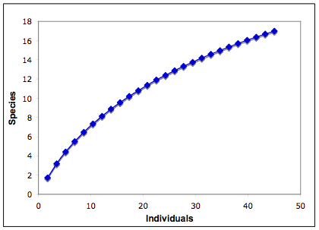

Fig. 2. Individual-based rarefaction curve generated EstimatesS 8.2 (Colwell 2009) using presence-absence data for 17 species (including birds) encountered at Guthrie-Bancroft during four years (2004-2007) of camera trapping.

This indicates that over the four years species were continuously added and that the total number of species present has not yet been reached. The area is regularly visited by – if not residence to – large mammals that have recovered in recent years in Vermont, such as moose, black bear and coyote.
It appears that the Guthrie-Bancroft Parcel has quite high species diversity and that more species might be recorded with additional sampling. Trap success was twice as high as that recorded during a study conducted at Bromley Mountain (Bennington Co.) in 2009, an area which has a much higher disturbance levels due to skiing and summer recreational and maintenance activities including ATV traffic on forest trails. The long-term conservation and “forever wild” concept implemented at Guthrie Bancroft may already provide a safe haven for medium-sized and large mammals “disturbed” only modestly by some hunting activity in the fall, as documented by the cameras.

Literature Cited
Colwell, R. K. 2009. EstimateS: Statistical estimation of species richness and shared species from samples. Version 8.2. User's Guide and application published at: http://purl.oclc.org/estimates.
Decher, J. 2004. 2004 Camera Trap Survey at Guthrie-Bancroft Parcel, Colby Hill, Lincoln,
Vermont. Burlington: Colby Hill Ecological Project.
Decher, J. 2005. 2005 Camera Trap Survey at Guthrie-Bancroft Parcel, Colby Hill, Lincoln, Vermont.
Decher, J. 2006. 2006 Camera Trap Survey at Guthrie-Bancroft Parcel, Colby Hill, Lincoln and Bristol Vermont.
Decher, J., Chris R. Gray and Alia M. Richardson. 2009. Non-game Mammal Assessment for the Bromley Mountain Environmental Impact Statement. Final Report to Heindel & Noyes Inc. , Burlington, VT, November 2009.
Kelly, M., and E. L. Holub. 2008. Camera Trapping of Carnivores: Trap Success Among Camera Types and Across Species, and Habitat Selection by Species, on Salt Pond Mountain, Giles County, Virginia. Northeastern Naturalist 15:249-262.
Appendix I: Photographs
1. Mammals
1.1 Artiodactyls
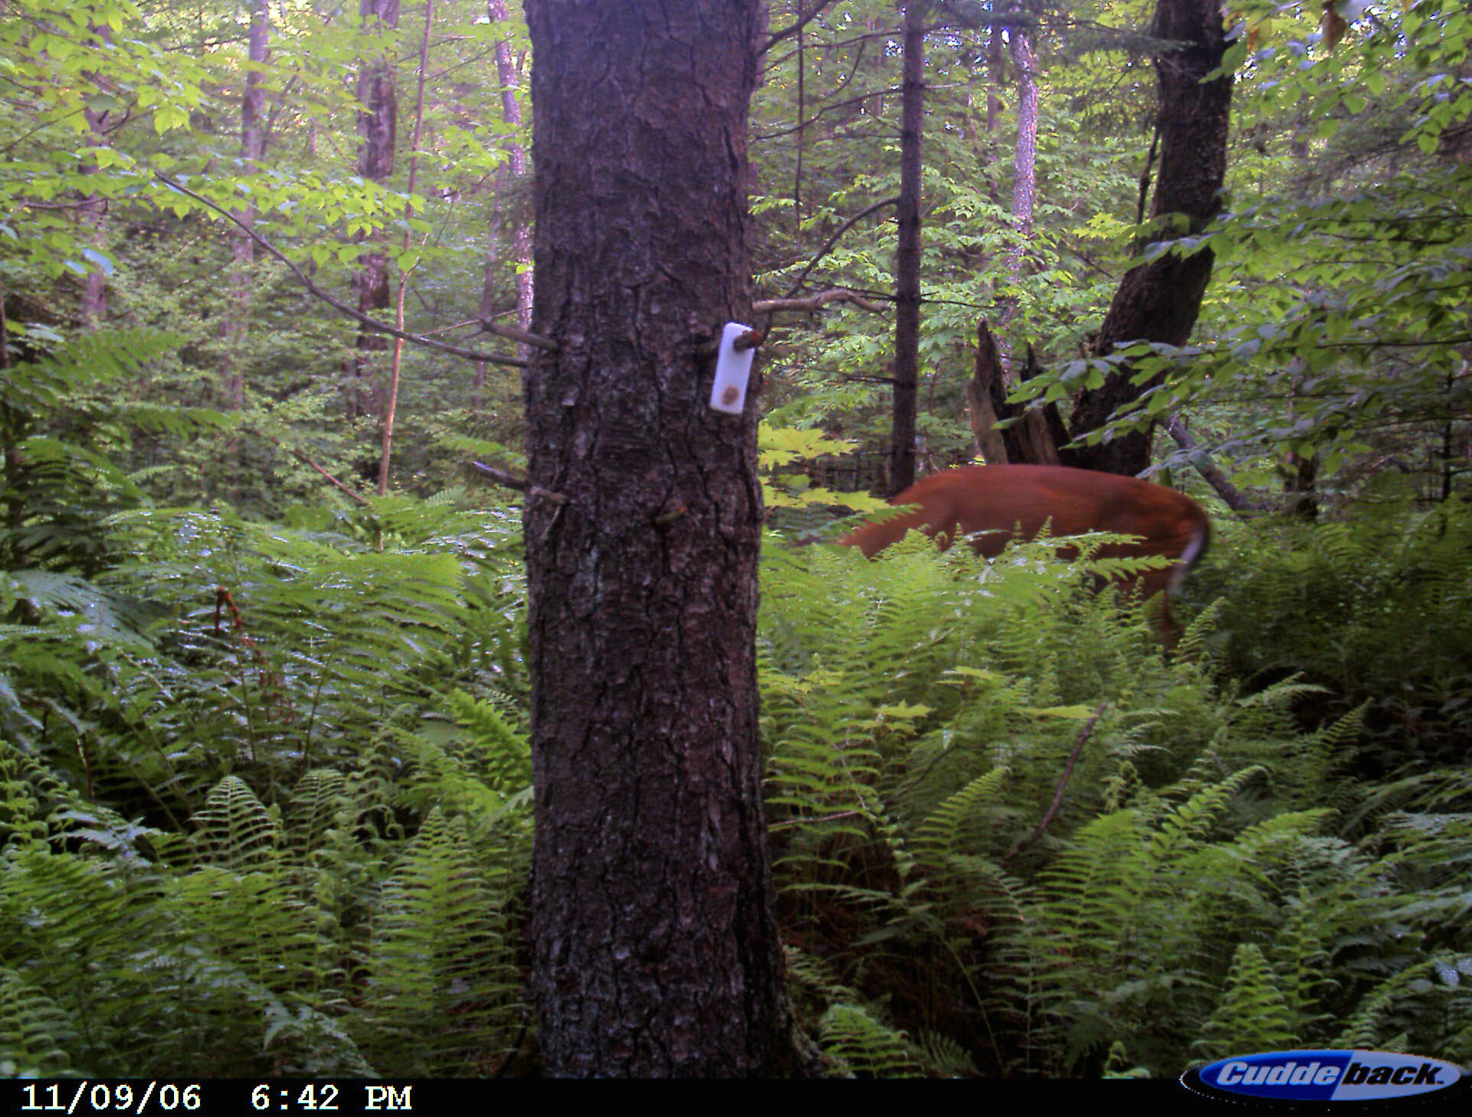
Plate 1. Odocoileus virginanus (White-tailed Deer). Date: 24 June 2007 (imprinted date incorrect) Location Code: 07CD01. GPS: 44°09'22.1"N, 73°01'30.0"W Habitat: ES 6 just north of “pot road”.

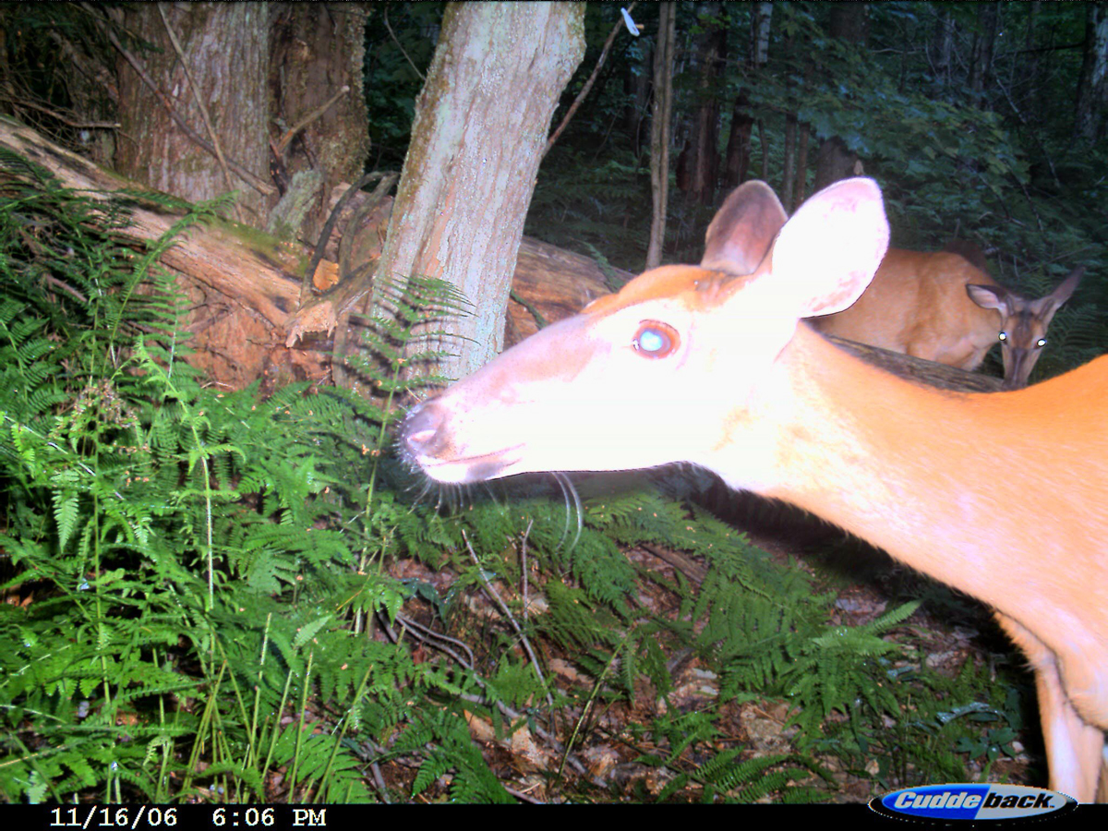
Plate 2. Odocoileus virginanus (White-tailed Deer). Date: 1 July 2007 (imprinted date incorrect) Location Code: 07CD02. GPS: 44°09'21.3"N, 73°01'34.4"W Habitat: ES 6 (1 out of 2 pictures).

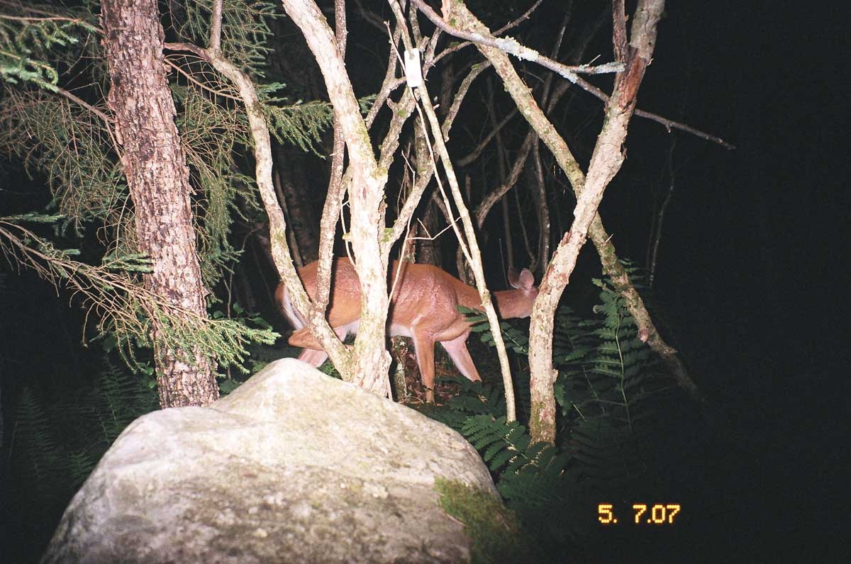
Plate 3. Odocoileus virginanus (White-tailed Deer). Date: 5 Jul 2007 Location Code: 07CA01.
GPS: 44°09'09.6"N, 73°01'17.5"W Habitat: North of American Chestnut tree.

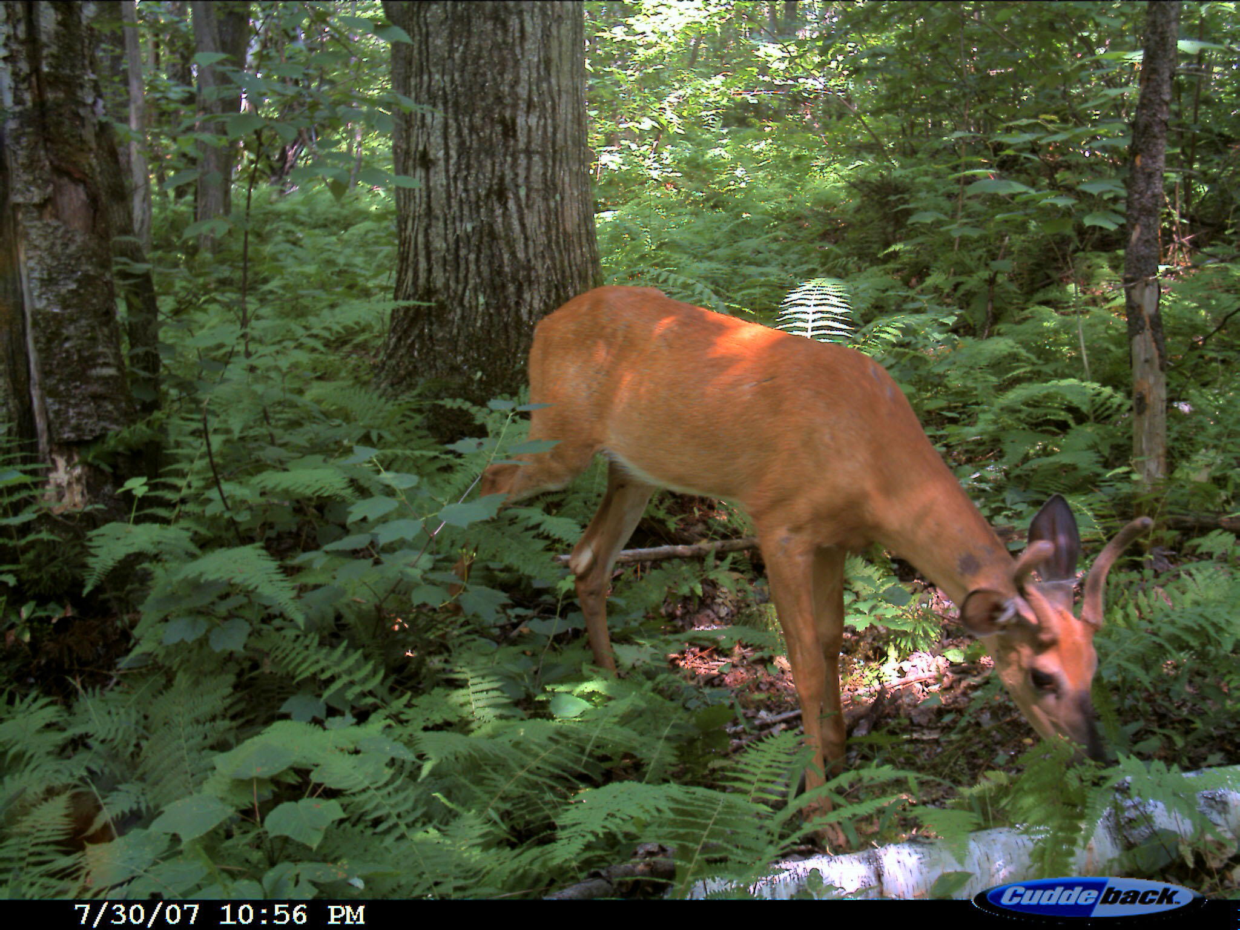
Plate 4. Odocoileus virginanus (White-tailed Buck). Date: 30 Jul & 1 Aug 2007 Location Code: 07CD03. GPS: 44°09'16.0"N, 73°01'41.3”W Habitat: ES1. (1 out of 2 pictures)
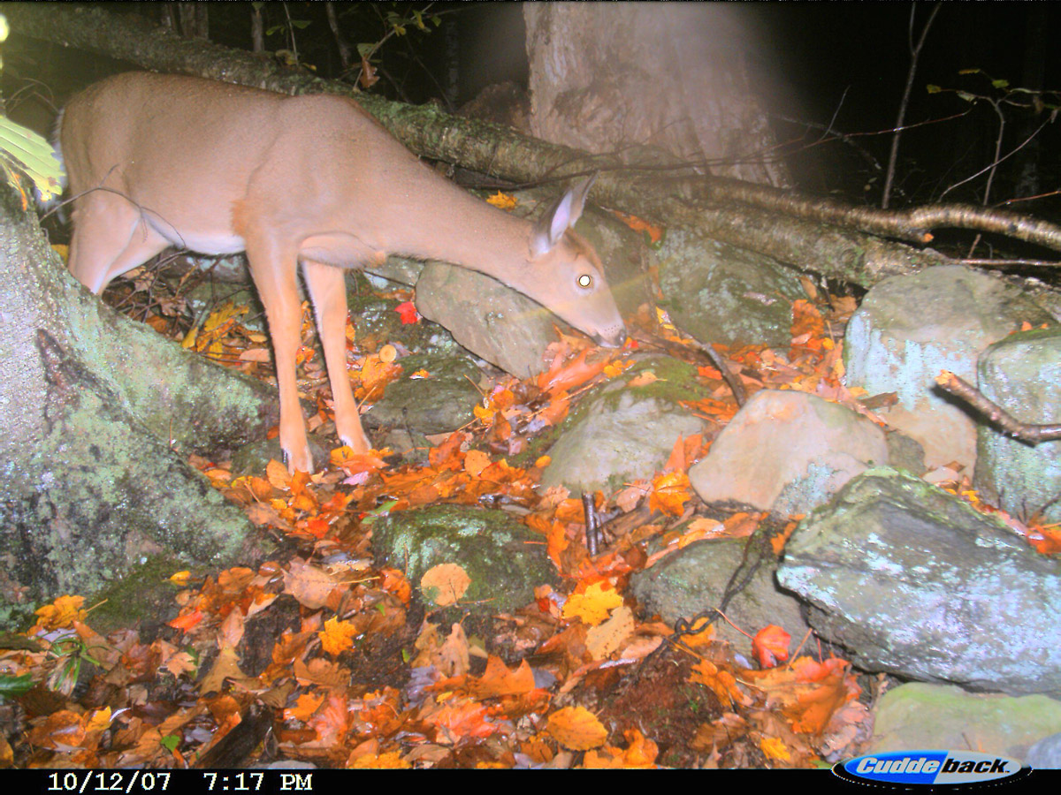
Plate 5. Odocoileus virginanus (White-tailed Deer). Date: 12 Oct 2007 Location Code: 07CD04.
GPS: 44°09'11.5"N, 73°01'44.7"W Habitat: ES1.

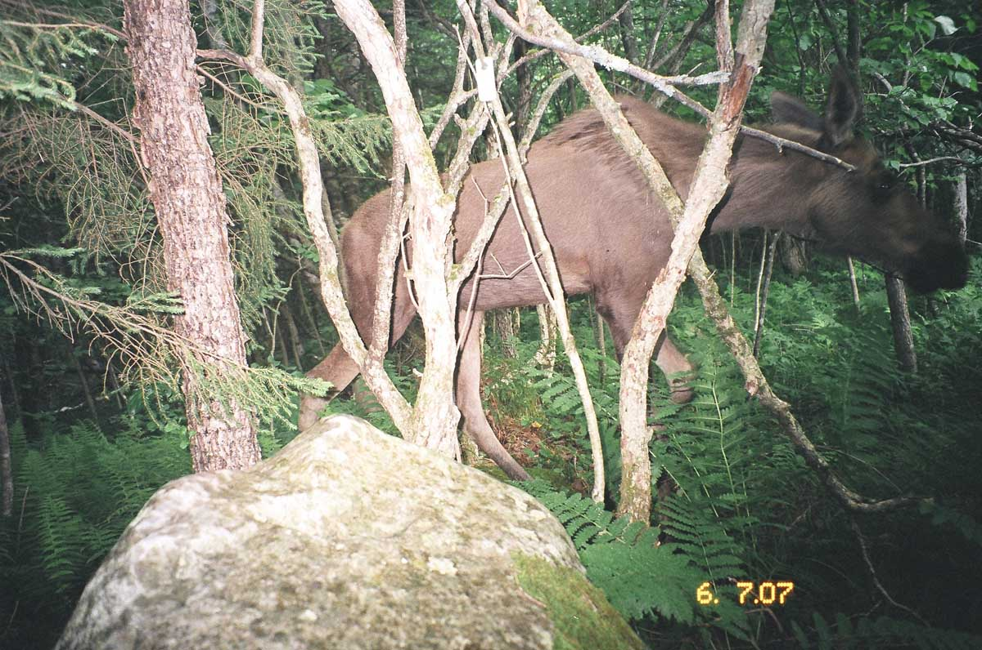
Plate 6. Alces americanus (Moose). Date: 6 Jul 2007 Location Code: 07CA01.
GPS: 44°09'09.6"N, 73°01'17.5"W Habitat: North of American Chestnut tree.

1.2 Carnivores

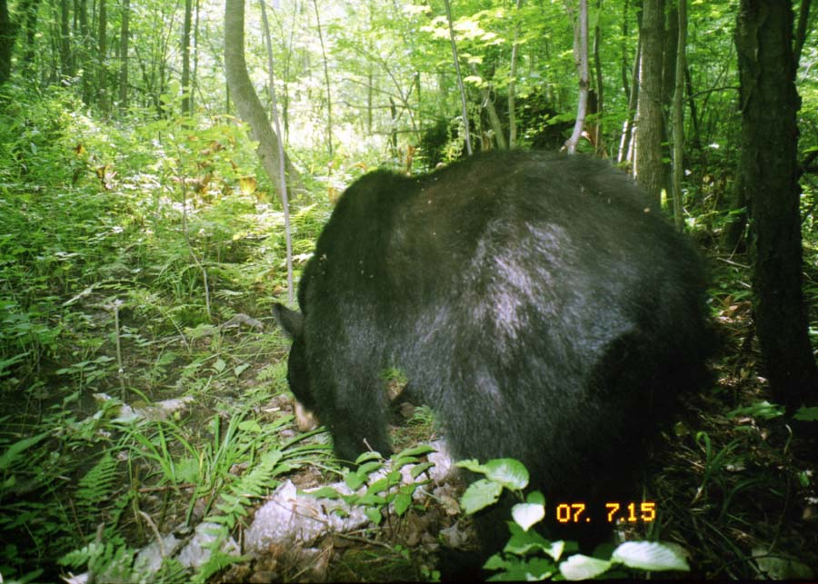
Plate 7 Ursus americanus (Black Bear). Date: 15 July 2007. Location Code: 07CA02.
GPS: 44°09'12.8"N, 73°01'21.8”W. Near large American Chestnut tree.

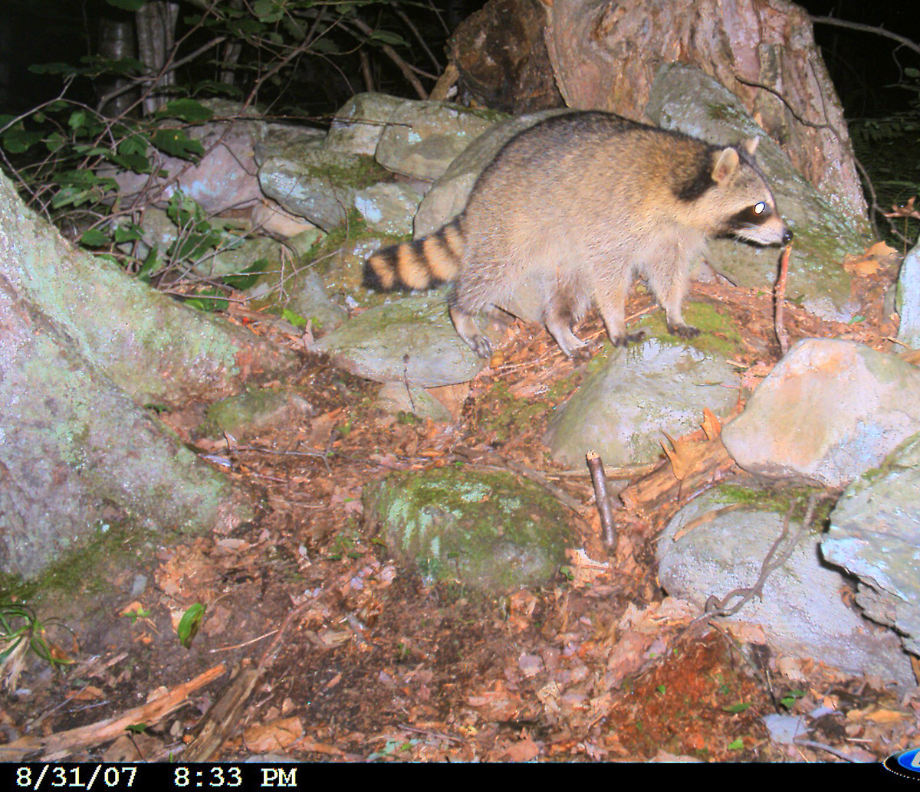
Plate 8 Procyon lotor (Raccoons). Date: 31 August 2007. Location Code: 07CD04.
GPS: 44°09'11.5"N, 73°01'44.7”W. Habitat: ES 1.

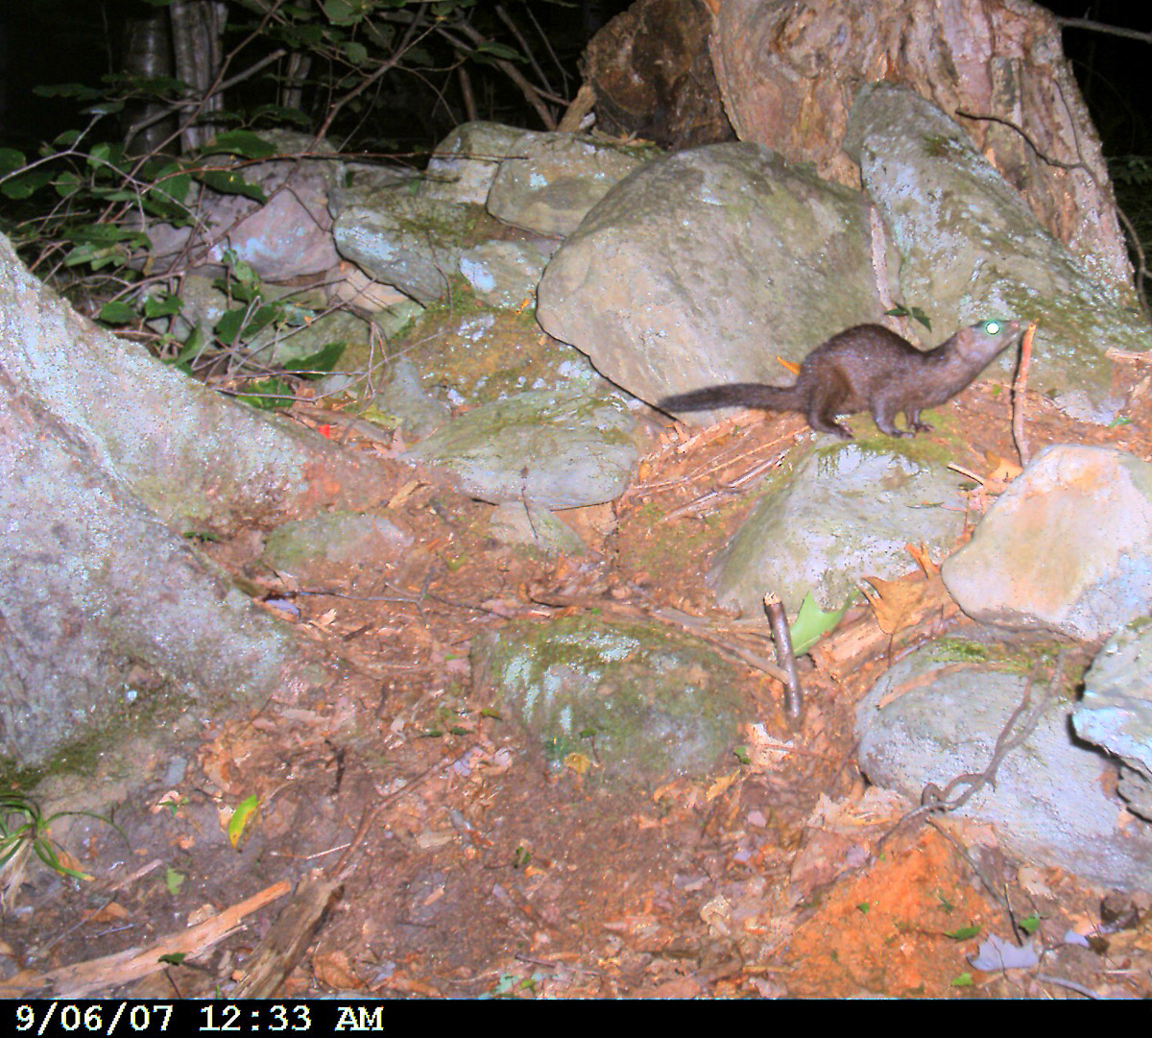
Plate 9 Neovison vison (Mink). Date: 6 Sept 2007. Location Code: 07CD04.
GPS: 44°09'11.5"N, 73°01'44.7”W. Habitat: ES 1.

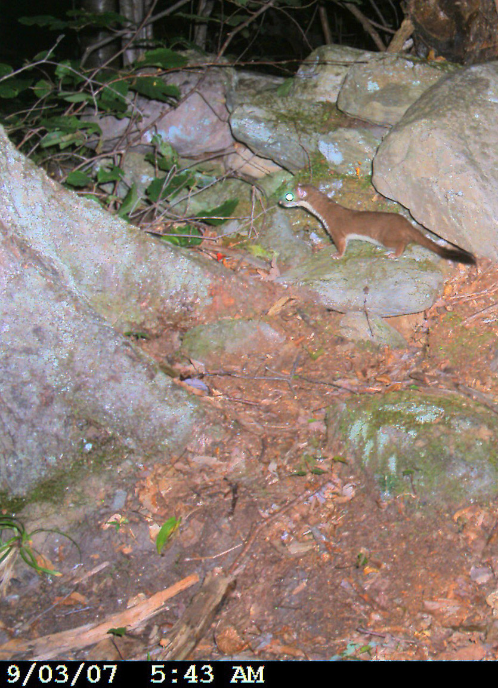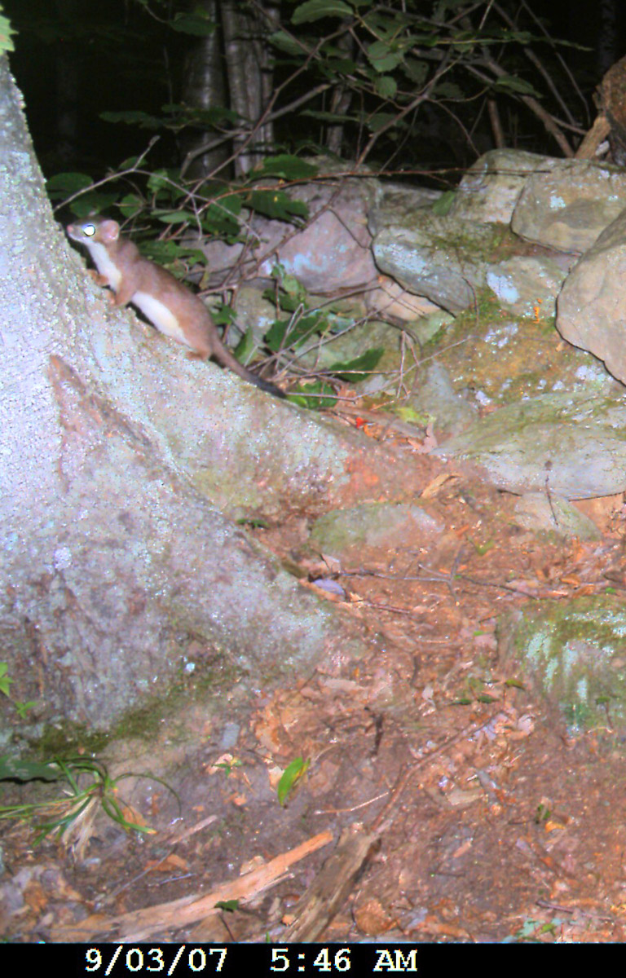
Plates 10+11 Mustela sp. (Weasel). Date: 3 + 30 Sept 2007. Location Code: 07CD04.
GPS: 44°09'11.5"N, 73°01'44.7”W. Habitat: ES 1. (2 out of 3 pictures).

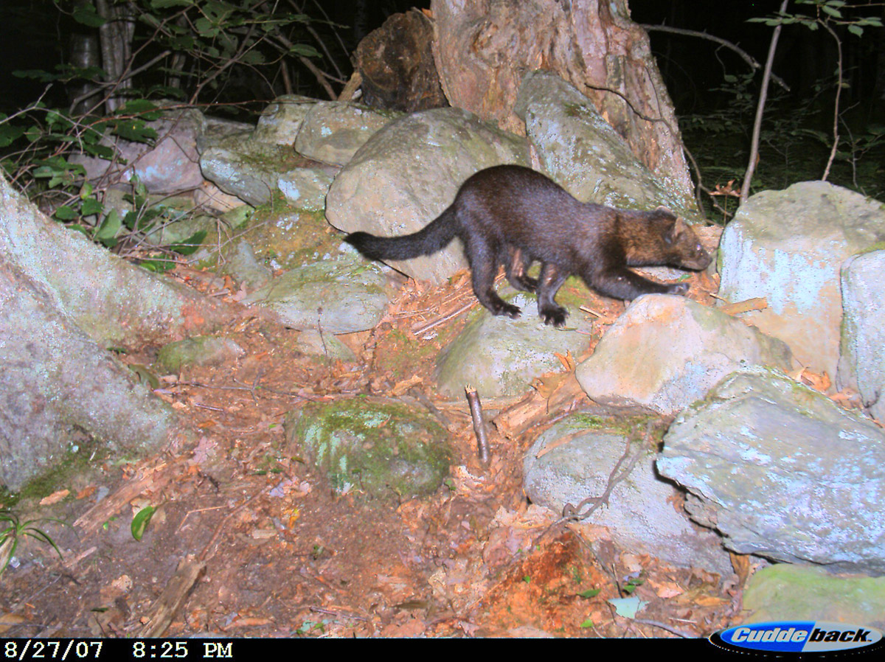
Plate 12 Martes pennanti. (Fisher). Date: 27 Aug 2007. Location Code: 07CD04.
GPS: 44°09'11.5"N, 73°01'44.7”W. Habitat: ES 1. (Total of 3 pictures from this date.)

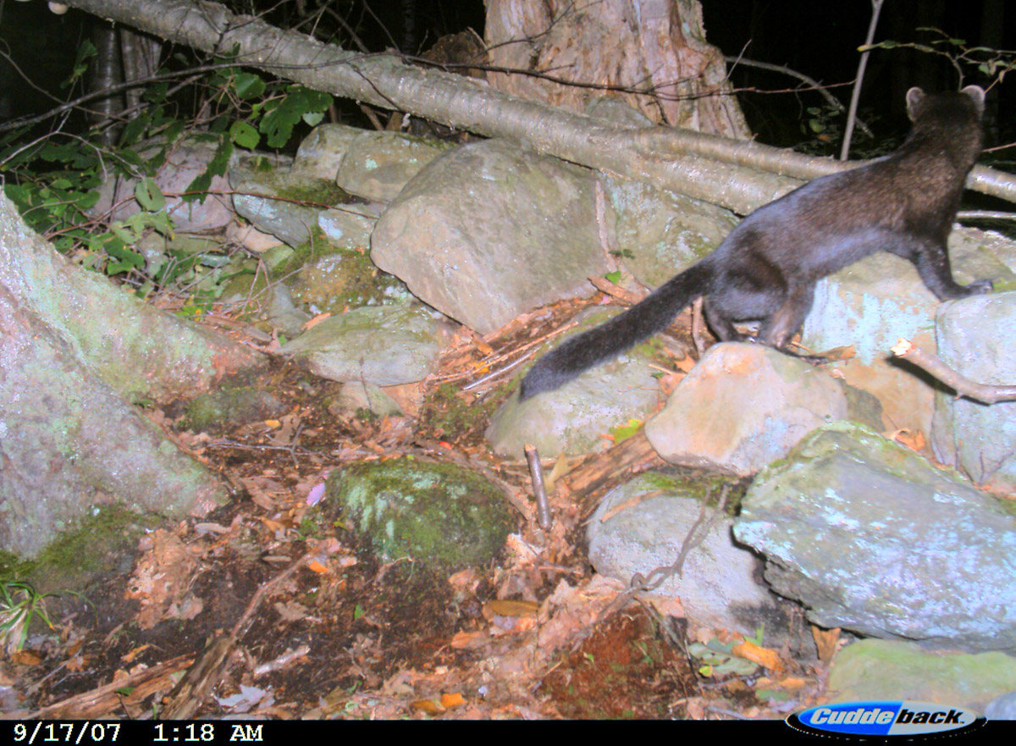
Plate 13 Martes pennanti. (Fisher). Date: 14+17 Sep 2007. Location Code: 07CD04.
GPS: 44°09'11.5"N, 73°01'44.7”W. Habitat: ES 1. (One of 2 pictures from these dates).

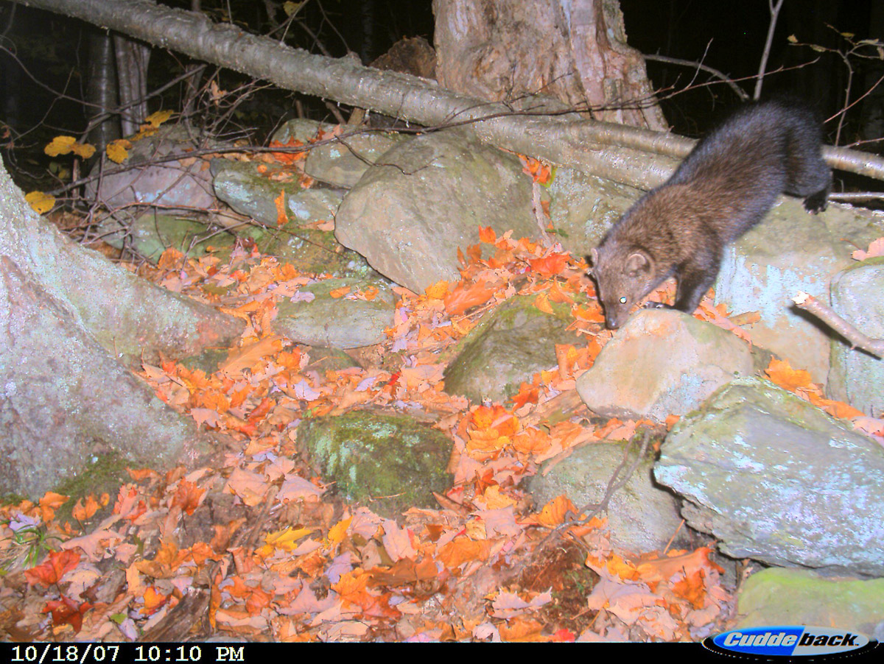
Plate 14 Martes pennanti. (Fisher). Date: 18 Oct 2007. Location Code: 07CD04.
GPS: 44°09'11.5"N, 73°01'44.7”W. Habitat: ES 1.

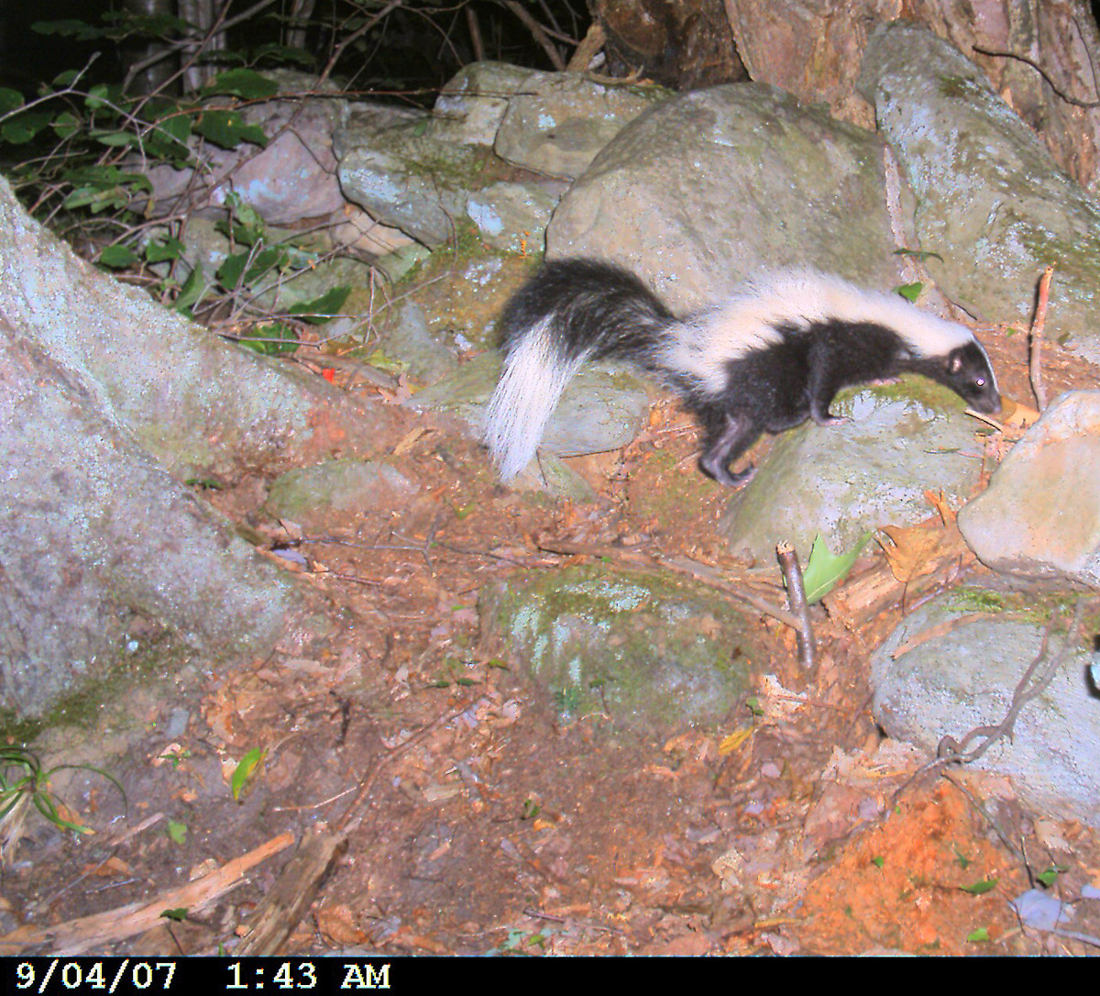
Plate 15 Mephitis mephitis (Striped Skunk). Date: 4 Sep 2007. Location Code: 07CD04.
GPS: 44°09'11.5"N, 73°01'44.7”W. Habitat: ES 1.

1.3 Rodents
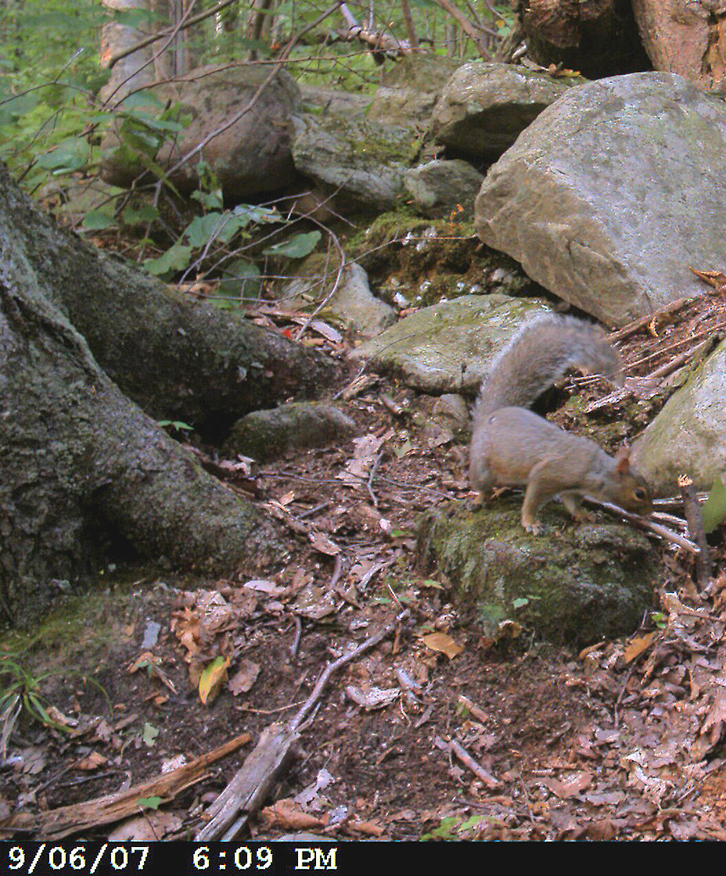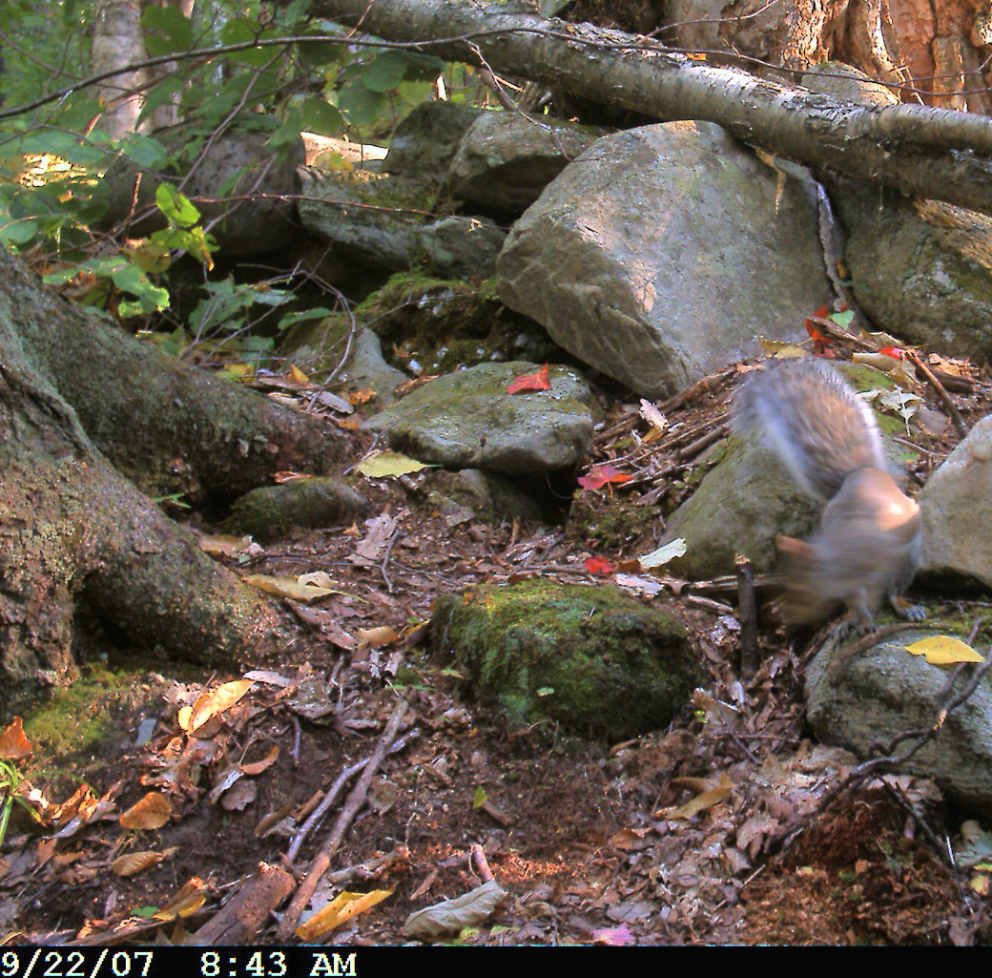
Plates 16+17 Sciurus carolinensis (Gray Squirrel). Date: 6+22 Sep 2007. Location Code: 07CD04.
GPS: 44°09'11.5"N, 73°01'44.7”W. Habitat: ES 1. (see also video from 22 Sep 2007)

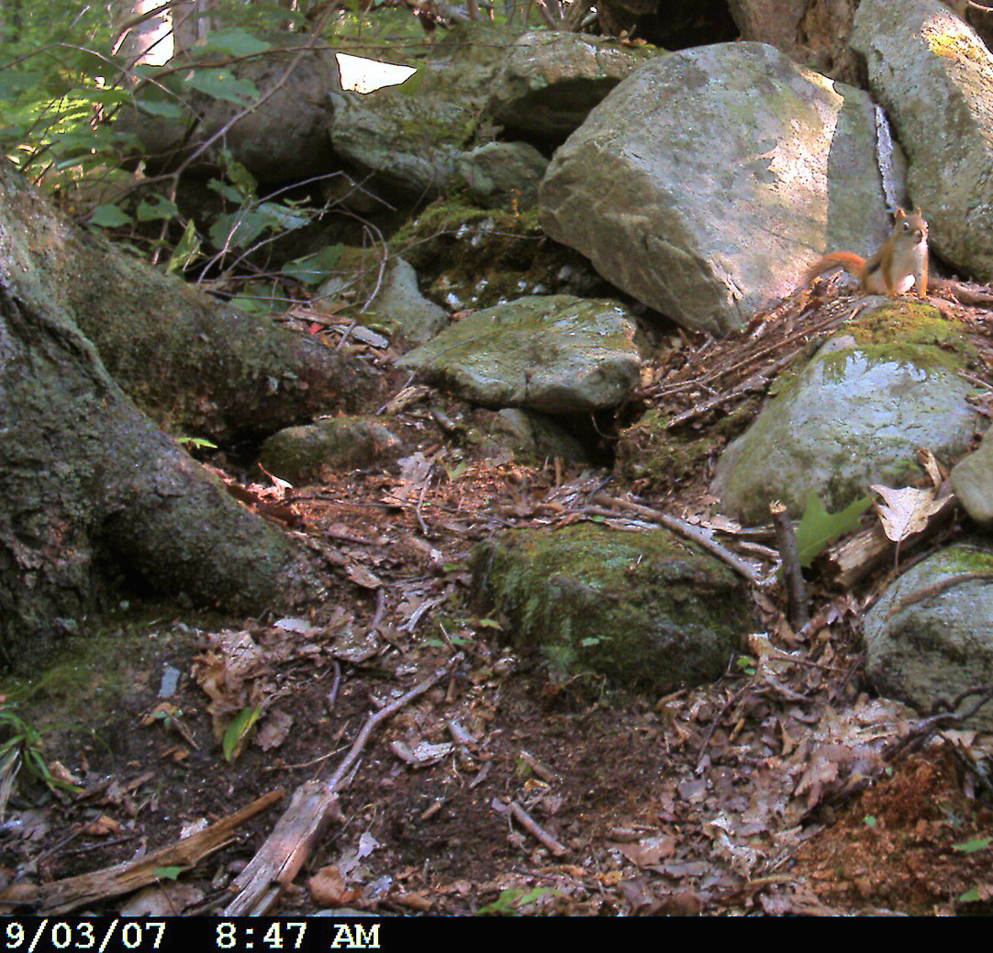
Plate 18 Tamiasciurus hudsonicus (Red Squirrel). Date: 21Aug., 3+4 Sep., 3 Oct 2007. Location Code: 07CD04. GPS: 44°09'11.5"N, 73°01'44.7”W. Habitat: ES 1. (1 out of 4 pictures, see also video from 3 Oct 2007 ).

Appendix II - Overview 2004-2007 Camera Trapping

 |  |  |  |  | Mammals |  |  |  |  |  |  |  |  |  |  |  |  |  | Birds
GPS Code | Date | ES | Latitude | Longitude | Bear | Fisher | W.-T. Deer | Moose | Raccoon | Skunk | Mink | Weasel | Coyote | Red Fox | Cottontail | Grey Squirrel | Red Squirrel | Peromyscus | Turkey | Ruffed Grouse | Wh.-br. Nuthatch | Hunters/Dogs
04CA01 | 19-28 May 04 | 14 | 44°08'57.4" | 73°01'05.3" |  |  |  |  |  |  |  |  |  |  |  |  |  |  | 1
04CA03 | 4-12 Jun 04 | 14 | 44°08'57.5" | 73°01'08.1" | 1 |  |  |  |  |  |  |  | 1
04CA04 | 12-18 Jun 04 | 14 | 44°08'58.3" | 73°01'04.2" | 1
04CA05 | 18–26 Jun 04 | 14 | 44°08’53.8” | 73°01’07.0” | 1
04CA07 | 6-20 Jul 04 | 4 | 44°08'56.1" | 73°01'02.1" |  |  |  |  | 1
04CA08 | 20 Jul-11Aug04 | 20 | 44°09'08.6" | 73°01'28.7" | 1 |  |  | 5 |  |  |  |  |  |  |  |  |  |  |  | 1
04CA09 | 11-27 Aug 04 | 2 | 44°09'09.9" | 73°01'28.9" | 1 |  |  |  |  |  |  |  |  |  | 1
04CA13 | 22 Oct-11 Nov 04 | 21,14 | 44°09'11.2" | 73°01'14.4" |  |  |  |  |  |  |  |  |  |  |  |  |  | 1 |  |  | 1
05CA01 | 19-Jul-05 | 20 | 44°09'08.0" | 73°01'28.8" |  |  |  | 5
05CA04 | 28Sep-11Dec05 | 14/22 | 44°09'02.8" | 73°01'07.7" |  |  | 1 |  | 1
05CD02 | 5 Oct-2 Nov05 | 14 | 44°09'04.4" | 73°01'12.1" |  | 4 | 1 |  |  |  |  |  |  | 3 |  |  |  |  |  | 1 |  | 1
05CD03 | 2 Nov-14Dec 05 | 14 | 44°08'55.5" | 73°01'07.8" |  |  |  |  |  |  |  |  |  |  |  |  |  |  |  |  |  | 1
06CA01 | 31-Jul-06 | 12 | 44°09’18.7” | 73°01’13.5” |  |  | 1 |  |  |  |  |  | 1 |  |  |  |  |  | 1
06CA02 | 8-Aug-06 | 12/21 | 44°09’20.2” | 73°01’14.0” |  |  | 2 |  |  |  |  |  |  |  |  |  |  |  |  |  |  | 1
06CA03 | 17-Aug-06 | 2/12 | 44°09’25.9” | 73°01’15.9” |  |  | 1
06CD02 | 7-Aug-06 | 6 | 44°09’22.0” | 73°01’32.0” | 1 |  |  |  | 1
06CD05 | 8-Sep-06 | 6 | 44°09’23.9” | 73°01’33.8” |  |  | 2 | 1 |  |  |  |  |  |  |  | 1
Appendix III continued
 |  |  |  |  | Mammals |  |  |  |  |  |  |  |  |  |  |  |  |  | Birds
GPS Code | Date | ES | Latitude | Longitude | Bear | Fisher | W.-T. Deer | Moose | Raccoon | Skunk | Mink | Weasel | Coyote | Red Fox | Cottontail | Grey Squirrel | Red Squirrel | Peromyscus | Turkey | Ruffed Grouse | Wh.-br. Nuthatch | Hunters/Dogs
06CD06 | 3-Oct-06 | 6 | 44°09’23.0” | 73°01’41.5” |  |  |  |  |  |  |  |  | 1
06CD07 | 13-Oct-06 | 1 | 44°09’09.8” | 73°01’44.8” |  |  |  |  |  |  |  |  | 2
07CA01 | 19 Jun-13 Jul | n/a | 44°09'09.6" | -73°01'17.5" |  |  | 1 | 1
07CA02 | 13Jul-20Aug | n/a | 44°09'12.8" | -73°01'21.8" | 1
07CA03 | 20Aug-19 Sep | 20 | 44°09'11.8" | -73°01'26.2"
07CA04 | 19 Sep-22 Oct | 20 | 44°09'11.1" | -73°01'28.1"
07CD011 | 19-27Jun | 6 | 44°09'22.1" | -73°01'30.0" |  |  | 1
07CD02 | 27 Jun-12 Jul | 6 | 44°09'21.3" | -73°01'34.4" |  |  | 2
07CD03 | 12Jul-20Aug | 1 | 44°09'16.0" | -73°01'41.3" |  |  | 2
07CD04 | 20 Aug-22 Oct | 1 | 44°09'11.5" | -73°01'44.7" |  | 6 | 1 |  | 1 | 1 | 1 | 3 |  |  |  | 2 | 4
 |  |  |  | Total Images: | 7 | 10 | 15 | 12 | 4 | 1 | 1 | 3 | 5 | 3 | 1 | 3 | 4 | 1 | 2 | 2 | 1 | 3

Table 3. 2004-2007 camera trap codes, localities and all species documented.
Appendix III – Map of 2004-2007 Camera Trap Locations

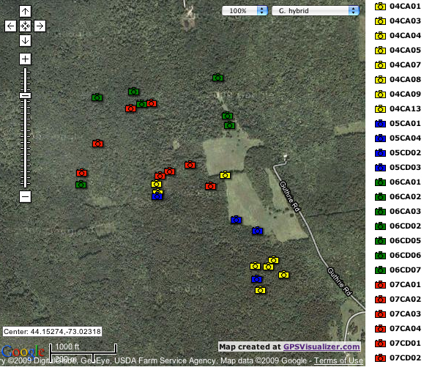

Fig. 3. Google Map generated with GPS Visualizer (http://www.gpsvisualizer.com/) for all productive camera trap sites showing the four years in different colors.

