Loading and enhancing Landsat images in common geospatial software

There are several GIS and Remote Sensing software packages that commercially available. Each of these programs are capable of loading and enhancing satellite images, but there are differences in the way that these images are handled. Below are some practical guides to loading and enhancing Landsat imagery in three commonly used, commercially available GIS and Remote Sensing software packages.

ArcView 3.x

1. In an open ArcView project, open the extensions list by choosing Extensions… from the File drop down menu. Make sure that Spatial Analyst and TIFF 6.0 Image Support are selected to work with tif images and raster data.

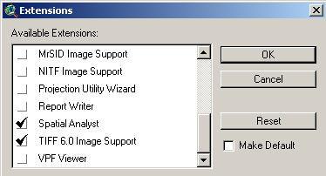

2. To add an image to the project, use the add theme button . Find and select the image that you would like to view. ArcView 3.x is able to view satellite image data in tif, erdas img, esri grid and bil formats. Be sure to set the Data Source Type to Image Data Source to view the available image files.

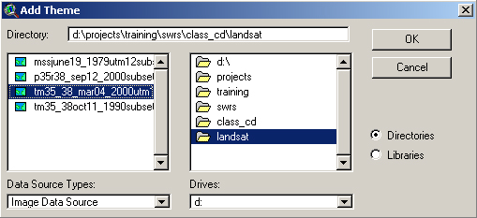
3. Once the image is loaded, it may be seen in the viewer by checking the box next to the theme name in the table of contents bar to the left. Without any initial enhancements, the image may appear dark in color. To enhance the image, double-click the theme name and access the legend editor.

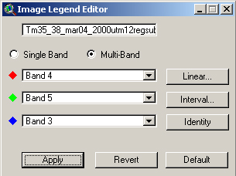

4. The image legend editor allows you to change the RGB band combination using the drop down menus, hit apply to see the changes. You can also do some basic image enhancements using the linear and interval buttons.

5. A georeferenced image may be used as a base layer for digitizing and viewing data, but this is basically the limit of available image resources in ArcView without an additional extension that must be purchased.

ArcMap

1. In an open ArcMap project, use the Add Data button to locate and add an image. Highlight the file name and click the Add button. Double-clicking the file enables you to access individual bands within a single file.

2. ArcMap should already have applied some default enhancements to the image. To access these options, double-click the file name in the table of contents to the left, or right click the file and choose Properties. Choose the Symbology tab at the top of the Layer properties dialog.

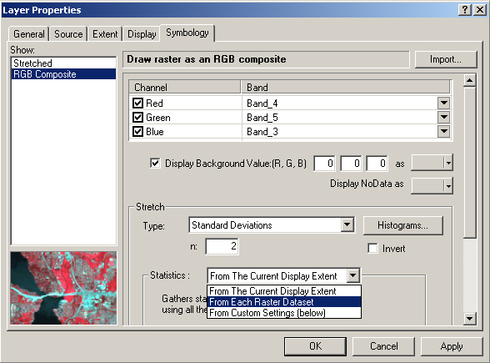
3. In this menu, you can choose an RGB band combination, and clear the black background color by checking the appropriate box. Unlike its predecessor, ArcMap is able to apply several common enhancements to make the image easier to interpret. The most common enhancement is a standard deviation stretch, but you may experiment to find the best fit. These enhancements affect the way the image is viewed on screen, but the data values remain unchanged. New to ArcGIS 9.0 is the ability to use the extent of the display to determine the enhancement statistics. This is very handy to bring out certain features when zoomed in to a particular area.

4. Although there are more options with regards to viewing satellite image data with ArcMap, it is still limited to using the image as a base map for digitizing without the purchase of an additional extension.

Erdas Imagine

Unlike Arcview and ArcMap which are GIS software packages, Erdas Imagine is software specifically designed to handle remote sensing. With this in mind, there are many applications available in this software that may be used to enhance, manipulate and utilize satellite imagery. Below are the steps to simply load and view an image with Imagine.

1. In an open viewer window, click the Open Layer button to select an image to view. Investigate the Files of type option to view the different types of files that can be loaded. Choose All Raster Extensions to select any available file type. Click once on an image file, then select the Raster Options tab at the top. Here you may choose a band combination and other options before viewing the image. Choose OK to load the image to the viewer.



