Why do you think we needed to do the RECLASSIFY step before we could use the EUCLIDEAN DISTANCE tool?

In the final output, why did we get the value “100” as the minimum distance in the zone that represented the ocean?

Please identify the GIS tool and what you would need to tell it in order to make layer B from layer A.
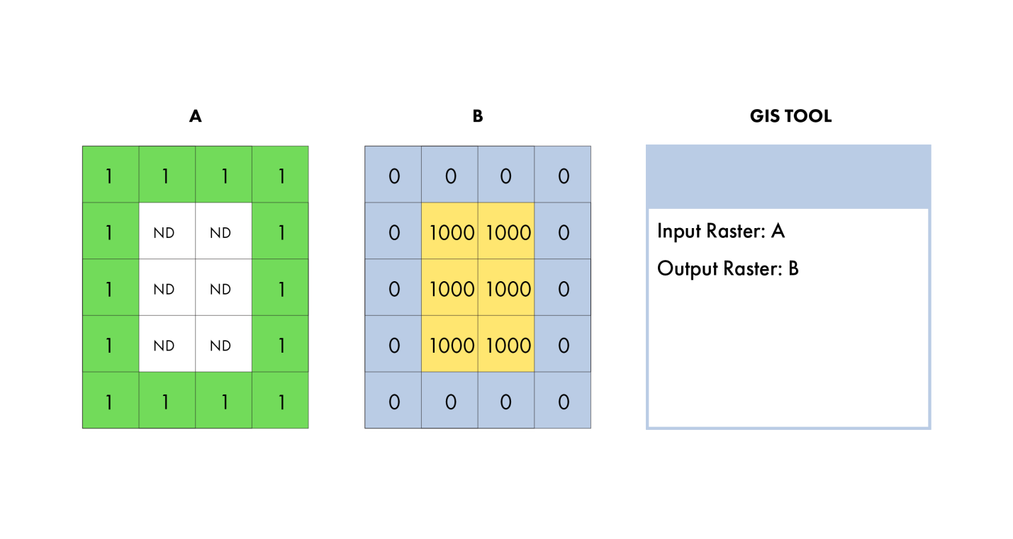

Please identify the GIS tool and what you would need to tell it in order to make layer B from layer A.

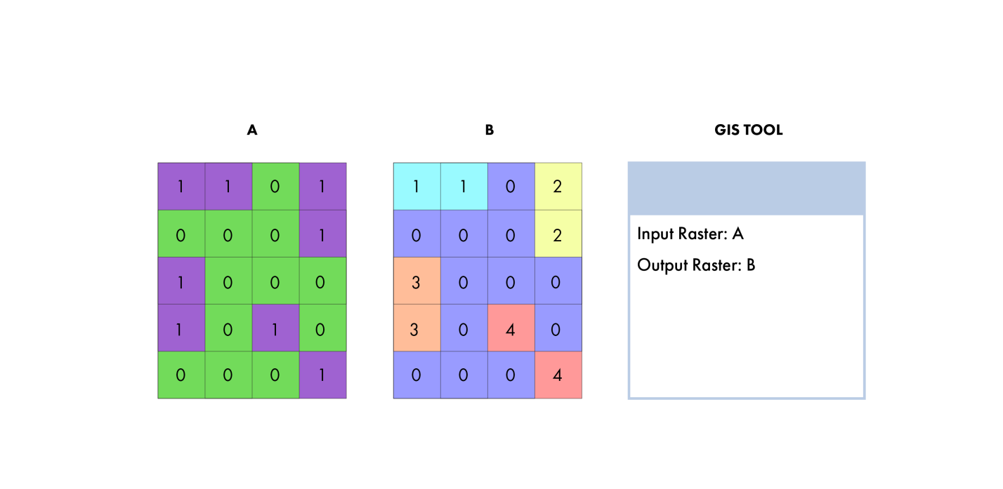

Please fill out the values in Layer C that you would make with this tool and these two input layers.
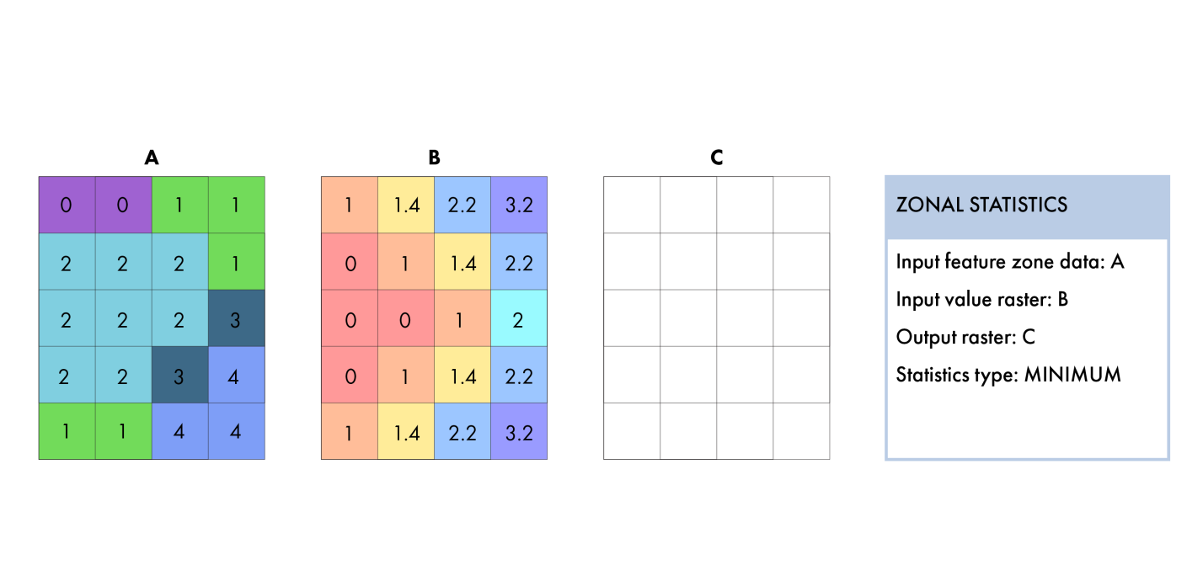

Please fill out the values in Layer B that you would make with Layer A using this GIS tool.
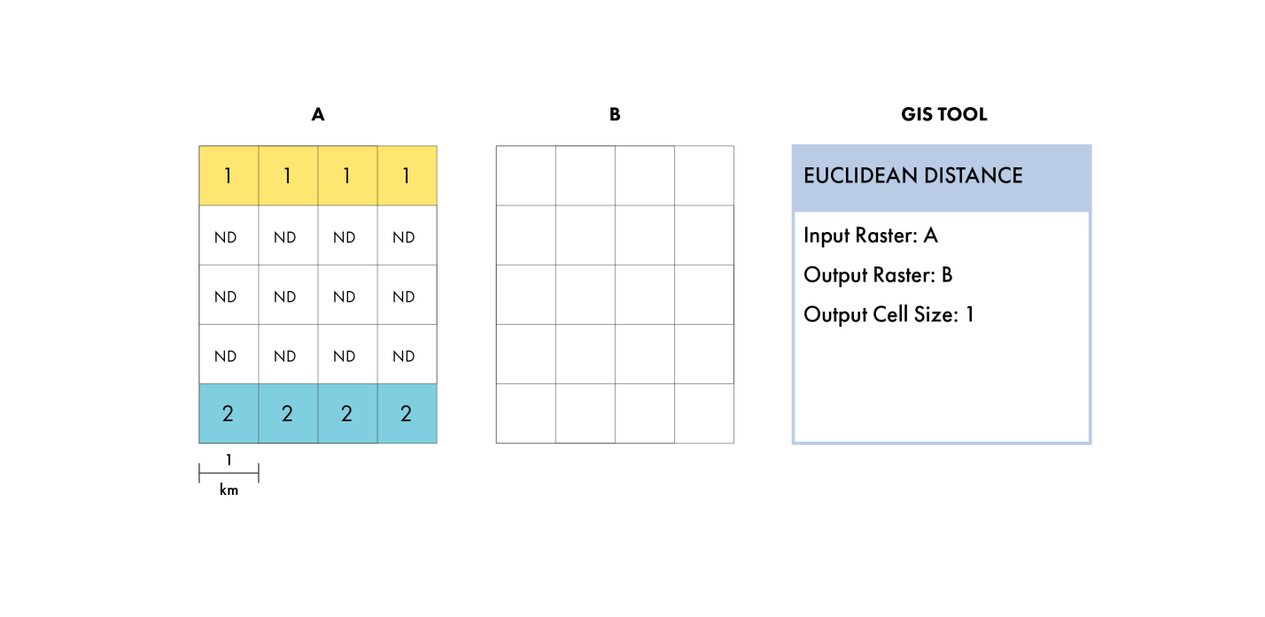

Please fill out the values in Layer B that you would make with Layer A using this GIS tool.
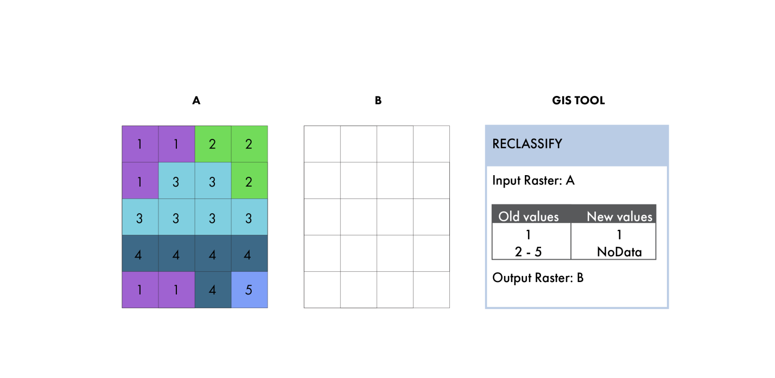

Please fill out the values in Layer B that you would make with Layer A using this GIS tool.
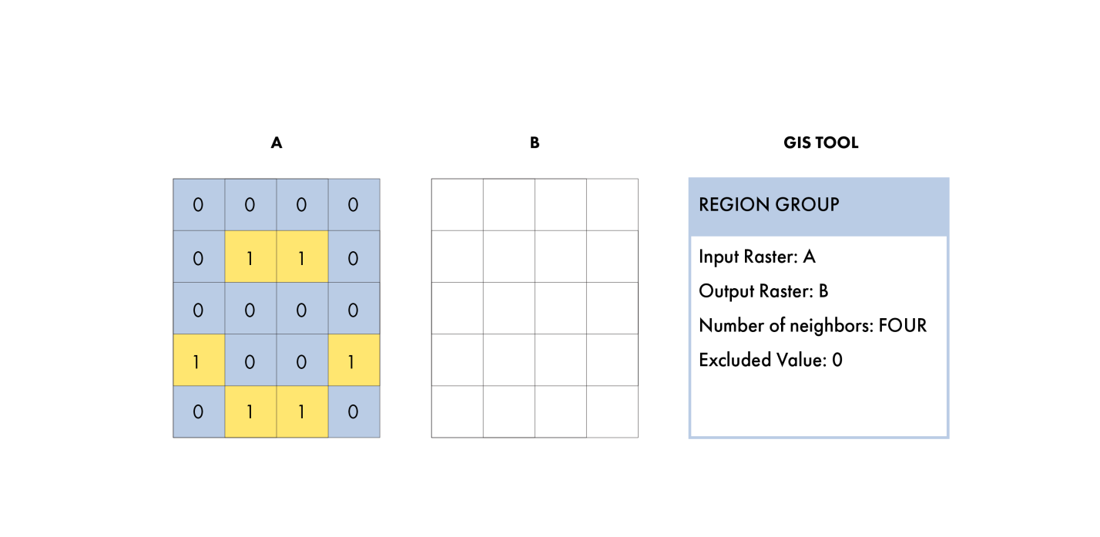

Please fill out the values in Layer A that would let you make Layer B using this GIS tool.
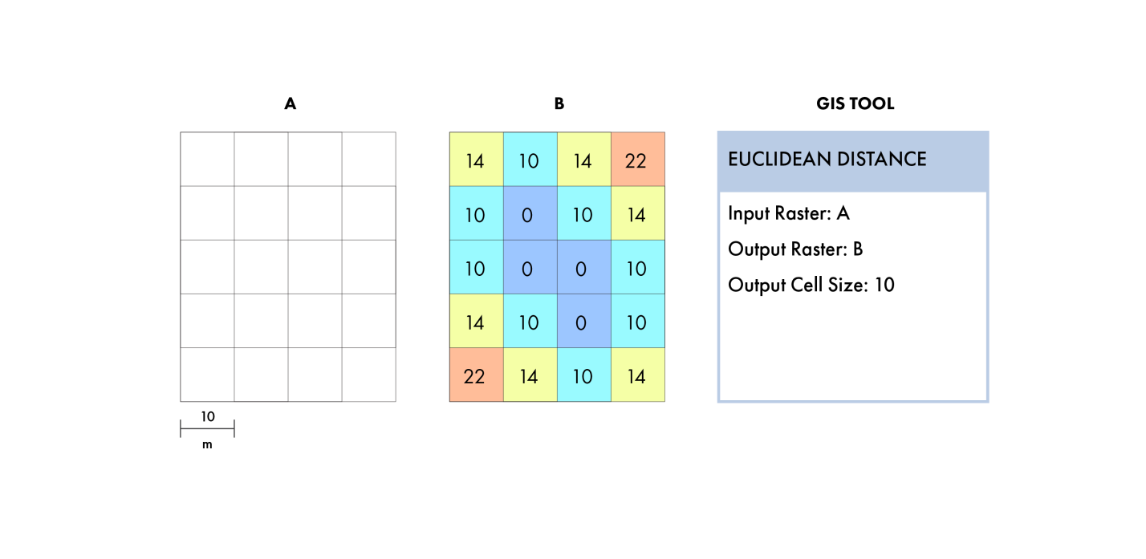

Please fill out the values in Layer A that would let you make Layer B using this GIS tool.

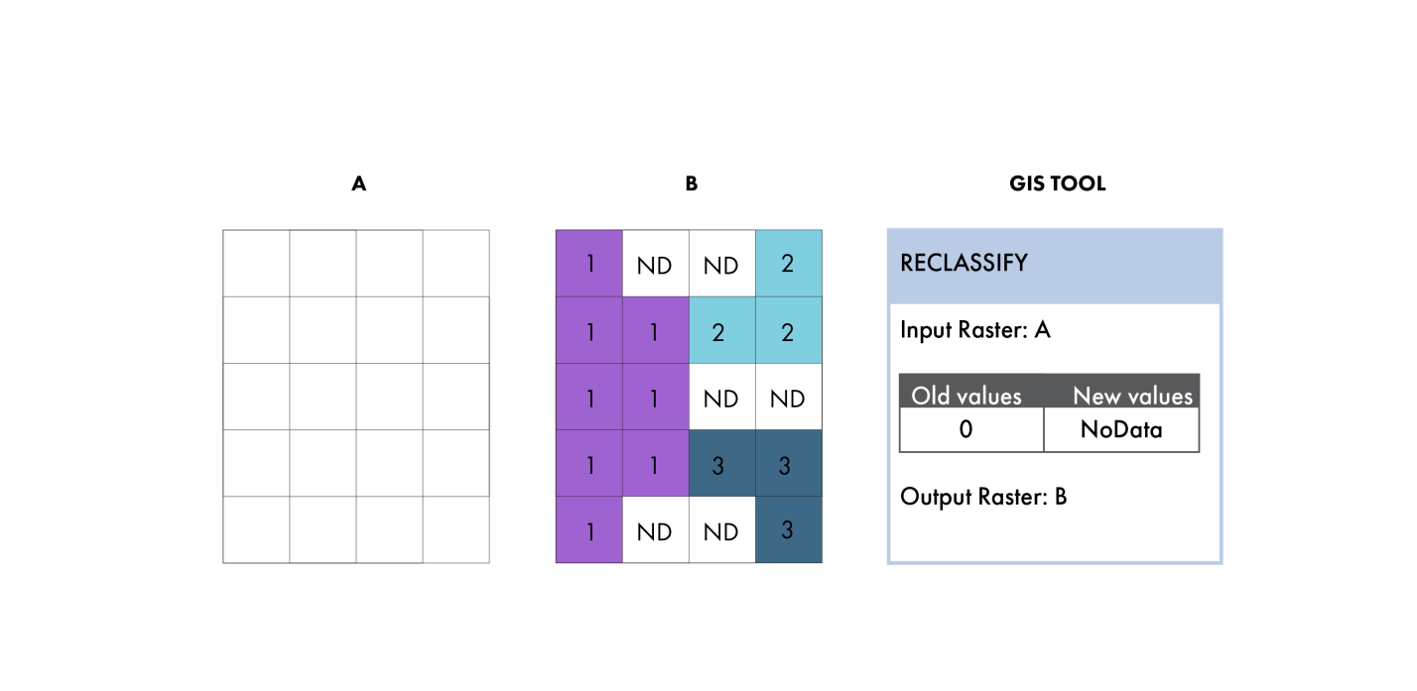

Please fill out the values in Layer A that would let you make Layer B using this GIS tool.
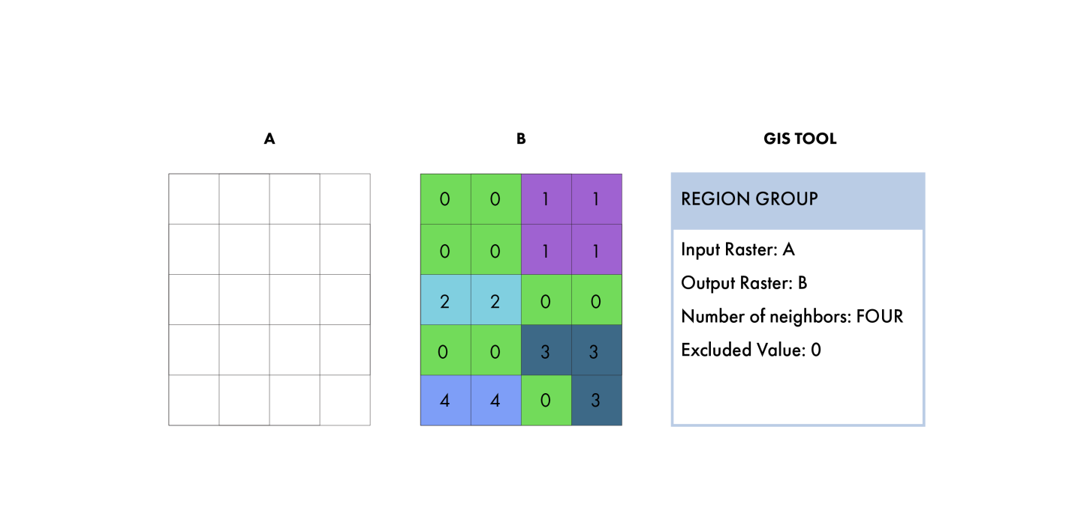

Please fill out the values in Layer A that you would make with Layer C using this GIS tool and Layer B.
